xBookShop

AN AUTOMATED BOOKSHOP SOLUTION



Soham Banerjee

Roll no. c3-96

2nd year, dept. of computer science and engg.

Institute of engineering and management, Kolkata

Contents

Acknowledgements 2

Introduction 3

Design and Testing Environment 3

UI/UX Design 3

Application Screens 4

Login Screen 4

Home Screen 4

Billing Screen 5

Inventory Screen 5

Users Screen 6

Catalog Screen 6

Database Design 7

Splash Screen (\Forms\SplashView.frm) 8

Source Code 8

Screenshot 10

Login Screen (\Forms\LoginView.frm) 11

Souce Code 11

Screenshots 13

Home Screen (\Forms\HomeView.frm) 15

Source Code 15

Screenshots 22

Billing Screen (\Forms\BillingView.frm) 24

Source Code 24

Screenshots 30

Bill Print Screen (\Forms\PrintView.frm) 35

Source Code 35

Screenshots 36

Inventory Screen (\Forms\InventoryView.frm) 37

Source Code 37

Screenshots 59

Catalog Screen (\Forms\CatalogView.frm) 62

Source Code 62

Screenshots 63

Users Screen (\Forms\UserView.frm) 63

Source Code 63

Screenshots 72

modGDIplusResize (\lib\modGDIplusResize.bas) 75

Description 75

Source Code 75

modUser (\lib\modUser.bas) 81

Description 81

Source Code 81

modDatabase (\lib\modDatabase.bas) 82

Description 82

Source Code 82

Roadmap 83

Discussion 83

References 83

# Acknowledgements

I would like to express my heartfelt gratitude to Prof. Subhabrata Sengupta for assigning me this project. It was a wonderful experience working on this project and I have gained a lot of knowledge in development of software applications and also improved my technical skill regarding the Win32 API.

I would like to thank Mr. Pinaki Karmakar, Ms. Arpita Ghosh and other faculty members, along with our respected Head of The Department of Computer Science and Engineering, Mrs. Debika Bhattacharya for extending their support and co-operation at all times.

Mention must be made of my friends for their encouragement and support, without whom completing this project would have been a distant reality. My heartfelt thanks goes out to them.

Last but not the least, it is only when you start working on software development that you truly appreciate the awesome tool that GitHub is. Thank you, Linus Torvalds!

This project uses the Roboto™ and Holo™ open typefaces, which are the intellectual property of Google Inc. and licensed under the GNU GPL.

This project uses the OpenFrameset layout framework which is licensed from <http://www.edgemeal.net>. © 2009 Ed Wilk, Edgemeal.net. All Rights Reserved.

BookShop

A COMPLETE BOOKSHOP AUTOMATION SOLUTION

# Introduction

xBookShop is a Book Store Automation portal. xBookShop is designed with fluidity and ease of use in mind. xBookShop provides an option to replace pen-and-paper based Inventory Management with a fully computerized system, using a relational database backend. This is beneficial as it does away with clerical and human errors and also leads to savings in the long run. Also, xBookShop provides an integrated billing and payment portal, where customer receipts can be generated and printed.

xBookShop is designed using an event-driven approach, with more emphasis given on the day-to-day workflow in an actual book retail outlet. Most book stores have the following basic needs:

* To view a list of all available titles in-house.
* To be able to add and remove items from the list.
* To be able to update the stocks of each item in-house.
* To generate bills and receipts for customer copy.

xBookShop takes care of all these basic scenarios and also adds useful and essential information wherever relevant. We also find that in many stores, the store owner has access to all of the store documents, whereas the employees are not authorized to have that level of access. Keeping this situation in mind, xBookShop is built from the ground up to be a multi-user system, with access-protection being enforced among user accounts.

# Design and Testing Environment

xBookShop was designed using Microsoft Visual Basic 6.0 and an RDBMS back-end implemented in a Microsoft Access Database. The Database Connection was implemented using the Microsoft ActiveX Data Object controls. xBookShop was tested extensively on Windows 8.1 (Update 1) and Windows 7 (SP1), and is designed to be compatible with all versions of Windows from Windows XP and up.

# UI/UX Design

xBookShop is conformant to the design guidelines laid down by Microsoft in its Metro/Modern UI specification. The UI is designed to be contemporary and minimalist, with focus being on the content and data with minimal distractions. xBookShop uses the Roboto open font family by Google as its Primary UX font. It uses Holo Blue as consistent color scheme throughout all app screens.

The various applications views are designed to be complementary rather than contrasting. In line with the minimalist design, application screens fade in and out of view as and when they are required. Thus, at any given moment, there is only one application window on the desktop, which gives the user an immersive experience without any distractions or unnecessary information.

Some design elements such as the Shop Name, Shop Logo and Main Divider remain constant through the various application screens. This gives a sense of branding and also provides an aesthetic way to denote the relationship between various app views.

# Application Screens

## Login Screen

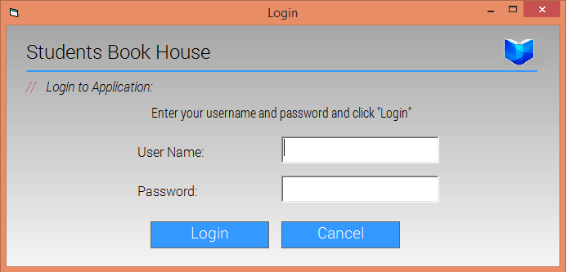

The login screen showing the prompt for user name and password.

## Home Screen

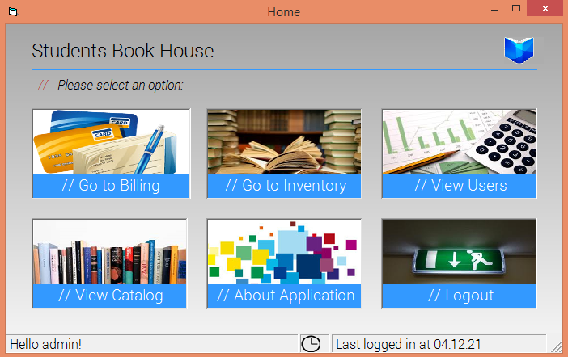

The initial or Home view of the application, after login. A simple gradient has been used as the app view background throughout all app screens.

## Billing Screen

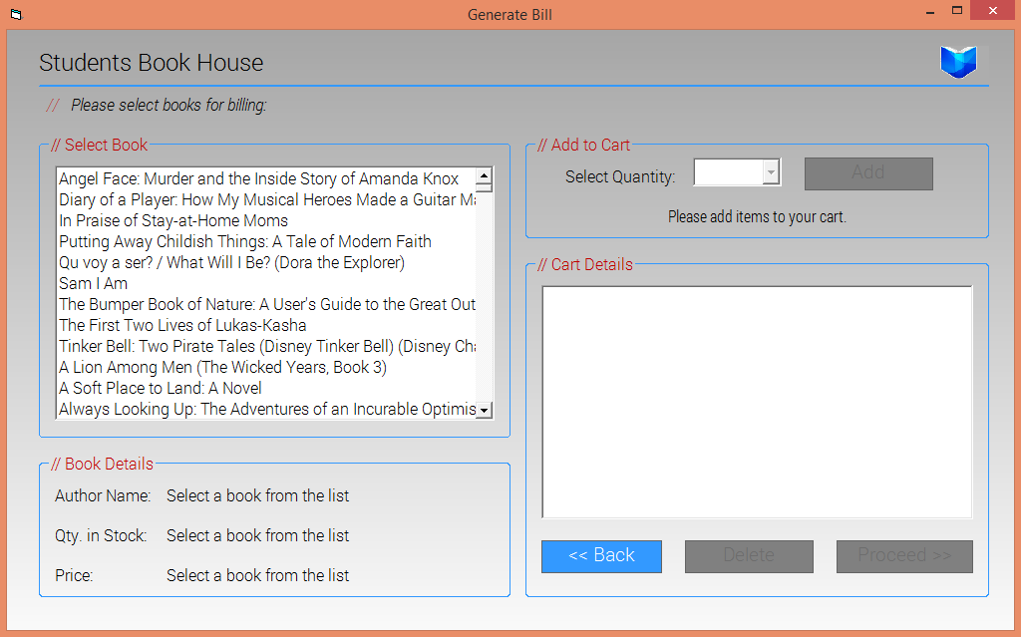

The billing screen to generate invoices. Note that the disabled controls are greyed out and are dynamically enabled as and when required.

## Inventory Screen

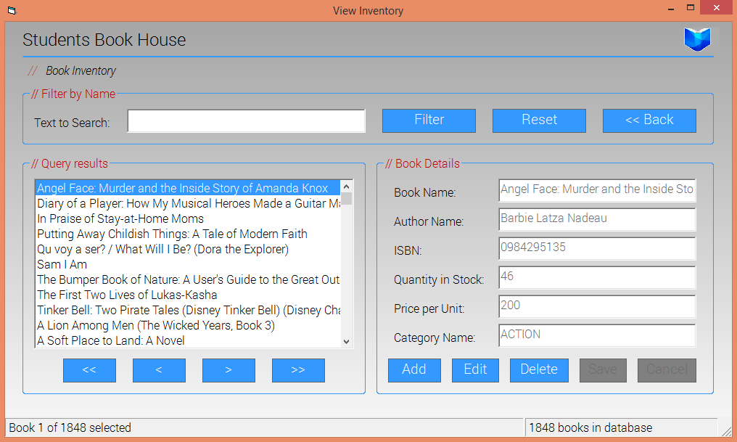

The inventory screen, containing options for inserting, deleting and updating current stocks of books as well as book details. The disabled controls are grayed out.

## Users Screen

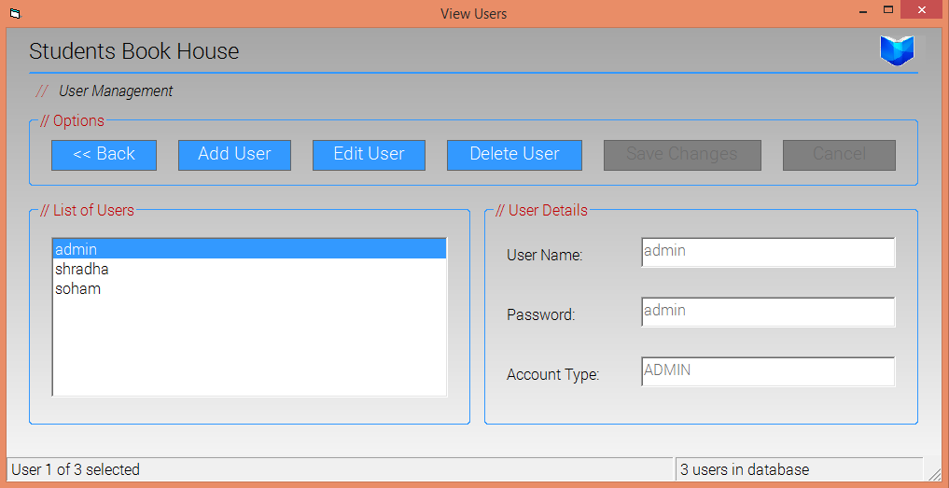

The user management portal. Only an administrator can add or remove other users.

## Catalog Screen

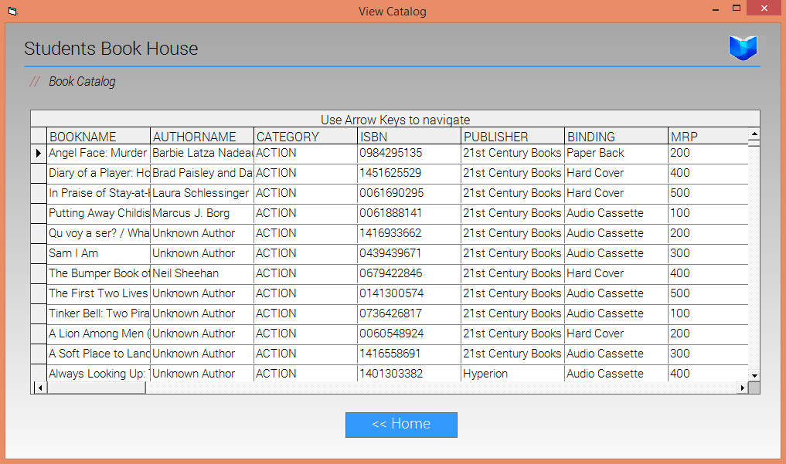

The catalog screen, showing a list of list of all books and prices in tabular form.

# Database Design

The heart of xBookShop is in its Database. xBookShop is designed to work with either a local or remote data source. In its current iteration, xBookShop references a database stored at db\BookDB.mdb with respect to the current working directory. This can be configured to any absolute or relative path, or any ODBC data source.

The database has 3 main tables:

* Books – Keeps a track of the individual books in the store.
* Stocks – Keeps a track of the available stock of each book, prices and sales.
* Users – Keeps a track of the users recognized in the storefront, and account types.

Since we are using an RDBMS system, we have enforced a Left Join upon Books and Stocks, so that a Book and its Stock are directly linked.

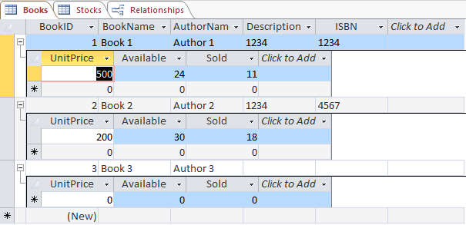

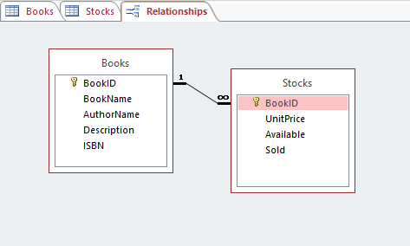

The database can be password-protected and encrypted to ensure data security and integrity.

Form Design

# Splash Screen (\Forms\SplashView.frm)

## Source Code

**Dim** dShort **As** **Integer**

**Dim** dLong, dLong2, dLong3 **As** **Integer**

**Dim** animCount, animCount2, animCount3 **As** **Integer**

**Dim** doneAnim, animStarted2, animStarted3 **As** **Boolean**

**Dim** loadTime **As** **Long**

**Private** **Sub** **Form_Load**()

    doneAnim **=** **False**

    animCount **=** 0

    dShort **=** 100

    dLong **=** 300

    dLong2 **=** 300

    dLong3 **=** 300

    animStarted2 **=** **False**

    animStarted3 **=** **False**

    Timer1.Enabled **=** **True**

    Label3.Left **=** 0

    Label3.Visible **=** **False**

    Label2.Left **=** 0

    Label2.Visible **=** **False**

    Label1.Left **=** 0

    Label1.Visible **=** **False**

    Label4.FontBold **=** **True**

    loadTime **=** 0

    initUser

    initDB

**End** **Sub**

**Private** **Sub** **Timer1_Timer**()

**If** animCount **=** 0 **Then**

        Label1.Visible **=** **True**

        Label1.Left **=** 0

        animCount **=** animCount **+** 1

**End** **If**

**If** animCount **>** 0 **And** animCount **<=** 8 **Then**

        Label1.Left **=** Label1.Left **+** dLong

        animCount **=** animCount **+** 1

        dLong **=** dLong **+** 10

**End** **If**

**If** animCount **>** 8 **And** animCount **<=** 25 **Then**

        Label1.Left **=** Label1.Left **+** dShort

        animCount **=** animCount **+** 1

**End** **If**

**If** animCount **>** 25 **And** animCount **<=** 38 **Then**

        dLong **=** dLong **-** 10

        Label1.Left **=** Label1.Left **+** dLong

        animCount **=** animCount **+** 1

**End** **If**

**If** animCount **>** 38 **Then**

        Label1.Visible **=** **False**

        Label1.Left **=** 0

        animCount **=** 0

        dLong **=** 300

**End** **If**

    animCount2 **=** (animCount **-** 7)

**If** animCount2 **<** 0 **Then** animCount2 **=** animCount2 **+** 39

**If** animCount2 **=** 0 **Then**

        Label2.Visible **=** **True**

        Label2.Left **=** 0

        dLong2 **=** 300

        animStarted2 **=** **True**

**End** **If**

**If** animCount2 **>** 0 **And** animCount2 **<=** 8 **And** animStarted2 **Then**

        Label2.Left **=** Label2.Left **+** dLong2

        dLong2 **=** dLong2 **+** 20

**End** **If**

**If** animCount2 **>** 8 **And** animCount2 **<=** 25 **And** animStarted2 **Then**

        Label2.Left **=** Label2.Left **+** dShort

**End** **If**

**If** animCount2 **>** 25 **And** animCount2 **<=** 38 **And** animStarted2 **Then**

        dLong2 **=** dLong2 **-** 10

        Label2.Left **=** Label2.Left **+** dLong2

**End** **If**

**If** animCount2 **>** 38 **Then**

        Label2.Visible **=** **False**

        Label2.Left **=** 0

**End** **If**

    animCount3 **=** (animCount **-** 16)

**If** animCount3 **<** 0 **Then** animCount3 **=** animCount3 **+** 39

**If** animCount3 **=** 0 **Then**

        Label3.Visible **=** **True**

        Label3.Left **=** 0

        dLong3 **=** 300

        animStarted3 **=** **True**

**End** **If**

**If** animCount3 **>** 0 **And** animCount3 **<=** 8 **And** animStarted3 **Then**

        Label3.Left **=** Label3.Left **+** dLong3

        dLong3 **=** dLong3 **+** 5

**End** **If**

**If** animCount3 **>** 8 **And** animCount3 **<=** 25 **And** animStarted3 **Then**

        Label3.Left **=** Label3.Left **+** dShort

**End** **If**

**If** animCount3 **>** 25 **And** animCount3 **<=** 38 **And** animStarted3 **Then**

        dLong3 **=** dLong3 **-** 5

        Label3.Left **=** Label3.Left **+** dLong3

**End** **If**

**If** animCount3 **>** 38 **Then**

        Label3.Visible **=** **False**

        Label3.Left **=** 0

**End** **If**

    loadTime **=** loadTime **+** Timer1.Interval

**If** loadTime **=** 1000 **Then** MessageBar.Caption **=** "Loading resources..."

**If** loadTime **=** 2500 **Then** MessageBar.Caption **=** "Initializing database connection..."

**If** loadTime **=** 4500 **Then** MessageBar.Caption **=** "All done!"

**If** loadTime **>** 5000 **Then**

        Timer1.Enabled **=** **False**

        Unload **Me**

        LoginView.Show

**End** **If**

**End** **Sub**

## Screenshot

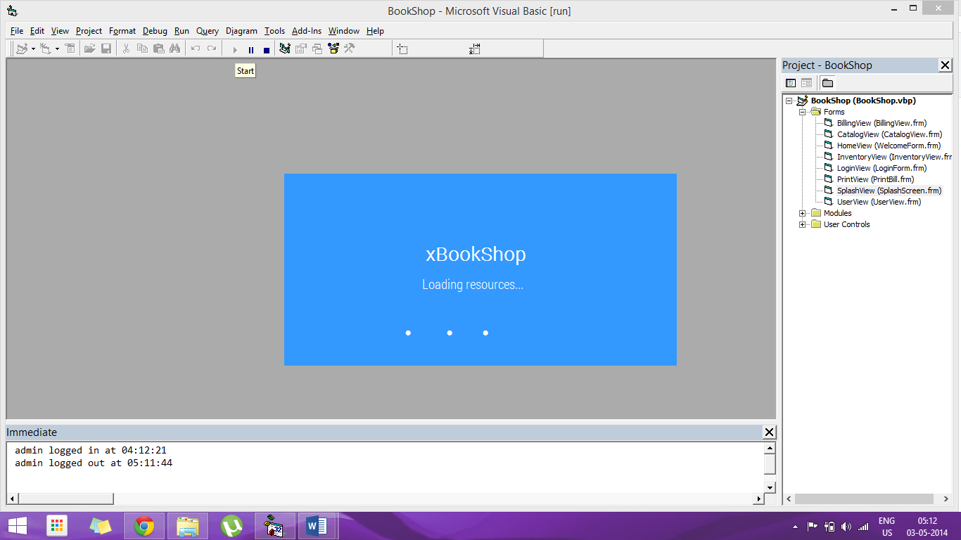

The initial loading screen of the application. The application caches all required graphics and resources while the Splash Screen is showing. It also initializes all database connections.

# Login Screen (\Forms\LoginView.frm)

## Souce Code

**Dim** Token **As** **Long**

**Dim** C **As** **Long**

**Dim** exitVal **As** **Integer**

**Dim** login **As** ADODB.Recordset

**Private** **Sub** **cmdCancel_Click**()

    Unload **Me**

**End** **Sub**

**Private** **Sub** **cmdCancel_MouseMove**(Button **As** **Integer**, Shift **As** **Integer**, X **As** **Single**, Y **As** **Single**)

    cmdLogin.BackColor **=** **&**H8000000D

    cmdCancel.BackColor **=** **&**HC0&

    cmdLogin.FontItalic **=** **False**

    cmdCancel.FontItalic **=** **True**

**End** **Sub**

**Private** **Sub** **cmdLogin_Click**()

    Timer1.Enabled **=** **False**

**If** txtUsername.Text **=** "" **Then**

        MessageBar.Caption **=** "ERROR: Username cannot be empty!"

        txtUsername.SetFocus

        Timer1.Enabled **=** **True**

**Exit** **Sub**

**ElseIf** txtPassword.Text **=** "" **Then**

        MessageBar.Caption **=** "ERROR: Password cannot be empty!"

        txtPassword.SetFocus

        Timer1.Enabled **=** **True**

**Exit** **Sub**

**Else**

**Set** login **=** **New** ADODB.Recordset

        login.CursorType **=** adOpenDynamic

        login.CursorLocation **=** adUseClient

        login.LockType **=** adLockOptimistic

        login.Open "Select * from Users where UserName='" **&** txtUsername.Text **&** "'", conn, login.CursorType, login.LockType, adCmdUnknown

**If** login.EOF **Then**

            MessageBar.Caption **=** "ERROR: No such user exists! Please check for spelling errors."

            txtUsername.SetFocus

            Timer1.Enabled **=** **True**

**Exit** **Sub**

**Else**

**If** login.Fields("Password") **=** txtPassword.Text **Then**

**Me**.Hide

                HomeView.Show

                usrLogin login.Fields("UserName"), login.Fields("Password"), login.Fields("UserType")

                txtUsername.Text **=** ""

                txtPassword.Text **=** ""

**Else**

                MessageBar.Caption **=** "ERROR: Wrong password! Please check for spelling/capitalization errors."

                txtPassword.SetFocus

                Timer1.Enabled **=** **True**

**Exit** **Sub**

**End** **If**

**End** **If**

**End** **If**

**End** **Sub**

**Private** **Sub** **cmdLogin_MouseMove**(Button **As** **Integer**, Shift **As** **Integer**, X **As** **Single**, Y **As** **Single**)

    cmdLogin.BackColor **=** **&**HC0&

    cmdCancel.BackColor **=** **&**H8000000D

    cmdLogin.FontItalic **=** **True**

    cmdCancel.FontItalic **=** **False**

**End** **Sub**

**Private** **Sub** **Form_Activate**()

    txtUsername.SetFocus

    exitVal **=** vbNo

**End** **Sub**

**Private** **Sub** **Form_Initialize**()

    Token **=** InitGDIPlus

    C **=** **Me**.BackColor

**If** C **<** 0 **Then** C **=** GetSysColor(C **-** **&**H80000000)

**End** **Sub**

**Private** **Sub** **Form_Load**()

    ShopLogo.Picture **=** LoadPictureGDIPlus(App.Path **&** "\Images\logo.png", 100, 80, **&**HADADAD, **True**)

    cmdLogin.BackColor **=** **&**H8000000D

    cmdCancel.BackColor **=** **&**H8000000D

    Timer1.Enabled **=** **False**

    exitVal **=** vbNo

**End** **Sub**

**Private** **Sub** **Form_MouseMove**(Button **As** **Integer**, Shift **As** **Integer**, X **As** **Single**, Y **As** **Single**)

    cmdLogin.BackColor **=** **&**H8000000D

    cmdCancel.BackColor **=** **&**H8000000D

    cmdLogin.FontItalic **=** **False**

    cmdCancel.FontItalic **=** **False**

**End** **Sub**

**Private** **Sub** **Form_Unload**(Cancel **As** **Integer**)

    exitVal **=** MsgBox("Are you sure you want to exit the application?", vbYesNo **+** vbDefaultButton2 **+** vbQuestion **+** vbApplicationModal, "Confirm Exit")

**If** exitVal **=** vbYes **Then**

        FreeGDIPlus Token

**End**

**Else**

        Cancel **=** 1

**End** **If**

**End** **Sub**

**Private** **Sub** **Timer1_Timer**()

    MessageBar.FontBold **=** **Not** MessageBar.FontBold

**End** **Sub**

**Private** **Sub** **txtUsername_KeyDown**(KeyCode **As** **Integer**, Shift **As** **Integer**)

**If** KeyCode **=** 13 **Then** **Call** cmdLogin_Click

**End** **Sub**

**Private** **Sub** **txtPassword_KeyDown**(KeyCode **As** **Integer**, Shift **As** **Integer**)

**If** KeyCode **=** 13 **Then** **Call** cmdLogin_Click

**End** **Sub**

## Screenshots

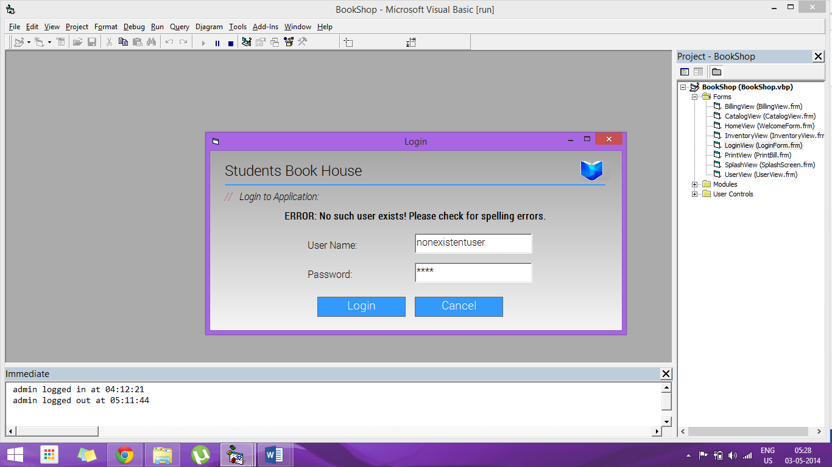

The login screen showing an error for a non-existent user login. An animated error message is flashed inline instead of using a MsgBox, as it is less obtrusive.

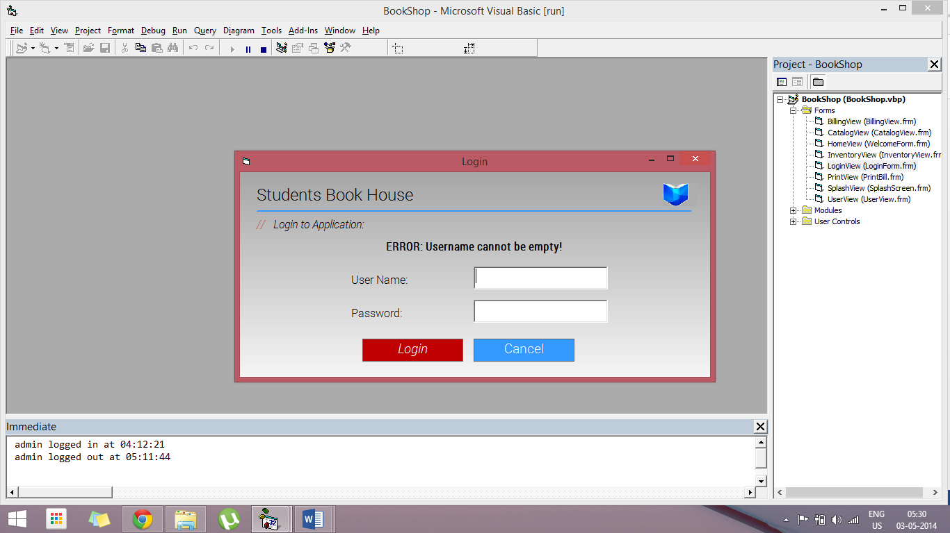

Login screen showing error dialog for empty username.

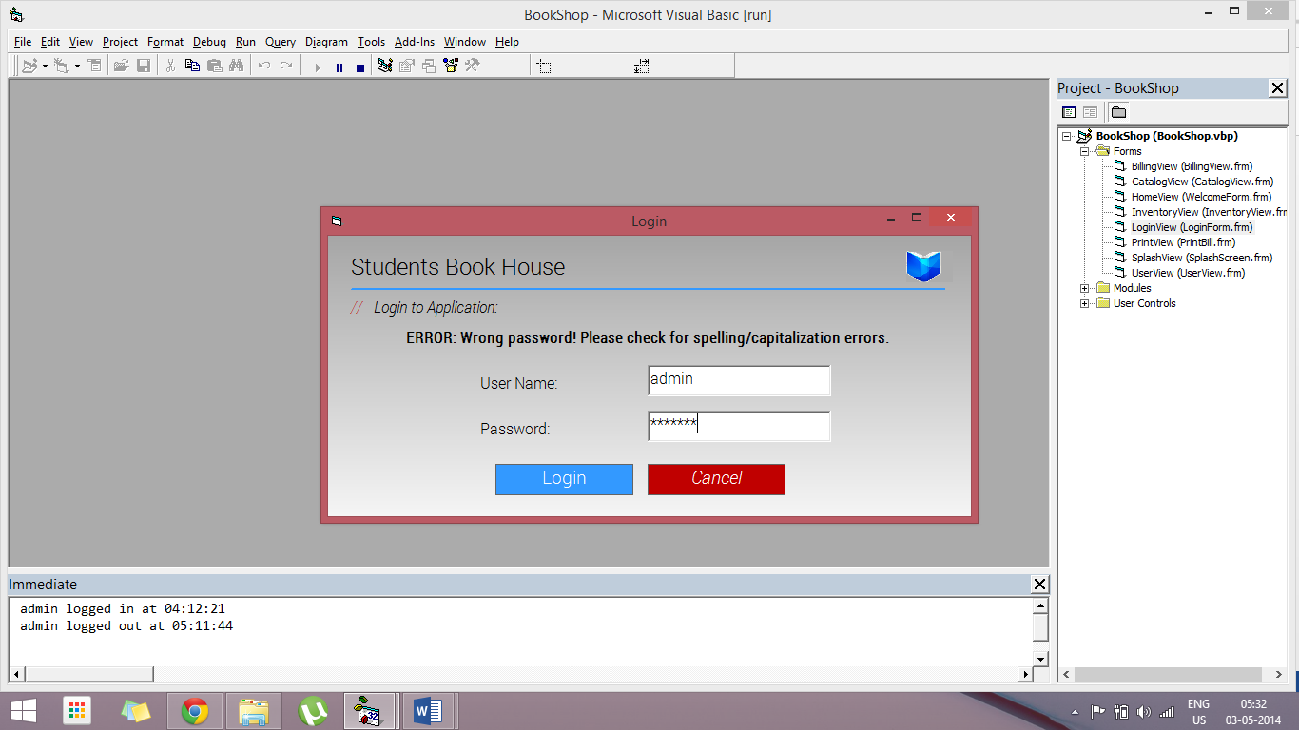

Login screen showing error dialog for wrong password entered.

# Home Screen (\Forms\HomeView.frm)

## Source Code

**Dim** Token **As** **Long**

**Dim** C **As** **Long**

**Dim** exitVal **As** **Integer**

**Private** **Sub** **AboutIcon_Click**()

    MsgBox "xBookShop" **&** vbNewLine **&** "Developed by Soham Banerjee" **&** vbNewLine **&** "2nd Year, CSE Dept." **&** vbNewLine **&** "IEM Kolkata" **&** vbNewLine **&** "www.xeqt.in" **&** vbNewLine **&** vbNewLine **&** "Licensed to Students Book House" **&** vbNewLine **&** "All Rights Reserved", vbApplicationModal **+** vbOKOnly **+** vbInformation, "About xBookShop"

**End** **Sub**

**Private** **Sub** **AboutOption_Click**()

    MsgBox "xBookShop" **&** vbNewLine **&** "Developed by Soham Banerjee" **&** vbNewLine **&** "2nd Year, CSE Dept." **&** vbNewLine **&** "IEM Kolkata" **&** vbNewLine **&** "www.xeqt.in" **&** vbNewLine **&** vbNewLine **&** "Licensed to Students Book House" **&** vbNewLine **&** "All Rights Reserved", vbApplicationModal **+** vbOKOnly **+** vbInformation, "About xBookShop"

**End** **Sub**

**Private** **Sub** **BillingIcon_Click**()

**Me**.Hide

    BillingView.Show

**End** **Sub**

**Private** **Sub** **BillingOption_Click**()

**Me**.Hide

    BillingView.Show

**End** **Sub**

**Private** **Sub** **CatalogOption_Click**()

**Me**.Hide

    CatalogView.Show

**End** **Sub**

**Private** **Sub** **CatalogIcon_Click**()

**Me**.Hide

    CatalogView.Show

**End** **Sub**

**Private** **Sub** **ExitIcon_Click**()

    Unload **Me**

**End** **Sub**

**Private** **Sub** **ExitOption_Click**()

    Unload **Me**

**End** **Sub**

**Private** **Sub** **Form_Activate**()

    StatusView.Panels(1).Text **=** "Hello " **&** username **&** "!"

    StatusView.Panels(3).Text **=** "Last logged in at " **&** lastLogin

    StatusView.Panels(2).Picture **=** LoadPictureGDIPlus(App.Path **&** "\Images\clock.png", 30, 25, C, **True**)

**End** **Sub**

**Private** **Sub** **Form_Initialize**()

    Token **=** InitGDIPlus

    C **=** **Me**.BackColor

**If** C **<** 0 **Then** C **=** GetSysColor(C **-** **&**H80000000)

**End** **Sub**

**Private** **Sub** **Form_Load**()

    ShopLogo.Picture **=** LoadPictureGDIPlus(App.Path **&** "\Images\logo.png", 100, 80, **&**HADADAD, **True**)

    BillingIcon.Picture **=** LoadPictureGDIPlus(App.Path **&** "\Images\billing.png", 400, 300, vbWhite, **True**)

    InventoryIcon.Picture **=** LoadPictureGDIPlus(App.Path **&** "\Images\inventory.jpg", 400, 300, C, **True**)

    ReportsIcon.Picture **=** LoadPictureGDIPlus(App.Path **&** "\Images\reports.jpg", 400, 300, C, **True**)

    CatalogIcon.Picture **=** LoadPictureGDIPlus(App.Path **&** "\Images\catalog.jpg", 400, 300, C, **True**)

    AboutIcon.Picture **=** LoadPictureGDIPlus(App.Path **&** "\Images\about.png", 500, 300, C, **True**)

    ExitIcon.Picture **=** LoadPictureGDIPlus(App.Path **&** "\Images\exit.jpg", 500, 300, C, **True**)

    BillingOption.BackColor **=** **&**H8000000D

    InventoryOption.BackColor **=** **&**H8000000D

    ReportsOption.BackColor **=** **&**H8000000D

    CatalogOption.BackColor **=** **&**H8000000D

    AboutOption.BackColor **=** **&**H8000000D

    ExitOption.BackColor **=** **&**H8000000D

    exitVal **=** vbNo

**End** **Sub**

**Private** **Sub** **Form_Unload**(Cancel **As** **Integer**)

    exitVal **=** MsgBox("Are you sure you want to log out?", vbYesNo **+** vbDefaultButton2 **+** vbQuestion **+** vbApplicationModal, "Confirm Exit")

**If** exitVal **=** vbYes **Then**

        usrLogout

        LoginView.Show

        FreeGDIPlus Token

        Unload **Me**

**Else**

        Cancel **=** 1

**End** **If**

**End** **Sub**

**Private** **Sub** **Form_MouseMove**(Button **As** **Integer**, Shift **As** **Integer**, X **As** **Single**, Y **As** **Single**)

    BillingOption.BackColor **=** **&**H8000000D

    InventoryOption.BackColor **=** **&**H8000000D

    ReportsOption.BackColor **=** **&**H8000000D

    CatalogOption.BackColor **=** **&**H8000000D

    AboutOption.BackColor **=** **&**H8000000D

    ExitOption.BackColor **=** **&**H8000000D

    BillingOption.FontItalic **=** **False**

    InventoryOption.FontItalic **=** **False**

    ReportsOption.FontItalic **=** **False**

    CatalogOption.FontItalic **=** **False**

    AboutOption.FontItalic **=** **False**

    ExitOption.FontItalic **=** **False**

**End** **Sub**

**Private** **Sub** **BillingOption_MouseMove**(Button **As** **Integer**, Shift **As** **Integer**, X **As** **Single**, Y **As** **Single**)

    BillingOption.BackColor **=** **&**H80&

    InventoryOption.BackColor **=** **&**H8000000D

    ReportsOption.BackColor **=** **&**H8000000D

    CatalogOption.BackColor **=** **&**H8000000D

    AboutOption.BackColor **=** **&**H8000000D

    ExitOption.BackColor **=** **&**H8000000D

    BillingOption.FontItalic **=** **True**

    InventoryOption.FontItalic **=** **False**

    ReportsOption.FontItalic **=** **False**

    CatalogOption.FontItalic **=** **False**

    AboutOption.FontItalic **=** **False**

    ExitOption.FontItalic **=** **False**

**End** **Sub**

**Private** **Sub** **BillingIcon_MouseMove**(Button **As** **Integer**, Shift **As** **Integer**, X **As** **Single**, Y **As** **Single**)

    BillingOption.BackColor **=** **&**H80&

    InventoryOption.BackColor **=** **&**H8000000D

    ReportsOption.BackColor **=** **&**H8000000D

    CatalogOption.BackColor **=** **&**H8000000D

    AboutOption.BackColor **=** **&**H8000000D

    ExitOption.BackColor **=** **&**H8000000D

    BillingOption.FontItalic **=** **True**

    InventoryOption.FontItalic **=** **False**

    ReportsOption.FontItalic **=** **False**

    CatalogOption.FontItalic **=** **False**

    AboutOption.FontItalic **=** **False**

    ExitOption.FontItalic **=** **False**

**End** **Sub**

**Private** **Sub** **InventoryIcon_Click**()

**If** usertype **=** "ADMIN" **Then**

**Me**.Hide

        InventoryView.Show

**Else**

        MsgBox "Only administrators can edit the inventory. Please login with an administrator account.", vbApplicationModal **+** vbOKOnly **+** vbInformation **+** vbDefaultButton1, "Administrator Account Required"

**End** **If**

**End** **Sub**

**Private** **Sub** **InventoryOption_Click**()

**If** usertype **=** "ADMIN" **Then**

**Me**.Hide

        InventoryView.Show

**Else**

        MsgBox "Only administrators can edit the inventory. Please login with an administrator account.", vbApplicationModal **+** vbOKOnly **+** vbInformation **+** vbDefaultButton1, "Administrator Account Required"

**End** **If**

**End** **Sub**

**Private** **Sub** **InventoryOption_MouseMove**(Button **As** **Integer**, Shift **As** **Integer**, X **As** **Single**, Y **As** **Single**)

    BillingOption.BackColor **=** **&**H8000000D

    InventoryOption.BackColor **=** **&**H80&

    ReportsOption.BackColor **=** **&**H8000000D

    CatalogOption.BackColor **=** **&**H8000000D

    AboutOption.BackColor **=** **&**H8000000D

    ExitOption.BackColor **=** **&**H8000000D

    BillingOption.FontItalic **=** **False**

    InventoryOption.FontItalic **=** **True**

    ReportsOption.FontItalic **=** **False**

    CatalogOption.FontItalic **=** **False**

    AboutOption.FontItalic **=** **False**

    ExitOption.FontItalic **=** **False**

**End** **Sub**

**Private** **Sub** **InventoryIcon_MouseMove**(Button **As** **Integer**, Shift **As** **Integer**, X **As** **Single**, Y **As** **Single**)

    BillingOption.BackColor **=** **&**H8000000D

    InventoryOption.BackColor **=** **&**H80&

    ReportsOption.BackColor **=** **&**H8000000D

    CatalogOption.BackColor **=** **&**H8000000D

    AboutOption.BackColor **=** **&**H8000000D

    ExitOption.BackColor **=** **&**H8000000D

    BillingOption.FontItalic **=** **False**

    InventoryOption.FontItalic **=** **True**

    ReportsOption.FontItalic **=** **False**

    CatalogOption.FontItalic **=** **False**

    AboutOption.FontItalic **=** **False**

    ExitOption.FontItalic **=** **False**

**End** **Sub**

**Private** **Sub** **ReportsIcon_Click**()

**If** usertype **=** "ADMIN" **Then**

**Me**.Hide

        Userview.Show

**Else**

        MsgBox "Only administrators can edit users. Please login with an administrator account.", vbApplicationModal **+** vbOKOnly **+** vbInformation **+** vbDefaultButton1, "Administrator Account Required"

**End** **If**

**End** **Sub**

**Private** **Sub** **ReportsOption_Click**()

**If** usertype **=** "ADMIN" **Then**

**Me**.Hide

        Userview.Show

**Else**

        MsgBox "Only administrators can edit users. Please login with an administrator account.", vbApplicationModal **+** vbOKOnly **+** vbInformation **+** vbDefaultButton1, "Administrator Account Required"

**End** **If**

**End** **Sub**

**Private** **Sub** **ReportsOption_MouseMove**(Button **As** **Integer**, Shift **As** **Integer**, X **As** **Single**, Y **As** **Single**)

    BillingOption.BackColor **=** **&**H8000000D

    InventoryOption.BackColor **=** **&**H8000000D

    ReportsOption.BackColor **=** **&**H80&

    CatalogOption.BackColor **=** **&**H8000000D

    AboutOption.BackColor **=** **&**H8000000D

    ExitOption.BackColor **=** **&**H8000000D

    BillingOption.FontItalic **=** **False**

    InventoryOption.FontItalic **=** **False**

    ReportsOption.FontItalic **=** **True**

    CatalogOption.FontItalic **=** **False**

    AboutOption.FontItalic **=** **False**

    ExitOption.FontItalic **=** **False**

**End** **Sub**

**Private** **Sub** **ReportsIcon_MouseMove**(Button **As** **Integer**, Shift **As** **Integer**, X **As** **Single**, Y **As** **Single**)

    BillingOption.BackColor **=** **&**H8000000D

    InventoryOption.BackColor **=** **&**H8000000D

    ReportsOption.BackColor **=** **&**H80&

    CatalogOption.BackColor **=** **&**H8000000D

    AboutOption.BackColor **=** **&**H8000000D

    ExitOption.BackColor **=** **&**H8000000D

    BillingOption.FontItalic **=** **False**

    InventoryOption.FontItalic **=** **False**

    ReportsOption.FontItalic **=** **True**

    CatalogOption.FontItalic **=** **False**

    AboutOption.FontItalic **=** **False**

    ExitOption.FontItalic **=** **False**

**End** **Sub**

**Private** **Sub** **CatalogOption_MouseMove**(Button **As** **Integer**, Shift **As** **Integer**, X **As** **Single**, Y **As** **Single**)

    BillingOption.BackColor **=** **&**H8000000D

    InventoryOption.BackColor **=** **&**H8000000D

    ReportsOption.BackColor **=** **&**H8000000D

    CatalogOption.BackColor **=** **&**H80&

    AboutOption.BackColor **=** **&**H8000000D

    ExitOption.BackColor **=** **&**H8000000D

    BillingOption.FontItalic **=** **False**

    InventoryOption.FontItalic **=** **False**

    ReportsOption.FontItalic **=** **False**

    CatalogOption.FontItalic **=** **True**

    AboutOption.FontItalic **=** **False**

    ExitOption.FontItalic **=** **False**

**End** **Sub**

**Private** **Sub** **CatalogIcon_MouseMove**(Button **As** **Integer**, Shift **As** **Integer**, X **As** **Single**, Y **As** **Single**)

    BillingOption.BackColor **=** **&**H8000000D

    InventoryOption.BackColor **=** **&**H8000000D

    ReportsOption.BackColor **=** **&**H8000000D

    CatalogOption.BackColor **=** **&**H80&

    AboutOption.BackColor **=** **&**H8000000D

    ExitOption.BackColor **=** **&**H8000000D

    BillingOption.FontItalic **=** **False**

    InventoryOption.FontItalic **=** **False**

    ReportsOption.FontItalic **=** **False**

    CatalogOption.FontItalic **=** **True**

    AboutOption.FontItalic **=** **False**

    ExitOption.FontItalic **=** **False**

**End** **Sub**

**Private** **Sub** **AboutOption_MouseMove**(Button **As** **Integer**, Shift **As** **Integer**, X **As** **Single**, Y **As** **Single**)

    BillingOption.BackColor **=** **&**H8000000D

    InventoryOption.BackColor **=** **&**H8000000D

    ReportsOption.BackColor **=** **&**H8000000D

    CatalogOption.BackColor **=** **&**H8000000D

    AboutOption.BackColor **=** **&**H80&

    ExitOption.BackColor **=** **&**H8000000D

    BillingOption.FontItalic **=** **False**

    InventoryOption.FontItalic **=** **False**

    ReportsOption.FontItalic **=** **False**

    CatalogOption.FontItalic **=** **False**

    AboutOption.FontItalic **=** **True**

    ExitOption.FontItalic **=** **False**

**End** **Sub**

**Private** **Sub** **AboutIcon_MouseMove**(Button **As** **Integer**, Shift **As** **Integer**, X **As** **Single**, Y **As** **Single**)

    BillingOption.BackColor **=** **&**H8000000D

    InventoryOption.BackColor **=** **&**H8000000D

    ReportsOption.BackColor **=** **&**H8000000D

    CatalogOption.BackColor **=** **&**H8000000D

    AboutOption.BackColor **=** **&**H80&

    ExitOption.BackColor **=** **&**H8000000D

    BillingOption.FontItalic **=** **False**

    InventoryOption.FontItalic **=** **False**

    ReportsOption.FontItalic **=** **False**

    CatalogOption.FontItalic **=** **False**

    AboutOption.FontItalic **=** **True**

    ExitOption.FontItalic **=** **False**

**End** **Sub**

**Private** **Sub** **ExitOption_MouseMove**(Button **As** **Integer**, Shift **As** **Integer**, X **As** **Single**, Y **As** **Single**)

    BillingOption.BackColor **=** **&**H8000000D

    InventoryOption.BackColor **=** **&**H8000000D

    ReportsOption.BackColor **=** **&**H8000000D

    CatalogOption.BackColor **=** **&**H8000000D

    AboutOption.BackColor **=** **&**H8000000D

    ExitOption.BackColor **=** **&**H80&

    BillingOption.FontItalic **=** **False**

    InventoryOption.FontItalic **=** **False**

    ReportsOption.FontItalic **=** **False**

    CatalogOption.FontItalic **=** **False**

    AboutOption.FontItalic **=** **False**

    ExitOption.FontItalic **=** **True**

**End** **Sub**

**Private** **Sub** **ExitIcon_MouseMove**(Button **As** **Integer**, Shift **As** **Integer**, X **As** **Single**, Y **As** **Single**)

    BillingOption.BackColor **=** **&**H8000000D

    InventoryOption.BackColor **=** **&**H8000000D

    ReportsOption.BackColor **=** **&**H8000000D

    CatalogOption.BackColor **=** **&**H8000000D

    AboutOption.BackColor **=** **&**H8000000D

    ExitOption.BackColor **=** **&**H80&

    BillingOption.FontItalic **=** **False**

    InventoryOption.FontItalic **=** **False**

    ReportsOption.FontItalic **=** **False**

    CatalogOption.FontItalic **=** **False**

    AboutOption.FontItalic **=** **False**

    ExitOption.FontItalic **=** **True**

**End** **Sub**

## Screenshots

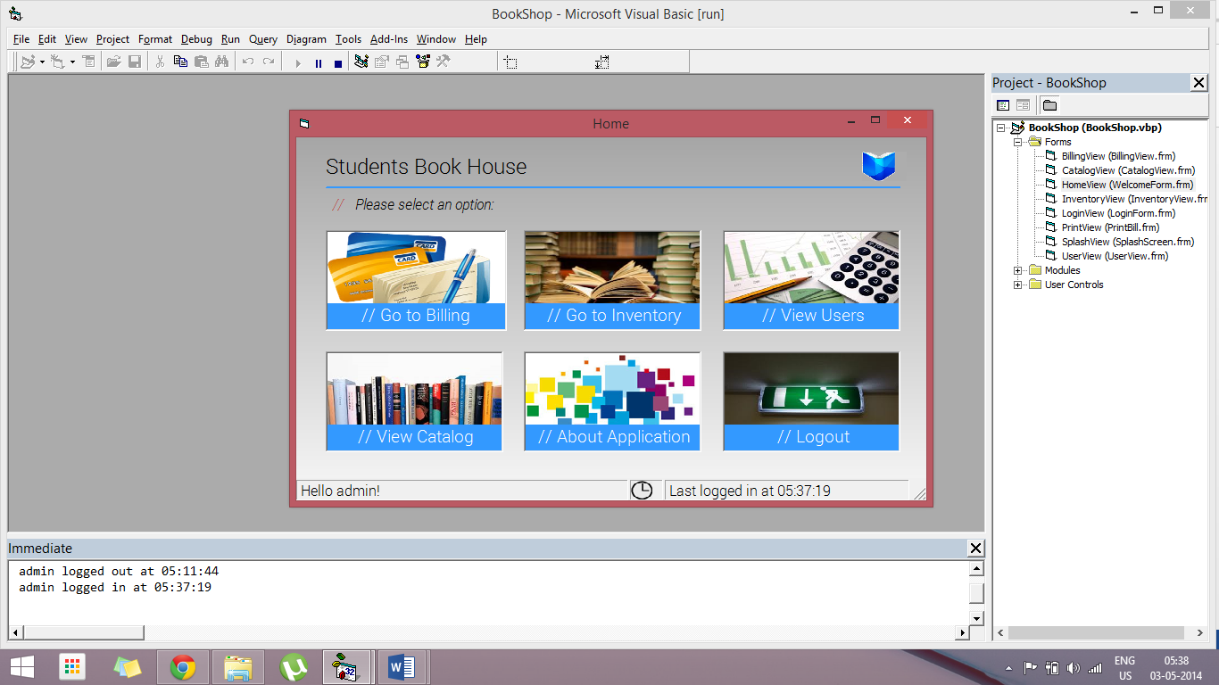

The Home Screen after logging in, showing the name of the currently logged in user, and the time of the last log-in.

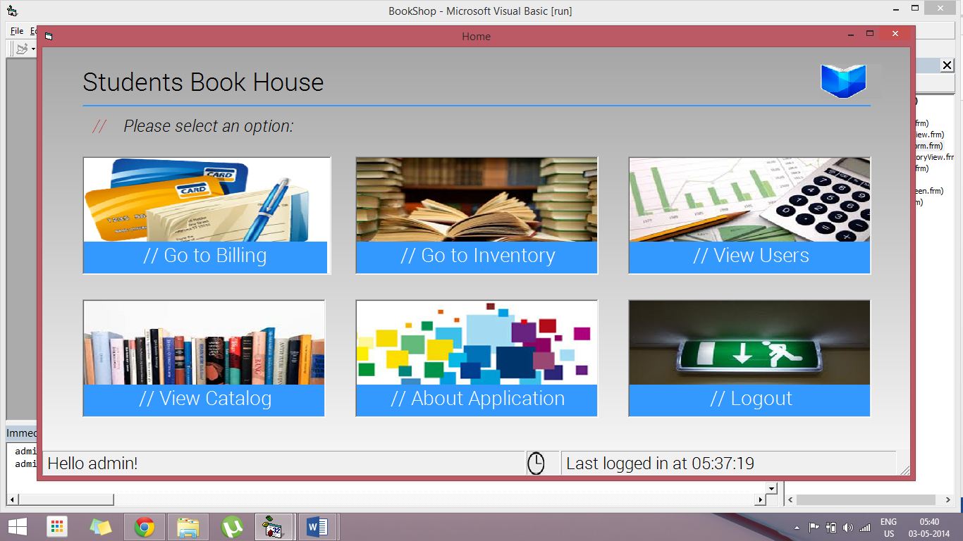

Home Screen showing Active Resize in action. The app scales itself automatically on resize to use all available screen real estate.

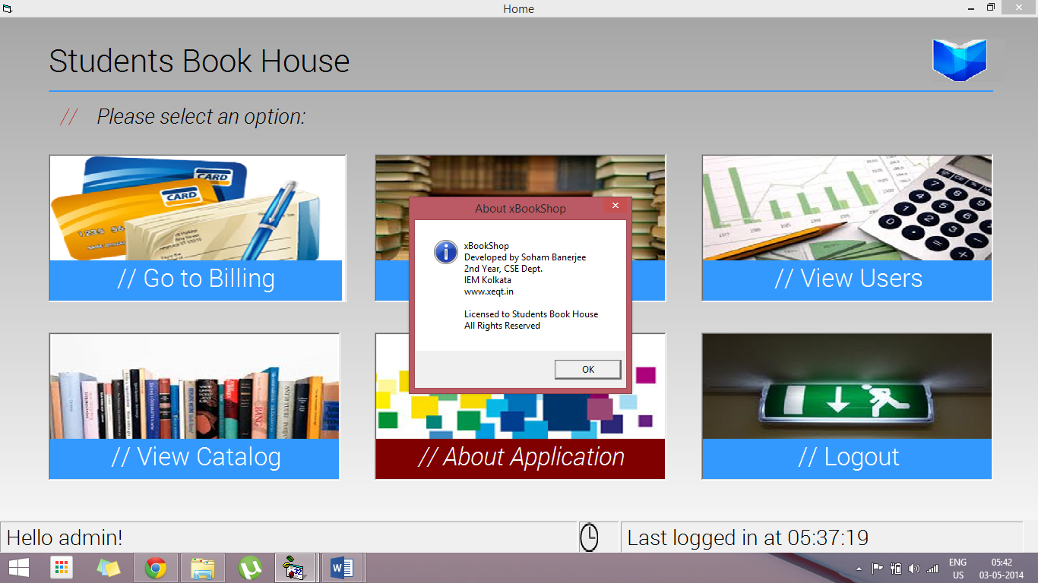

The Home Screen on clicking the “About Application” option

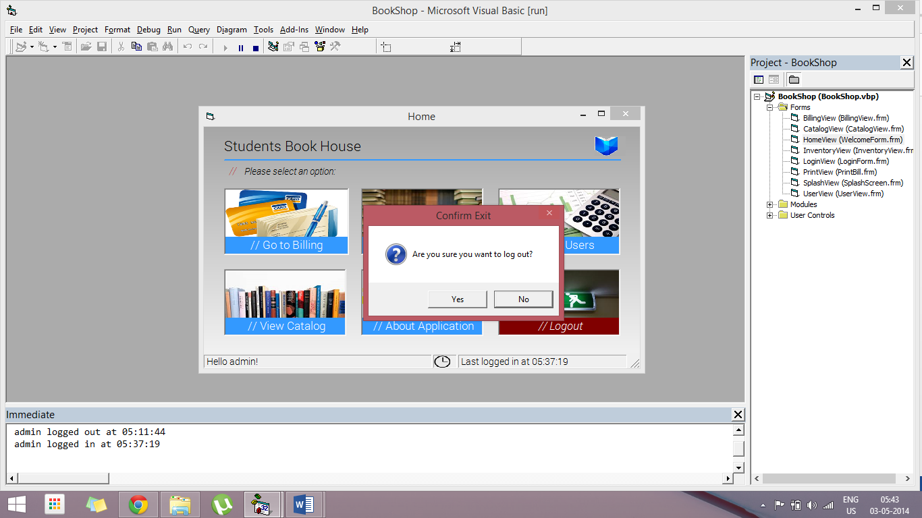

The Home Screen on clicking the “Logout” option

# Billing Screen (\Forms\BillingView.frm)

## Source Code

**Option** Explicit

**Dim** Token **As** **Long**

**Dim** C **As** **Long**

**Dim** exitVal **As** **Integer**

**Dim** billCount **As** **Integer**

**Private** **Sub** **BillList_MouseMove**(Button **As** **Integer**, Shift **As** **Integer**, X **As** **Single**, Y **As** **Single**)

**If** cmdAdd.Enabled **Then** cmdAdd.BackColor **=** **&**H8000000D

**If** cmdDelete.Enabled **Then** cmdDelete.BackColor **=** **&**H8000000D

**If** cmdProceed.Enabled **Then** cmdProceed.BackColor **=** **&**H8000000D

**If** cmdBack.Enabled **Then** cmdBack.BackColor **=** **&**H8000000D

    cmdAdd.FontItalic **=** **False**

    cmdProceed.FontItalic **=** **False**

    cmdDelete.FontItalic **=** **False**

    cmdBack.FontItalic **=** **False**

**End** **Sub**

**Private** **Sub** **BookContainer_Click**()

**If** BookContainer.SelectedItem **=** Null **Then**

**Exit** **Sub**

**Else**

        BookList.Recordset.AbsolutePosition **=** BookContainer.SelectedItem

        txtAuthor.Caption **=** BookList.Recordset.Fields("AUTHORNAME")

        txtQty.Caption **=** BookList.Recordset.Fields("QTY")

        txtPrice.Caption **=** "Rs. " **&** BookList.Recordset.Fields("MRP")

        BookQty.Clear

        BookQty.Enabled **=** **False**

        cmdAdd.Enabled **=** **False**

**Dim** q, i **As** **Integer**

        q **=** Val(BookList.Recordset.Fields("QTY"))

**If** (q **>** 0) **Then**

**For** i **=** 1 **To** q

                BookQty.AddItem i

**Next** i

            BookQty.Enabled **=** **True**

            cmdAdd.Enabled **=** **True**

            txtQty.ForeColor **=** **&**H0&

**Else**

            BookQty.AddItem 0

            txtQty.ForeColor **=** **&**HC0&

**End** **If**

**End** **If**

**End** **Sub**

**Private** **Sub** **BookContainer_MouseMove**(Button **As** **Integer**, Shift **As** **Integer**, X **As** **Single**, Y **As** **Single**)

**If** cmdAdd.Enabled **Then** cmdAdd.BackColor **=** **&**H8000000D

**If** cmdDelete.Enabled **Then** cmdDelete.BackColor **=** **&**H8000000D

**If** cmdProceed.Enabled **Then** cmdProceed.BackColor **=** **&**H8000000D

**If** cmdBack.Enabled **Then** cmdBack.BackColor **=** **&**H8000000D

    cmdAdd.FontItalic **=** **False**

    cmdProceed.FontItalic **=** **False**

    cmdDelete.FontItalic **=** **False**

    cmdBack.FontItalic **=** **False**

**End** **Sub**

**Private** **Sub** **cmdAdd_Click**()

**If** Val(BookQty.Text) **>=** 1 **Then**

**If** Val(BookQty.Text) **<=** Val(BookList.Recordset.Fields("QTY")) **Then**

**Select** **Case** MsgBox("Available in stock = " **&** BookList.Recordset.Fields("QTY") **&** vbNewLine **&** "Remaining in stock = " **&** **CStr**(Int(Val(BookList.Recordset.Fields("QTY"))) **-** (BookQty.ListIndex **+** 1)) **&** vbNewLine **&** "Add to cart?", vbQuestion **+** vbApplicationModal **+** vbYesNo **+** vbDefaultButton1, "Confirm add")

**Case** vbYes

                    BookList.Recordset.Fields("QTY") **=** (Int(Val(BookList.Recordset.Fields("QTY"))) **-** (BookQty.ListIndex **+** 1))

                    BookList.Recordset.Update

                    txtQty.Caption **=** BookList.Recordset.Fields("QTY")

                    MessageBar.Caption **=** "'" **&** BookList.Recordset.Fields("BOOKNAME") **&** "' added to cart!"

                    billCount **=** billCount **+** 1

                    BillList.AddItem BookList.Recordset.Fields("BOOKNAME") **&** " - Rs. " **&** BookList.Recordset.Fields("MRP") **&** " x " **&** (BookQty.ListIndex **+** 1)

                    BillList.ItemData(billCount **-** 1) **=** Val(BookList.Recordset.Fields("ID"))

                    cmdDelete.Enabled **=** **True**

                    cmdProceed.Enabled **=** **True**

                    cmdDelete.BackColor **=** **&**H8000000D

                    cmdProceed.BackColor **=** **&**H8000000D

                    BookQty.Clear

                    BookQty.Enabled **=** **False**

                    cmdAdd.Enabled **=** **False**

**Dim** q, i **As** **Integer**

                    q **=** Val(BookList.Recordset.Fields("QTY"))

**If** (q **>** 0) **Then**

**For** i **=** 1 **To** q

                            BookQty.AddItem i

**Next** i

                        BookQty.Enabled **=** **True**

                        cmdAdd.Enabled **=** **True**

**Else**

                        BookQty.AddItem 0

                        txtQty.ForeColor **=** **&**HC0&

**End** **If**

**Case** vbNo

                    MessageBar.Caption **=** "Cart not updated! Please review cart."

**End** **Select**

**Else**

            MsgBox "The quantity is more than available stock!", vbApplicationModal **+** vbOKOnly **+** vbExclamation, "Please select valid quantity"

**End** **If**

**Else**

        MsgBox "Please select a valid quantity first!", vbApplicationModal **+** vbOKOnly **+** vbExclamation, "Please select quantity"

**End** **If**

**End** **Sub**

**Private** **Sub** **cmdAdd_MouseMove**(Button **As** **Integer**, Shift **As** **Integer**, X **As** **Single**, Y **As** **Single**)

    cmdAdd.BackColor **=** **&**H80&

**If** cmdDelete.Enabled **Then** cmdDelete.BackColor **=** **&**H8000000D

**If** cmdProceed.Enabled **Then** cmdProceed.BackColor **=** **&**H8000000D

**If** cmdBack.Enabled **Then** cmdBack.BackColor **=** **&**H8000000D

    cmdAdd.FontItalic **=** **True**

    cmdProceed.FontItalic **=** **False**

    cmdDelete.FontItalic **=** **False**

    cmdBack.FontItalic **=** **False**

**End** **Sub**

**Private** **Sub** **cmdBack_Click**()

    Unload **Me**

**End** **Sub**

**Private** **Sub** **cmdBack_MouseMove**(Button **As** **Integer**, Shift **As** **Integer**, X **As** **Single**, Y **As** **Single**)

**If** cmdAdd.Enabled **Then** cmdAdd.BackColor **=** **&**H8000000D

**If** cmdDelete.Enabled **Then** cmdDelete.BackColor **=** **&**H8000000D

**If** cmdProceed.Enabled **Then** cmdProceed.BackColor **=** **&**H8000000D

    cmdBack.BackColor **=** **&**H80&

    cmdAdd.FontItalic **=** **False**

    cmdProceed.FontItalic **=** **False**

    cmdDelete.FontItalic **=** **False**

    cmdBack.FontItalic **=** **True**

**End** **Sub**

**Private** **Sub** **cmdDelete_MouseMove**(Button **As** **Integer**, Shift **As** **Integer**, X **As** **Single**, Y **As** **Single**)

**If** cmdAdd.Enabled **Then** cmdAdd.BackColor **=** **&**H8000000D

    cmdDelete.BackColor **=** **&**H80&

**If** cmdProceed.Enabled **Then** cmdProceed.BackColor **=** **&**H8000000D

**If** cmdBack.Enabled **Then** cmdBack.BackColor **=** **&**H8000000D

    cmdAdd.FontItalic **=** **False**

    cmdProceed.FontItalic **=** **False**

    cmdDelete.FontItalic **=** **True**

    cmdBack.FontItalic **=** **False**

**End** **Sub**

**Private** **Sub** **cmdProceed_MouseMove**(Button **As** **Integer**, Shift **As** **Integer**, X **As** **Single**, Y **As** **Single**)

**If** cmdAdd.Enabled **Then** cmdAdd.BackColor **=** **&**H8000000D

**If** cmdDelete.Enabled **Then** cmdDelete.BackColor **=** **&**H8000000D

    cmdProceed.BackColor **=** **&**H80&

**If** cmdBack.Enabled **Then** cmdBack.BackColor **=** **&**H8000000D

    cmdAdd.FontItalic **=** **False**

    cmdProceed.FontItalic **=** **True**

    cmdDelete.FontItalic **=** **False**

    cmdBack.FontItalic **=** **False**

**End** **Sub**

**Private** **Sub** **Form_MouseMove**(Button **As** **Integer**, Shift **As** **Integer**, X **As** **Single**, Y **As** **Single**)

**If** cmdAdd.Enabled **Then** cmdAdd.BackColor **=** **&**H8000000D

**If** cmdDelete.Enabled **Then** cmdDelete.BackColor **=** **&**H8000000D

**If** cmdProceed.Enabled **Then** cmdProceed.BackColor **=** **&**H8000000D

**If** cmdBack.Enabled **Then** cmdBack.BackColor **=** **&**H8000000D

    cmdAdd.FontItalic **=** **False**

    cmdProceed.FontItalic **=** **False**

    cmdDelete.FontItalic **=** **False**

    cmdBack.FontItalic **=** **False**

**End** **Sub**

**Private** **Sub** **cmdDelete_Click**()

**If** BillList.ListCount **<=** 0 **Then**

        MsgBox "Your cart is empty. Add items to cart first!", vbApplicationModal **+** vbOKOnly **+** vbExclamation, "No items to delete"

**Else**

**If** BillList.ListIndex **<** 0 **Then**

            MsgBox "Please select the item you want to delete!", vbApplicationModal **+** vbOKOnly **+** vbExclamation, "Select item to delete"

**Else**

**Dim** pos **As** **Integer**

            pos **=** InStrRev(BillList.Text, "x", , vbTextCompare)

**Select** **Case** MsgBox("Are you sure you want to remove '" **&** Left$(BillList.Text, (InStrRev(BillList.Text, "-", , vbTextCompare) **-** 2)) **&** "' from your cart?", vbQuestion **+** vbApplicationModal **+** vbYesNo **+** vbDefaultButton1, "Confirm delete")

**Case** vbYes

                    conn.Execute "UPDATE BookList SET QTY = QTY + " **&** Mid$(BillList.Text, pos **+** 2) **&** " WHERE ID = " **&** BillList.ItemData(BillList.ListIndex) **&** ";"

                    BookList.RecordSource **=** "BookList"

                    BookList.Refresh

                    MessageBar.Caption **=** "'" **&** Left$(BillList.Text, (InStrRev(BillList.Text, "-", , vbTextCompare) **-** 2)) **&** "' removed from cart."

                    BillList.RemoveItem BillList.ListIndex

                    billCount **=** billCount **-** 1

**If** BillList.ListCount **<=** 0 **Then**

                        cmdDelete.Enabled **=** **False**

                        cmdProceed.Enabled **=** **False**

                        cmdDelete.BackColor **=** QBColor(8)

                        cmdProceed.BackColor **=** QBColor(8)

**End** **If**

**Case** vbNo

                    MessageBar.Caption **=** "Item not removed! Please review cart."

**End** **Select**

**End** **If**

**End** **If**

**End** **Sub**

**Private** **Sub** **cmdProceed_Click**()

**Select** **Case** MsgBox("Proceed to payment?", vbApplicationModal **+** vbYesNo **+** vbQuestion **+** vbDefaultButton1, "Are you sure?")

**Case** vbYes

**Dim** i **As** **Integer**

**Dim** amt **As** **Double**

            amt **=** 0

**For** i **=** 0 **To** (BillList.ListCount **-** 1)

                PrintView.txtBill.Text **=** PrintView.txtBill.Text **&** (i **+** 1) **&** vbTab

**If** Len(Left$(BillList.List(i), (InStrRev(BillList.List(i), "-", , vbTextCompare) **-** 2))) **>** 32 **Then**

                    PrintView.txtBill.Text **=** PrintView.txtBill.Text **&** Left$(Left$(BillList.List(i), (InStrRev(BillList.List(i), "-", , vbTextCompare) **-** 2)), 32) **&** "..." **&** vbTab **&** vbTab

**Else**

                    PrintView.txtBill.Text **=** PrintView.txtBill.Text **&** Left$(BillList.List(i), (InStrRev(BillList.List(i), "-", , vbTextCompare) **-** 2)) **&** **String**$(43 **-** Len(Left$(BillList.List(i), (InStrRev(BillList.List(i), "-", , vbTextCompare) **-** 2))), " ") **&** vbTab **&** vbTab

**End** **If**

                PrintView.txtBill.Text **=** PrintView.txtBill.Text **&** Mid$(BillList.List(i), InStrRev(BillList.List(i), "x", , vbTextCompare) **+** 2) **&** vbTab **&** Mid$(BillList.List(i), InStrRev(BillList.List(i), ".", , vbTextCompare) **+** 2, (InStrRev(BillList.List(i), "x", , vbTextCompare) **-** 2) **-** (InStrRev(BillList.List(i), ".", , vbTextCompare) **+** 2) **+** 1) **&** vbTab **&** Val(Mid$(BillList.List(i), InStrRev(BillList.List(i), "x", , vbTextCompare) **+** 2)) **\*** Val(Mid$(BillList.List(i), InStrRev(BillList.List(i), ".", , vbTextCompare) **+** 2, (InStrRev(BillList.List(i), "x", , vbTextCompare) **-** 2) **-** (InStrRev(BillList.List(i), ".", , vbTextCompare) **+** 2) **+** 1)) **&** vbNewLine

                amt **=** amt **+** (Val(Mid$(BillList.List(i), InStrRev(BillList.List(i), "x", , vbTextCompare) **+** 2)) **\*** Val(Mid$(BillList.List(i), InStrRev(BillList.List(i), ".", , vbTextCompare) **+** 2, (InStrRev(BillList.List(i), "x", , vbTextCompare) **-** 2) **-** (InStrRev(BillList.List(i), ".", , vbTextCompare) **+** 2) **+** 1)))

**Next** i

            PrintView.OptionLabel.Caption **=** "Bill for " **&** billCount **&** " item(s)"

            PrintView.txtAmt.Caption **=** "Rs. " **&** amt

            billCount **=** 0

            BillList.Clear

            BookQty.Enabled **=** **False**

            BookQty.Clear

            cmdAdd.Enabled **=** **False**

            cmdDelete.Enabled **=** **False**

            cmdProceed.Enabled **=** **False**

            cmdDelete.BackColor **=** QBColor(8)

            cmdProceed.BackColor **=** QBColor(8)

**Me**.Hide

            PrintView.Show

**Case** vbNo

**Exit** **Sub**

**End** **Select**

**End** **Sub**

**Private** **Sub** **Form_Initialize**()

    Token **=** InitGDIPlus

    C **=** **Me**.BackColor

**If** C **<** 0 **Then** C **=** GetSysColor(C **-** **&**H80000000)

    BookList.ConnectionString **=** "Provider=Microsoft.Jet.OLEDB.4.0;Data Source=" **&** App.Path **&** "\db\BookDB.mdb;Persist Security Info=False"

    BookList.CursorLocation **=** adUseClient

    BookList.CursorType **=** adOpenDynamic

    BookList.CommandType **=** adCmdTable

    BookList.RecordSource **=** "BookList"

    BookList.Refresh

**End** **Sub**

**Private** **Sub** **Form_Load**()

   ShopLogo.Picture **=** LoadPictureGDIPlus(App.Path **&** "\Images\logo.png", 100, 80, **&**HADADAD, **True**)

   BookList.ConnectionString **=** "Provider=Microsoft.Jet.OLEDB.4.0;Data Source=" **&** App.Path **&** "\db\BookDB.mdb;Persist Security Info=False"

   BookList.CursorLocation **=** adUseClient

   BookList.CursorType **=** adOpenDynamic

   BookList.CommandType **=** adCmdTable

   BookList.RecordSource **=** "BookList"

   BookList.Refresh

   BookFrame.AutoReDraw **=** **True**

   BookFrame.ReDraw

   PriceFrame.AutoReDraw **=** **True**

   PriceFrame.ReDraw

   OptionsFrame.AutoReDraw **=** **True**

   OptionsFrame.ReDraw

   BillFrame.AutoReDraw **=** **True**

   BillFrame.ReDraw

**Me**.Width **=** **Me**.Width **+** 10

   BookQty.Clear

   BookQty.AddItem 0

   BookQty.Enabled **=** **False**

   cmdAdd.Enabled **=** **False**

   cmdDelete.Enabled **=** **False**

   cmdProceed.Enabled **=** **False**

   cmdDelete.BackColor **=** QBColor(8)

   cmdProceed.BackColor **=** QBColor(8)

   cmdAdd.BackColor **=** QBColor(8)

   MessageBar.Caption **=** "Please add items to your cart."

   exitVal **=** vbNo

   billCount **=** 0

**End** **Sub**

**Private** **Sub** **Form_Resize**()

    BookFrame.ReDraw

    PriceFrame.ReDraw

    OptionsFrame.ReDraw

    BillFrame.ReDraw

**End** **Sub**

**Private** **Sub** **Form_Unload**(Cancel **As** **Integer**)

    exitVal **=** MsgBox("Go back to main screen?", vbYesNo **+** vbDefaultButton2 **+** vbQuestion **+** vbApplicationModal, "Confirm Exit")

**If** exitVal **=** vbYes **Then**

        HomeView.Show

        FreeGDIPlus Token

        Unload **Me**

**Else**

        Cancel **=** 1

**End** **If**

**End** **Sub**

## Screenshots

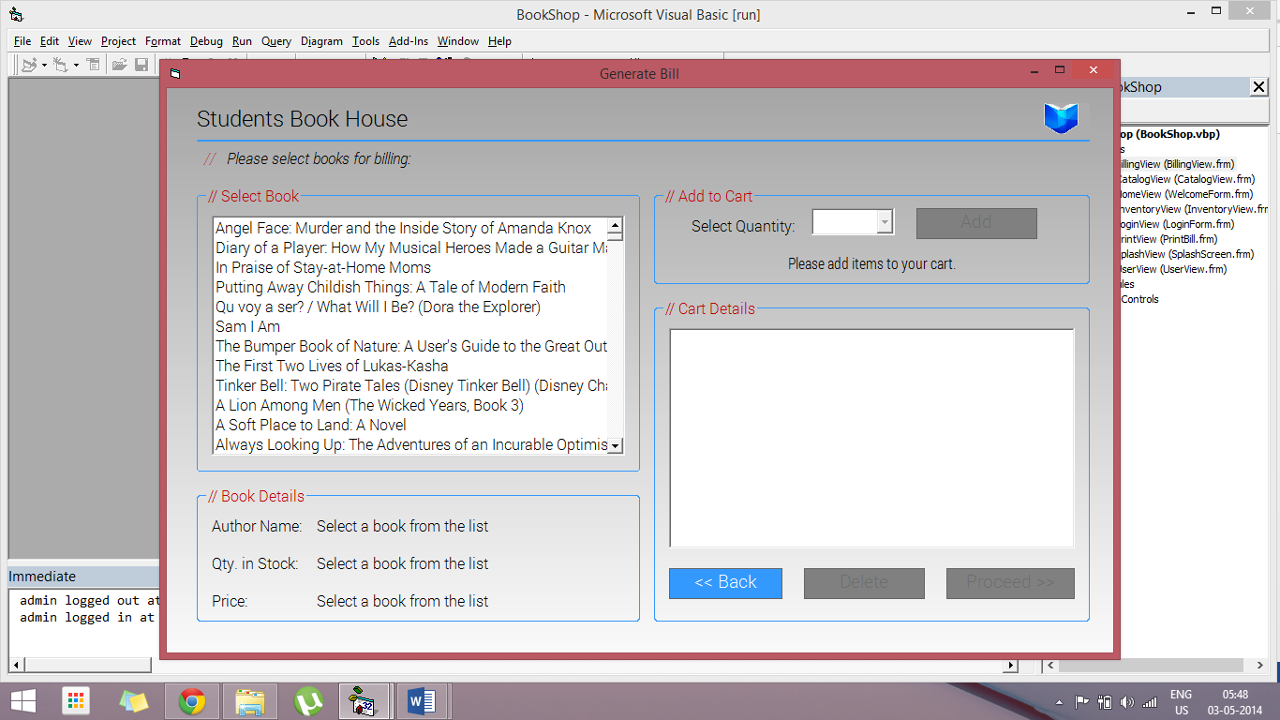

The initial view on opening the Billing Screen

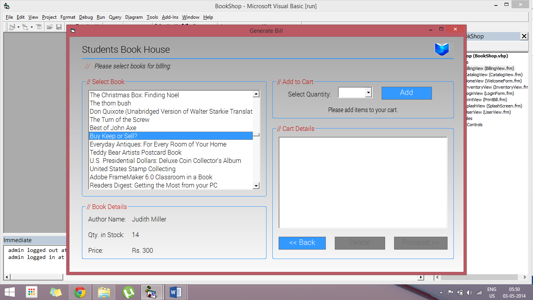

The Billing Screen after selecting a book from the list.

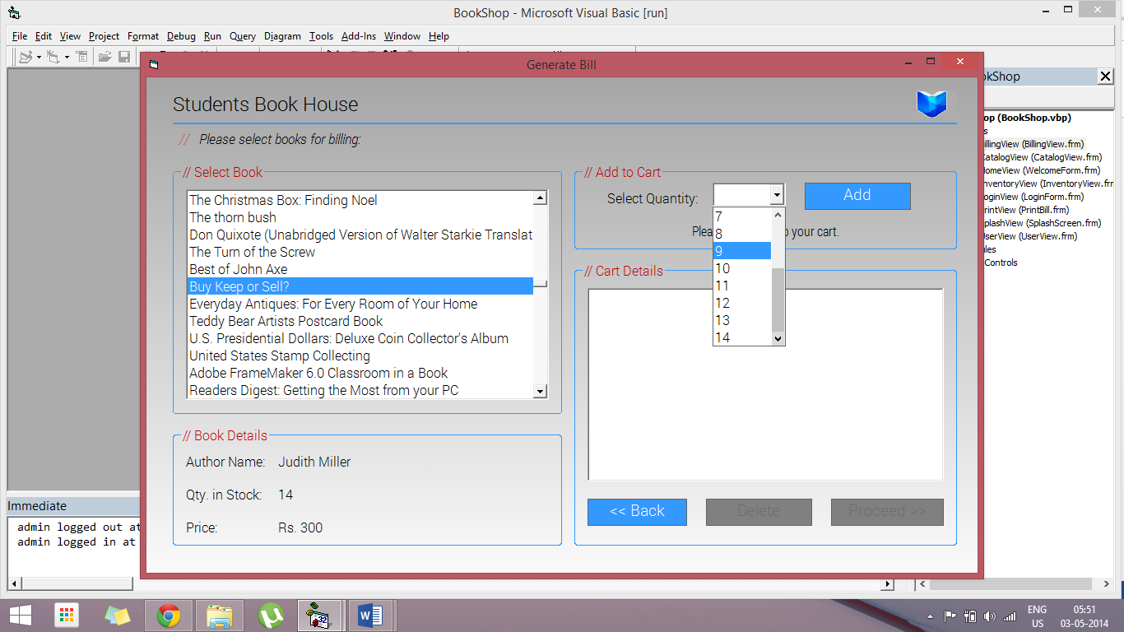

The Billing Screen showing quantity selection before adding to cart.

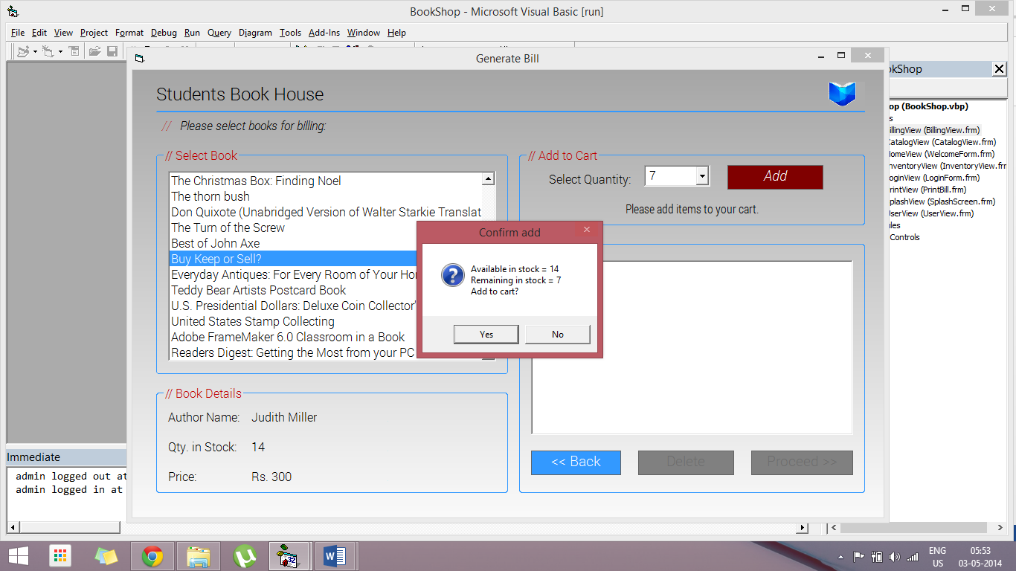

The Billing Screen showing the Add to Cart confirmation.

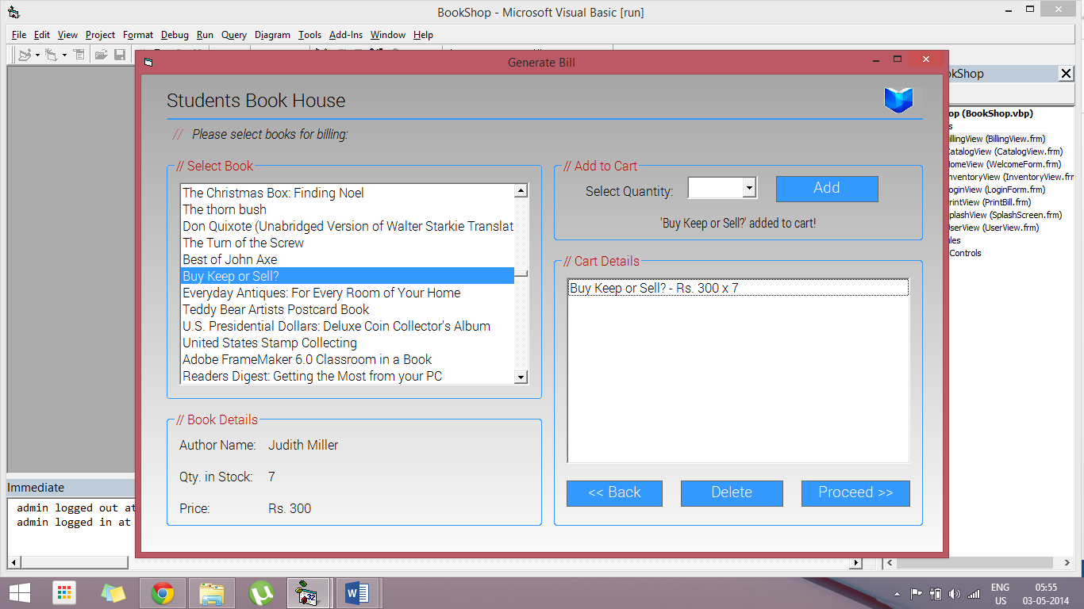

The Billing Screen after successfully adding to cart.

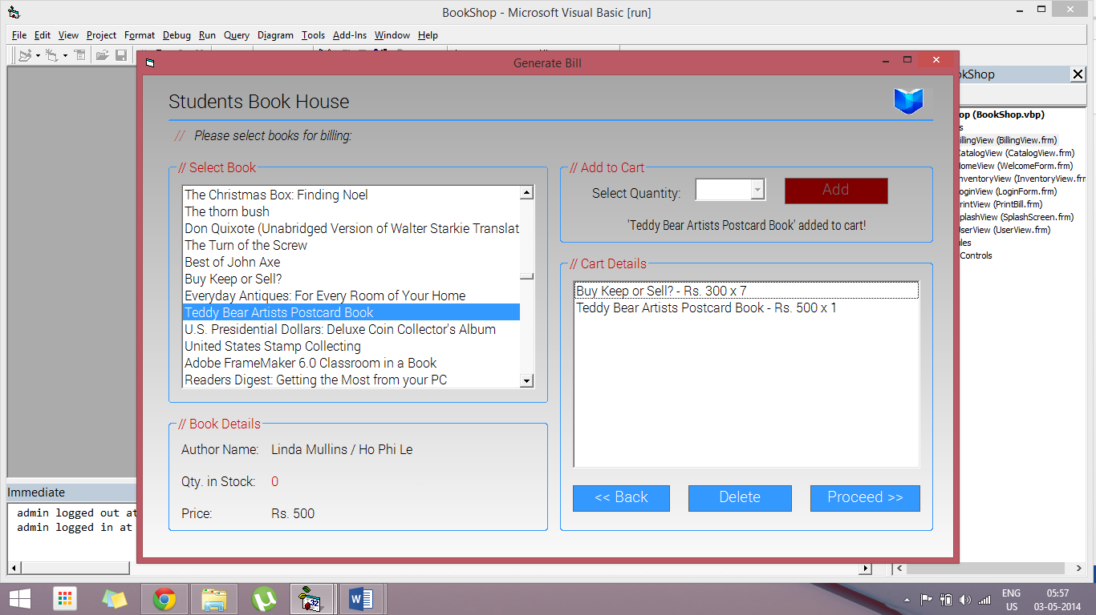

Billing Screen showing item unavailable in stock. The “Add” button becomes unavailable.

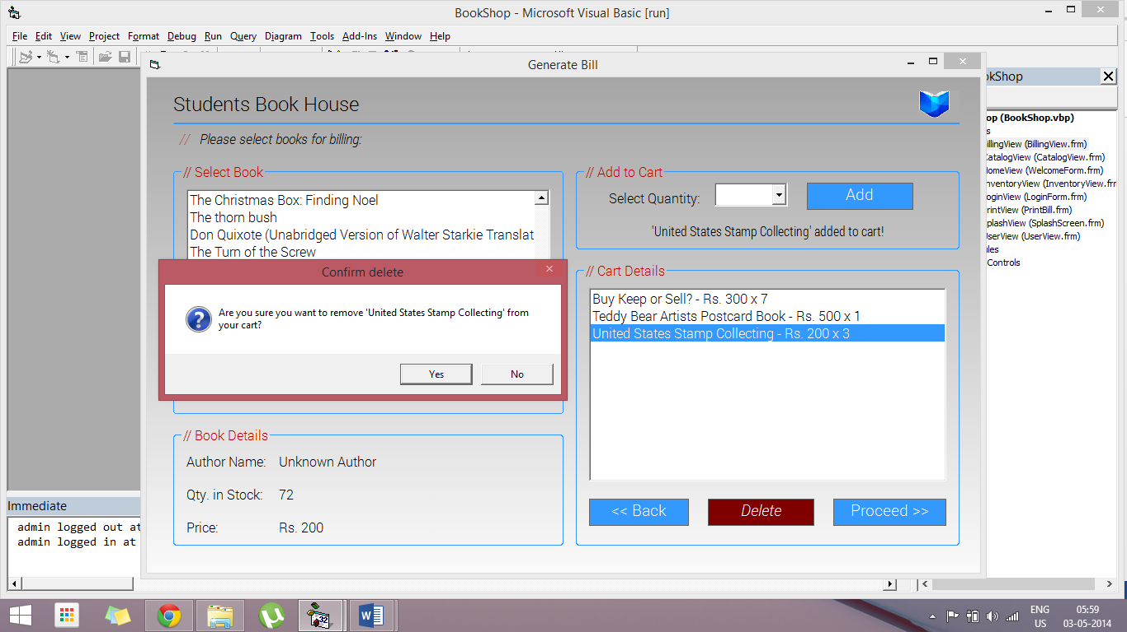

Billing Screen showing item removal from cart confirmation.

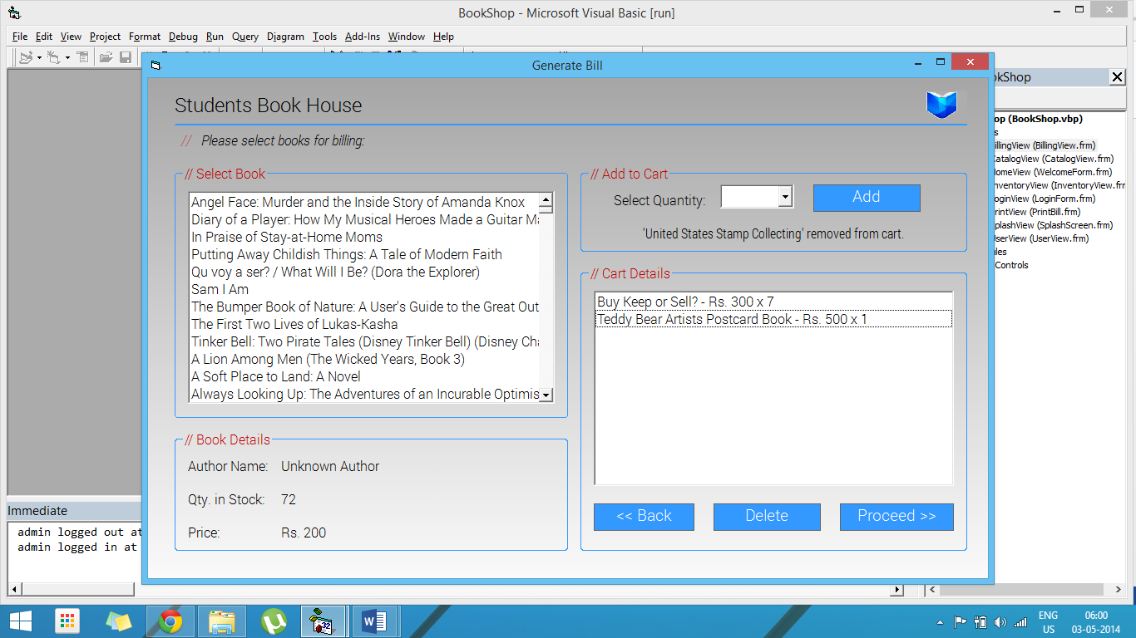

Billing Screen after item removal from cart.

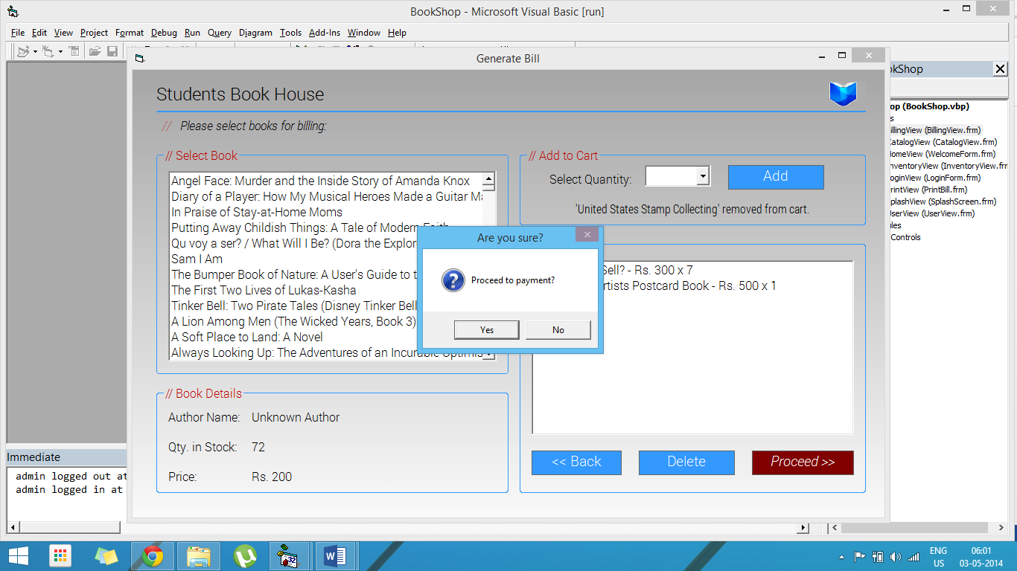

Billing Screen showing proceed to payment confirmation.

# Bill Print Screen (\Forms\PrintView.frm)

## Source Code

**Option** Explicit

**Dim** Token **As** **Long**

**Dim** C **As** **Long**

**Private** **Sub** **cmdPrint_Click**()

    cmdPrint.Visible **=** **False**

    cmdProceed.Visible **=** **False**

    PrintForm

    cmdPrint.Visible **=** **True**

    cmdProceed.Visible **=** **True**

**End** **Sub**

**Private** **Sub** **cmdProceed_Click**()

**Select** **Case** MsgBox("Go back to home screen?", vbApplicationModal **+** vbYesNo **+** vbQuestion **+** vbDefaultButton1, "Sure to proceed?")

**Case** vbYes

            Unload **Me**

            HomeView.Show

**Case** vbNo

**Exit** **Sub**

**End** **Select**

**End** **Sub**

**Private** **Sub** **cmdPrint_MouseMove**(Button **As** **Integer**, Shift **As** **Integer**, X **As** **Single**, Y **As** **Single**)

    cmdPrint.BackColor **=** **&**H80&

    cmdProceed.BackColor **=** **&**H8000000D

    cmdPrint.FontItalic **=** **True**

    cmdProceed.FontItalic **=** **False**

**End** **Sub**

**Private** **Sub** **cmdProceed_MouseMove**(Button **As** **Integer**, Shift **As** **Integer**, X **As** **Single**, Y **As** **Single**)

    cmdPrint.BackColor **=** **&**H8000000D

    cmdProceed.BackColor **=** **&**H80&

    cmdPrint.FontItalic **=** **False**

    cmdProceed.FontItalic **=** **True**

**End** **Sub**

**Private** **Sub** **Form_Initialize**()

    Token **=** InitGDIPlus

    C **=** **Me**.BackColor

**If** C **<** 0 **Then** C **=** GetSysColor(C **-** **&**H80000000)

**End** **Sub**

**Private** **Sub** **Form_Load**()

    ShopLogo.Picture **=** LoadPictureGDIPlus(App.Path **&** "\Images\logo.png", 100, 80, **&**HADADAD, **True**)

    txtBill.Text **=** "Item No." **&** vbTab **&** "Name" **&** vbTab **&** vbTab **&** vbTab **&** vbTab **&** vbTab **&** "Qty." **&** vbTab **&** "Rate" **&** vbTab **&** "Price" **&** vbNewLine

    txtBill.Text **=** txtBill.Text **&** **String**$(70, "=") **&** vbNewLine

    txtDate.Caption **=** DateValue(Now)

    txtTime.Caption **=** TimeValue(Now)

    lblDate.FontBold **=** **True**

    lblTime.FontBold **=** **True**

    lblBill.FontBold **=** **True**

    lblAmt.FontBold **=** **True**

**End** **Sub**

**Private** **Sub** **Form_MouseMove**(Button **As** **Integer**, Shift **As** **Integer**, X **As** **Single**, Y **As** **Single**)

    cmdPrint.BackColor **=** **&**H8000000D

    cmdProceed.BackColor **=** **&**H8000000D

    cmdPrint.FontItalic **=** **False**

    cmdProceed.FontItalic **=** **False**

**End** **Sub**

**Private** **Sub** **Form_Unload**(Cancel **As** **Integer**)

    FreeGDIPlus Token

**End** **Sub**

## Screenshots

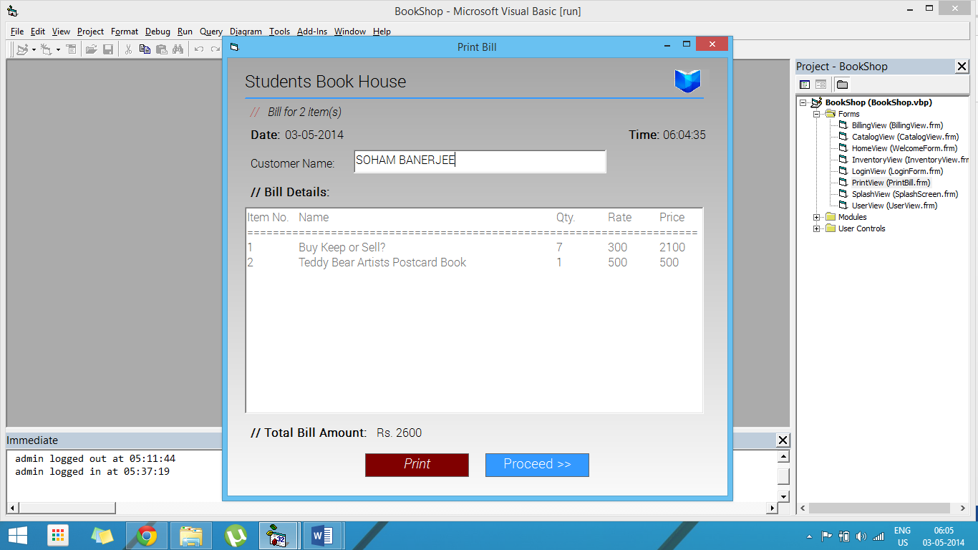

The Bill Print Screen showing the generated invoice.

# Inventory Screen (\Forms\InventoryView.frm)

## Source Code

**Option** Explicit

**Dim** Token **As** **Long**

**Dim** C **As** **Long**

**Dim** LastI **As** **Integer**

**Dim** flagNew **As** **Boolean**

**Private** **Sub** **BookResults_Click**()

    BookList.Recordset.AbsolutePosition **=** BookResults.ListIndex **+** 1

    txtBookName.Text **=** BookList.Recordset.Fields("BOOKNAME")

    txtAuthorName.Text **=** BookList.Recordset.Fields("AUTHORNAME")

    txtISBN.Text **=** BookList.Recordset.Fields("ISBN")

    txtCategory.Text **=** BookList.Recordset.Fields("CATEGORY")

    txtQty.Text **=** BookList.Recordset.Fields("QTY")

    txtPrice.Text **=** BookList.Recordset.Fields("MRP")

    StatusView.Panels(1).Text **=** "Book " **&** (BookResults.ListIndex **+** 1) **&** " of " **&** BookResults.ListCount **&** " selected"

**End** **Sub**

**Private** **Sub** **BookResults_MouseMove**(Button **As** **Integer**, Shift **As** **Integer**, X **As** **Single**, Y **As** **Single**)

**If** cmdAdd.Enabled **Then** cmdAdd.BackColor **=** **&**H8000000D

**If** cmdEdit.Enabled **Then** cmdEdit.BackColor **=** **&**H8000000D

**If** cmdSave.Enabled **Then** cmdSave.BackColor **=** **&**H8000000D

**If** cmdCancel.Enabled **Then** cmdCancel.BackColor **=** **&**H8000000D

    cmdNext.BackColor **=** **&**H8000000D

    cmdPrev.BackColor **=** **&**H8000000D

    cmdFirst.BackColor **=** **&**H8000000D

    cmdLast.BackColor **=** **&**H8000000D

    cmdBack.BackColor **=** **&**H8000000D

    cmdFilter.BackColor **=** **&**H8000000D

    cmdReset.BackColor **=** **&**H8000000D

**If** cmdDelete.Enabled **Then** cmdDelete.BackColor **=** **&**H8000000D

    cmdAdd.FontItalic **=** **False**

    cmdEdit.FontItalic **=** **False**

    cmdSave.FontItalic **=** **False**

    cmdCancel.FontItalic **=** **False**

    cmdNext.FontBold **=** **False**

    cmdPrev.FontBold **=** **False**

    cmdFirst.FontBold **=** **False**

    cmdLast.FontBold **=** **False**

    cmdBack.FontItalic **=** **False**

    cmdFilter.FontItalic **=** **False**

    cmdReset.FontItalic **=** **False**

    cmdDelete.FontItalic **=** **False**

**End** **Sub**

**Private** **Sub** **cmdAdd_Click**()

    txtBookName.Text **=** ""

    txtAuthorName.Text **=** ""

    txtISBN.Text **=** ""

    txtCategory.Text **=** ""

    txtQty.Text **=** ""

    txtPrice.Text **=** ""

    txtBookName.Enabled **=** **True**

    txtAuthorName.Enabled **=** **True**

    txtISBN.Enabled **=** **True**

    txtCategory.Enabled **=** **True**

    txtQty.Enabled **=** **True**

    txtPrice.Enabled **=** **True**

    cmdAdd.Enabled **=** **False**

    cmdAdd.BackColor **=** QBColor(8)

    cmdEdit.Enabled **=** **False**

    cmdEdit.BackColor **=** QBColor(8)

    cmdDelete.Enabled **=** **False**

    cmdDelete.BackColor **=** QBColor(8)

    cmdSave.Enabled **=** **True**

    cmdSave.BackColor **=** **&**H8000000D

    cmdCancel.Enabled **=** **True**

    cmdCancel.BackColor **=** **&**H8000000D

    flagNew **=** **True**

    BookList.Recordset.AddNew

    txtBookName.SetFocus

**End** **Sub**

**Private** **Sub** **cmdAdd_MouseMove**(Button **As** **Integer**, Shift **As** **Integer**, X **As** **Single**, Y **As** **Single**)

**If** cmdAdd.Enabled **Then** cmdAdd.BackColor **=** **&**H80&

**If** cmdEdit.Enabled **Then** cmdEdit.BackColor **=** **&**H8000000D

**If** cmdSave.Enabled **Then** cmdSave.BackColor **=** **&**H8000000D

**If** cmdCancel.Enabled **Then** cmdCancel.BackColor **=** **&**H8000000D

    cmdNext.BackColor **=** **&**H8000000D

    cmdPrev.BackColor **=** **&**H8000000D

    cmdFirst.BackColor **=** **&**H8000000D

    cmdLast.BackColor **=** **&**H8000000D

    cmdBack.BackColor **=** **&**H8000000D

    cmdFilter.BackColor **=** **&**H8000000D

    cmdReset.BackColor **=** **&**H8000000D

**If** cmdDelete.Enabled **Then** cmdDelete.BackColor **=** **&**H8000000D

    cmdAdd.FontItalic **=** **True**

    cmdEdit.FontItalic **=** **False**

    cmdSave.FontItalic **=** **False**

    cmdCancel.FontItalic **=** **False**

    cmdNext.FontBold **=** **False**

    cmdPrev.FontBold **=** **False**

    cmdFirst.FontBold **=** **False**

    cmdLast.FontBold **=** **False**

    cmdBack.FontItalic **=** **False**

    cmdFilter.FontItalic **=** **False**

    cmdReset.FontItalic **=** **False**

    cmdDelete.FontItalic **=** **False**

**End** **Sub**

**Private** **Sub** **cmdBack_Click**()

    Unload **Me**

**End** **Sub**

**Private** **Sub** **cmdBack_MouseMove**(Button **As** **Integer**, Shift **As** **Integer**, X **As** **Single**, Y **As** **Single**)

**If** cmdAdd.Enabled **Then** cmdAdd.BackColor **=** **&**H8000000D

**If** cmdEdit.Enabled **Then** cmdEdit.BackColor **=** **&**H8000000D

**If** cmdSave.Enabled **Then** cmdSave.BackColor **=** **&**H8000000D

**If** cmdCancel.Enabled **Then** cmdCancel.BackColor **=** **&**H8000000D

    cmdNext.BackColor **=** **&**H8000000D

    cmdPrev.BackColor **=** **&**H8000000D

    cmdFirst.BackColor **=** **&**H8000000D

    cmdLast.BackColor **=** **&**H8000000D

    cmdBack.BackColor **=** **&**H80&

    cmdFilter.BackColor **=** **&**H8000000D

    cmdReset.BackColor **=** **&**H8000000D

**If** cmdDelete.Enabled **Then** cmdDelete.BackColor **=** **&**H8000000D

    cmdAdd.FontItalic **=** **False**

    cmdEdit.FontItalic **=** **False**

    cmdSave.FontItalic **=** **False**

    cmdCancel.FontItalic **=** **False**

    cmdNext.FontBold **=** **False**

    cmdPrev.FontBold **=** **False**

    cmdFirst.FontBold **=** **False**

    cmdLast.FontBold **=** **False**

    cmdBack.FontItalic **=** **True**

    cmdFilter.FontItalic **=** **False**

    cmdReset.FontItalic **=** **False**

    cmdDelete.FontItalic **=** **False**

**End** **Sub**

**Private** **Sub** **cmdCancel_Click**()

**If** flagNew **Then**

        BookList.Recordset.Cancel

        BookList.Recordset.CancelUpdate

        BookResults.ListIndex **=** 0

        flagNew **=** **False**

**End** **If**

    cmdAdd.Enabled **=** **True**

    cmdAdd.BackColor **=** **&**H8000000D

    cmdEdit.Enabled **=** **True**

    cmdEdit.BackColor **=** **&**H8000000D

    cmdDelete.Enabled **=** **True**

    cmdDelete.BackColor **=** **&**H8000000D

    cmdSave.Enabled **=** **False**

    cmdSave.BackColor **=** QBColor(8)

    cmdCancel.Enabled **=** **False**

    cmdCancel.BackColor **=** QBColor(8)

    txtBookName.Enabled **=** **False**

    txtAuthorName.Enabled **=** **False**

    txtISBN.Enabled **=** **False**

    txtCategory.Enabled **=** **False**

    txtQty.Enabled **=** **False**

    txtPrice.Enabled **=** **False**

**End** **Sub**

**Private** **Sub** **cmdCancel_MouseMove**(Button **As** **Integer**, Shift **As** **Integer**, X **As** **Single**, Y **As** **Single**)

**If** cmdAdd.Enabled **Then** cmdAdd.BackColor **=** **&**H8000000D

**If** cmdEdit.Enabled **Then** cmdEdit.BackColor **=** **&**H8000000D

**If** cmdSave.Enabled **Then** cmdSave.BackColor **=** **&**H8000000D

**If** cmdCancel.Enabled **Then** cmdCancel.BackColor **=** **&**H80&

    cmdNext.BackColor **=** **&**H8000000D

    cmdPrev.BackColor **=** **&**H8000000D

    cmdFirst.BackColor **=** **&**H8000000D

    cmdLast.BackColor **=** **&**H8000000D

    cmdBack.BackColor **=** **&**H8000000D

    cmdFilter.BackColor **=** **&**H8000000D

    cmdReset.BackColor **=** **&**H8000000D

**If** cmdDelete.Enabled **Then** cmdDelete.BackColor **=** **&**H8000000D

    cmdAdd.FontItalic **=** **False**

    cmdEdit.FontItalic **=** **False**

    cmdSave.FontItalic **=** **False**

    cmdCancel.FontItalic **=** **True**

    cmdNext.FontBold **=** **False**

    cmdPrev.FontBold **=** **False**

    cmdFirst.FontBold **=** **False**

    cmdLast.FontBold **=** **False**

    cmdBack.FontItalic **=** **False**

    cmdFilter.FontItalic **=** **False**

    cmdReset.FontItalic **=** **False**

    cmdDelete.FontItalic **=** **False**

**End** **Sub**

**Private** **Sub** **cmdDelete_Click**()

**Dim** index **As** **Integer**

**Select** **Case** MsgBox("Are you sure you want to delete this book from the inventory?", vbApplicationModal **+** vbYesNo **+** vbQuestion **+** vbDefaultButton1, "Confirm delete")

**Case** vbYes

            index **=** BookResults.ListIndex **-** 1

            BookList.Recordset.Delete

            BookList.Recordset.Update

            BookResults.RemoveItem BookResults.ListIndex

**If** index **>=** 0 **Then**

                BookResults.ListIndex **=** index

**Else**

                BookResults.ListIndex **=** 0

**End** **If**

**End** **Select**

    StatusView.Panels(2).Text **=** BookResults.ListCount **&** " books in database"

**End** **Sub**

**Private** **Sub** **cmdDelete_MouseMove**(Button **As** **Integer**, Shift **As** **Integer**, X **As** **Single**, Y **As** **Single**)

**If** cmdAdd.Enabled **Then** cmdAdd.BackColor **=** **&**H8000000D

**If** cmdEdit.Enabled **Then** cmdEdit.BackColor **=** **&**H8000000D

**If** cmdSave.Enabled **Then** cmdSave.BackColor **=** **&**H8000000D

**If** cmdCancel.Enabled **Then** cmdCancel.BackColor **=** **&**H8000000D

    cmdNext.BackColor **=** **&**H8000000D

    cmdPrev.BackColor **=** **&**H8000000D

    cmdFirst.BackColor **=** **&**H8000000D

    cmdLast.BackColor **=** **&**H8000000D

    cmdBack.BackColor **=** **&**H8000000D

    cmdFilter.BackColor **=** **&**H8000000D

    cmdReset.BackColor **=** **&**H8000000D

**If** cmdDelete.Enabled **Then** cmdDelete.BackColor **=** **&**H80&

    cmdAdd.FontItalic **=** **False**

    cmdEdit.FontItalic **=** **False**

    cmdSave.FontItalic **=** **False**

    cmdCancel.FontItalic **=** **False**

    cmdNext.FontBold **=** **False**

    cmdPrev.FontBold **=** **False**

    cmdFirst.FontBold **=** **False**

    cmdLast.FontBold **=** **False**

    cmdBack.FontItalic **=** **False**

    cmdFilter.FontItalic **=** **False**

    cmdReset.FontItalic **=** **False**

    cmdDelete.FontItalic **=** **True**

**End** **Sub**

**Private** **Sub** **cmdEdit_Click**()

    txtBookName.Enabled **=** **True**

    txtAuthorName.Enabled **=** **True**

    txtISBN.Enabled **=** **True**

    txtCategory.Enabled **=** **True**

    txtQty.Enabled **=** **True**

    txtPrice.Enabled **=** **True**

    cmdAdd.Enabled **=** **False**

    cmdAdd.BackColor **=** QBColor(8)

    cmdEdit.Enabled **=** **False**

    cmdEdit.BackColor **=** QBColor(8)

    cmdDelete.Enabled **=** **False**

    cmdDelete.BackColor **=** QBColor(8)

    cmdSave.Enabled **=** **True**

    cmdSave.BackColor **=** **&**H8000000D

    cmdCancel.Enabled **=** **True**

    cmdCancel.BackColor **=** **&**H8000000D

    flagNew **=** **False**

    txtBookName.SetFocus

**End** **Sub**

**Private** **Sub** **cmdEdit_MouseMove**(Button **As** **Integer**, Shift **As** **Integer**, X **As** **Single**, Y **As** **Single**)

**If** cmdAdd.Enabled **Then** cmdAdd.BackColor **=** **&**H8000000D

**If** cmdEdit.Enabled **Then** cmdEdit.BackColor **=** **&**H80&

**If** cmdSave.Enabled **Then** cmdSave.BackColor **=** **&**H8000000D

**If** cmdCancel.Enabled **Then** cmdCancel.BackColor **=** **&**H8000000D

    cmdNext.BackColor **=** **&**H8000000D

    cmdPrev.BackColor **=** **&**H8000000D

    cmdFirst.BackColor **=** **&**H8000000D

    cmdLast.BackColor **=** **&**H8000000D

    cmdBack.BackColor **=** **&**H8000000D

    cmdFilter.BackColor **=** **&**H8000000D

    cmdReset.BackColor **=** **&**H8000000D

**If** cmdDelete.Enabled **Then** cmdDelete.BackColor **=** **&**H8000000D

    cmdAdd.FontItalic **=** **False**

    cmdEdit.FontItalic **=** **True**

    cmdSave.FontItalic **=** **False**

    cmdCancel.FontItalic **=** **False**

    cmdNext.FontBold **=** **False**

    cmdPrev.FontBold **=** **False**

    cmdFirst.FontBold **=** **False**

    cmdLast.FontBold **=** **False**

    cmdBack.FontItalic **=** **False**

    cmdFilter.FontItalic **=** **False**

    cmdReset.FontItalic **=** **False**

    cmdDelete.FontItalic **=** **False**

**End** **Sub**

**Private** **Sub** **cmdFilter_Click**()

**If** txtSearch.Text **=** "" **Then**

        MsgBox "Enter text to search for!", vbApplicationModal **+** vbOKOnly **+** vbInformation, "Enter search term"

        txtSearch.SetFocus

**Exit** **Sub**

**End** **If**

**Dim** i **As** **Integer**

**For** i **=** LastI **To** BookResults.ListCount **-** 1

**If** InStr(1, BookResults.List(i), txtSearch.Text, vbTextCompare) **>** 0 **Then**

            BookResults.ListIndex **=** i

            LastI **=** i

**Exit** **Sub**

**End** **If**

**Next** i

    MsgBox "'" **&** txtSearch.Text **&** "' not found in the records!", vbApplicationModal **+** vbOKOnly **+** vbInformation, "Not found"

**End** **Sub**

**Private** **Sub** **cmdFilter_MouseMove**(Button **As** **Integer**, Shift **As** **Integer**, X **As** **Single**, Y **As** **Single**)

**If** cmdAdd.Enabled **Then** cmdAdd.BackColor **=** **&**H8000000D

**If** cmdEdit.Enabled **Then** cmdEdit.BackColor **=** **&**H8000000D

**If** cmdSave.Enabled **Then** cmdSave.BackColor **=** **&**H8000000D

**If** cmdCancel.Enabled **Then** cmdCancel.BackColor **=** **&**H8000000D

    cmdNext.BackColor **=** **&**H8000000D

    cmdPrev.BackColor **=** **&**H8000000D

    cmdFirst.BackColor **=** **&**H8000000D

    cmdLast.BackColor **=** **&**H8000000D

    cmdBack.BackColor **=** **&**H8000000D

    cmdFilter.BackColor **=** **&**H80&

    cmdReset.BackColor **=** **&**H8000000D

**If** cmdDelete.Enabled **Then** cmdDelete.BackColor **=** **&**H8000000D

    cmdAdd.FontItalic **=** **False**

    cmdEdit.FontItalic **=** **False**

    cmdSave.FontItalic **=** **False**

    cmdCancel.FontItalic **=** **False**

    cmdNext.FontBold **=** **False**

    cmdPrev.FontBold **=** **False**

    cmdFirst.FontBold **=** **False**

    cmdLast.FontBold **=** **False**

    cmdBack.FontItalic **=** **False**

    cmdFilter.FontItalic **=** **True**

    cmdReset.FontItalic **=** **False**

    cmdDelete.FontItalic **=** **False**

**End** **Sub**

**Private** **Sub** **cmdFirst_Click**()

    BookResults.ListIndex **=** 0

**End** **Sub**

**Private** **Sub** **cmdFirst_MouseMove**(Button **As** **Integer**, Shift **As** **Integer**, X **As** **Single**, Y **As** **Single**)

**If** cmdAdd.Enabled **Then** cmdAdd.BackColor **=** **&**H8000000D

**If** cmdEdit.Enabled **Then** cmdEdit.BackColor **=** **&**H8000000D

**If** cmdSave.Enabled **Then** cmdSave.BackColor **=** **&**H8000000D

**If** cmdCancel.Enabled **Then** cmdCancel.BackColor **=** **&**H8000000D

    cmdNext.BackColor **=** **&**H8000000D

    cmdPrev.BackColor **=** **&**H8000000D

    cmdFirst.BackColor **=** **&**H80&

    cmdLast.BackColor **=** **&**H8000000D

    cmdBack.BackColor **=** **&**H8000000D

    cmdFilter.BackColor **=** **&**H8000000D

    cmdReset.BackColor **=** **&**H8000000D

**If** cmdDelete.Enabled **Then** cmdDelete.BackColor **=** **&**H8000000D

    cmdAdd.FontItalic **=** **False**

    cmdEdit.FontItalic **=** **False**

    cmdSave.FontItalic **=** **False**

    cmdCancel.FontItalic **=** **False**

    cmdNext.FontBold **=** **False**

    cmdPrev.FontBold **=** **False**

    cmdFirst.FontBold **=** **True**

    cmdLast.FontBold **=** **False**

    cmdBack.FontItalic **=** **False**

    cmdFilter.FontItalic **=** **False**

    cmdReset.FontItalic **=** **False**

    cmdDelete.FontItalic **=** **False**

**End** **Sub**

**Private** **Sub** **cmdLast_Click**()

    BookResults.ListIndex **=** BookResults.ListCount **-** 1

**End** **Sub**

**Private** **Sub** **cmdLast_MouseMove**(Button **As** **Integer**, Shift **As** **Integer**, X **As** **Single**, Y **As** **Single**)

**If** cmdAdd.Enabled **Then** cmdAdd.BackColor **=** **&**H8000000D

**If** cmdEdit.Enabled **Then** cmdEdit.BackColor **=** **&**H8000000D

**If** cmdSave.Enabled **Then** cmdSave.BackColor **=** **&**H8000000D

**If** cmdCancel.Enabled **Then** cmdCancel.BackColor **=** **&**H8000000D

    cmdNext.BackColor **=** **&**H8000000D

    cmdPrev.BackColor **=** **&**H8000000D

    cmdFirst.BackColor **=** **&**H8000000D

    cmdLast.BackColor **=** **&**H80&

    cmdBack.BackColor **=** **&**H8000000D

    cmdFilter.BackColor **=** **&**H8000000D

    cmdReset.BackColor **=** **&**H8000000D

**If** cmdDelete.Enabled **Then** cmdDelete.BackColor **=** **&**H8000000D

    cmdAdd.FontItalic **=** **False**

    cmdEdit.FontItalic **=** **False**

    cmdSave.FontItalic **=** **False**

    cmdCancel.FontItalic **=** **False**

    cmdNext.FontBold **=** **False**

    cmdPrev.FontBold **=** **False**

    cmdFirst.FontBold **=** **False**

    cmdLast.FontBold **=** **True**

    cmdBack.FontItalic **=** **False**

    cmdFilter.FontItalic **=** **False**

    cmdReset.FontItalic **=** **False**

    cmdDelete.FontItalic **=** **False**

**End** **Sub**

**Private** **Sub** **cmdNext_Click**()

**If** BookResults.ListIndex **=** BookResults.ListCount **-** 1 **Then**

        MsgBox "No records after this!", vbApplicationModal **+** vbOKOnly **+** vbInformation, "End of file reached"

**Else**

        BookResults.ListIndex **=** BookResults.ListIndex **+** 1

**End** **If**

**End** **Sub**

**Private** **Sub** **cmdNext_MouseMove**(Button **As** **Integer**, Shift **As** **Integer**, X **As** **Single**, Y **As** **Single**)

**If** cmdAdd.Enabled **Then** cmdAdd.BackColor **=** **&**H8000000D

**If** cmdEdit.Enabled **Then** cmdEdit.BackColor **=** **&**H8000000D

**If** cmdSave.Enabled **Then** cmdSave.BackColor **=** **&**H8000000D

**If** cmdCancel.Enabled **Then** cmdCancel.BackColor **=** **&**H8000000D

    cmdNext.BackColor **=** **&**H80&

    cmdPrev.BackColor **=** **&**H8000000D

    cmdFirst.BackColor **=** **&**H8000000D

    cmdLast.BackColor **=** **&**H8000000D

    cmdBack.BackColor **=** **&**H8000000D

    cmdFilter.BackColor **=** **&**H8000000D

    cmdReset.BackColor **=** **&**H8000000D

**If** cmdDelete.Enabled **Then** cmdDelete.BackColor **=** **&**H8000000D

    cmdAdd.FontItalic **=** **False**

    cmdEdit.FontItalic **=** **False**

    cmdSave.FontItalic **=** **False**

    cmdCancel.FontItalic **=** **False**

    cmdNext.FontBold **=** **True**

    cmdPrev.FontBold **=** **False**

    cmdFirst.FontBold **=** **False**

    cmdLast.FontBold **=** **False**

    cmdBack.FontItalic **=** **False**

    cmdFilter.FontItalic **=** **False**

    cmdReset.FontItalic **=** **False**

    cmdDelete.FontItalic **=** **False**

**End** **Sub**

**Private** **Sub** **cmdPrev_Click**()

**If** BookResults.ListIndex **=** 0 **Then**

        MsgBox "No records before this!", vbApplicationModal **+** vbOKOnly **+** vbInformation, "Start of file reached"

**Else**

        BookResults.ListIndex **=** BookResults.ListIndex **-** 1

**End** **If**

**End** **Sub**

**Private** **Sub** **cmdPrev_MouseMove**(Button **As** **Integer**, Shift **As** **Integer**, X **As** **Single**, Y **As** **Single**)

**If** cmdAdd.Enabled **Then** cmdAdd.BackColor **=** **&**H8000000D

**If** cmdEdit.Enabled **Then** cmdEdit.BackColor **=** **&**H8000000D

**If** cmdSave.Enabled **Then** cmdSave.BackColor **=** **&**H8000000D

**If** cmdCancel.Enabled **Then** cmdCancel.BackColor **=** **&**H8000000D

    cmdNext.BackColor **=** **&**H8000000D

    cmdPrev.BackColor **=** **&**H80&

    cmdFirst.BackColor **=** **&**H8000000D

    cmdLast.BackColor **=** **&**H8000000D

    cmdBack.BackColor **=** **&**H8000000D

    cmdFilter.BackColor **=** **&**H8000000D

    cmdReset.BackColor **=** **&**H8000000D

**If** cmdDelete.Enabled **Then** cmdDelete.BackColor **=** **&**H8000000D

    cmdAdd.FontItalic **=** **False**

    cmdEdit.FontItalic **=** **False**

    cmdSave.FontItalic **=** **False**

    cmdCancel.FontItalic **=** **False**

    cmdNext.FontBold **=** **False**

    cmdPrev.FontBold **=** **True**

    cmdFirst.FontBold **=** **False**

    cmdLast.FontBold **=** **False**

    cmdBack.FontItalic **=** **False**

    cmdFilter.FontItalic **=** **False**

    cmdReset.FontItalic **=** **False**

    cmdDelete.FontItalic **=** **False**

**End** **Sub**

**Private** **Sub** **cmdReset_Click**()

    LastI **=** 0

    BookResults.ListIndex **=** 0

    txtSearch.Text **=** ""

**End** **Sub**

**Private** **Sub** **cmdReset_MouseMove**(Button **As** **Integer**, Shift **As** **Integer**, X **As** **Single**, Y **As** **Single**)

**If** cmdAdd.Enabled **Then** cmdAdd.BackColor **=** **&**H8000000D

**If** cmdEdit.Enabled **Then** cmdEdit.BackColor **=** **&**H8000000D

**If** cmdSave.Enabled **Then** cmdSave.BackColor **=** **&**H8000000D

**If** cmdCancel.Enabled **Then** cmdCancel.BackColor **=** **&**H8000000D

    cmdNext.BackColor **=** **&**H8000000D

    cmdPrev.BackColor **=** **&**H8000000D

    cmdFirst.BackColor **=** **&**H8000000D

    cmdLast.BackColor **=** **&**H8000000D

    cmdBack.BackColor **=** **&**H8000000D

    cmdFilter.BackColor **=** **&**H8000000D

    cmdReset.BackColor **=** **&**H80&

**If** cmdDelete.Enabled **Then** cmdDelete.BackColor **=** **&**H8000000D

    cmdAdd.FontItalic **=** **False**

    cmdEdit.FontItalic **=** **False**

    cmdSave.FontItalic **=** **False**

    cmdCancel.FontItalic **=** **False**

    cmdNext.FontBold **=** **False**

    cmdPrev.FontBold **=** **False**

    cmdFirst.FontBold **=** **False**

    cmdLast.FontBold **=** **False**

    cmdBack.FontItalic **=** **False**

    cmdFilter.FontItalic **=** **False**

    cmdReset.FontItalic **=** **True**

    cmdDelete.FontItalic **=** **False**

**End** **Sub**

**Private** **Sub** **cmdSave_Click**()

**If** txtBookName.Text **=** "" **Then**

        MsgBox "Book name cannot be blank!", vbApplicationModal **+** vbExclamation **+** vbOKOnly, "Error"

        txtBookName.SetFocus

**Exit** **Sub**

**End** **If**

**If** txtAuthorName.Text **=** "" **Then**

        MsgBox "Author name cannot be blank!", vbApplicationModal **+** vbExclamation **+** vbOKOnly, "Error"

        txtAuthorName.SetFocus

**Exit** **Sub**

**End** **If**

**If** txtISBN.Text **=** "" **Then**

        MsgBox "ISBN cannot be blank!", vbApplicationModal **+** vbExclamation **+** vbOKOnly, "Error"

        txtISBN.SetFocus

**Exit** **Sub**

**End** **If**

**If** txtCategory.Text **=** "" **Then**

        MsgBox "Category cannot be blank!", vbApplicationModal **+** vbExclamation **+** vbOKOnly, "Error"

        txtCategory.SetFocus

**Exit** **Sub**

**End** **If**

**If** txtQty.Text **=** "" **Then**

        MsgBox "Quantity cannot be blank!", vbApplicationModal **+** vbExclamation **+** vbOKOnly, "Error"

        txtQty.SetFocus

**Exit** **Sub**

**End** **If**

**If** txtPrice.Text **=** "" **Then**

        MsgBox "Price cannot be blank!", vbApplicationModal **+** vbExclamation **+** vbOKOnly, "Error"

        txtPrice.SetFocus

**Exit** **Sub**

**End** **If**

**If** **Not** IsNumeric(txtQty.Text) **Then**

        MsgBox "Quantity must be a number!", vbApplicationModal **+** vbExclamation **+** vbOKOnly, "Error"

        txtQty.Text **=** ""

        txtQty.SetFocus

**Exit** **Sub**

**End** **If**

**If** **Not** IsNumeric(txtPrice.Text) **Then**

        MsgBox "Price must be a number!", vbApplicationModal **+** vbExclamation **+** vbOKOnly, "Error"

        txtPrice.Text **=** ""

        txtPrice.SetFocus

**Exit** **Sub**

**End** **If**

    BookList.Recordset.Fields("BOOKNAME") **=** txtBookName.Text

    BookList.Recordset.Fields("AUTHORNAME") **=** txtAuthorName.Text

    BookList.Recordset.Fields("ISBN") **=** txtISBN.Text

    BookList.Recordset.Fields("CATEGORY") **=** txtCategory.Text

    BookList.Recordset.Fields("QTY") **=** txtQty.Text

    BookList.Recordset.Fields("MRP") **=** txtPrice.Text

    BookList.Recordset.Update

**If** flagNew **Then**

        flagNew **=** **False**

        BookResults.AddItem txtBookName.Text

        BookResults.ListIndex **=** BookResults.ListCount **-** 1

**End** **If**

    cmdAdd.Enabled **=** **True**

    cmdAdd.BackColor **=** **&**H8000000D

    cmdEdit.Enabled **=** **True**

    cmdEdit.BackColor **=** **&**H8000000D

    cmdDelete.Enabled **=** **True**

    cmdDelete.BackColor **=** **&**H8000000D

    cmdSave.Enabled **=** **False**

    cmdSave.BackColor **=** QBColor(8)

    cmdCancel.Enabled **=** **False**

    cmdCancel.BackColor **=** QBColor(8)

    txtBookName.Enabled **=** **False**

    txtAuthorName.Enabled **=** **False**

    txtISBN.Enabled **=** **False**

    txtCategory.Enabled **=** **False**

    txtQty.Enabled **=** **False**

    txtPrice.Enabled **=** **False**

    StatusView.Panels(2).Text **=** BookResults.ListCount **&** " books in database"

**End** **Sub**

**Private** **Sub** **cmdSave_MouseMove**(Button **As** **Integer**, Shift **As** **Integer**, X **As** **Single**, Y **As** **Single**)

**If** cmdAdd.Enabled **Then** cmdAdd.BackColor **=** **&**H8000000D

**If** cmdEdit.Enabled **Then** cmdEdit.BackColor **=** **&**H8000000D

**If** cmdSave.Enabled **Then** cmdSave.BackColor **=** **&**H80&

**If** cmdCancel.Enabled **Then** cmdCancel.BackColor **=** **&**H8000000D

    cmdNext.BackColor **=** **&**H8000000D

    cmdPrev.BackColor **=** **&**H8000000D

    cmdFirst.BackColor **=** **&**H8000000D

    cmdLast.BackColor **=** **&**H8000000D

    cmdBack.BackColor **=** **&**H8000000D

    cmdFilter.BackColor **=** **&**H8000000D

    cmdReset.BackColor **=** **&**H8000000D

**If** cmdDelete.Enabled **Then** cmdDelete.BackColor **=** **&**H8000000D

    cmdAdd.FontItalic **=** **False**

    cmdEdit.FontItalic **=** **False**

    cmdSave.FontItalic **=** **True**

    cmdCancel.FontItalic **=** **False**

    cmdNext.FontBold **=** **False**

    cmdPrev.FontBold **=** **False**

    cmdFirst.FontBold **=** **False**

    cmdLast.FontBold **=** **False**

    cmdBack.FontItalic **=** **False**

    cmdFilter.FontItalic **=** **False**

    cmdReset.FontItalic **=** **False**

    cmdDelete.FontItalic **=** **False**

**End** **Sub**

**Private** **Sub** **Form_Activate**()

    StatusView.Panels(2).Text **=** BookResults.ListCount **&** " books in database"

**End** **Sub**

**Private** **Sub** **Form_Initialize**()

    Token **=** InitGDIPlus

    C **=** **Me**.BackColor

**If** C **<** 0 **Then** C **=** GetSysColor(C **-** **&**H80000000)

    BookList.ConnectionString **=** "Provider=Microsoft.Jet.OLEDB.4.0;Data Source=" **&** App.Path **&** "\db\BookDB.mdb;Persist Security Info=False"

    BookList.CursorLocation **=** adUseClient

    BookList.CursorType **=** adOpenDynamic

    BookList.CommandType **=** adCmdTable

    BookList.RecordSource **=** "BookList"

    BookList.Refresh

**End** **Sub**

**Private** **Sub** **Form_Load**()

    ShopLogo.Picture **=** LoadPictureGDIPlus(App.Path **&** "\Images\logo.png", 100, 80, **&**HADADAD, **True**)

    SearchFrame.AutoReDraw **=** **True**

    SearchFrame.ReDraw

    ListFrame.AutoReDraw **=** **True**

    DetailsFrame.ReDraw

    DetailsFrame.AutoReDraw **=** **True**

    DetailsFrame.ReDraw

**Me**.Width **=** **Me**.Width **+** 20

    txtBookName.Enabled **=** **False**

    txtAuthorName.Enabled **=** **False**

    txtISBN.Enabled **=** **False**

    txtCategory.Enabled **=** **False**

    txtQty.Enabled **=** **False**

    txtPrice.Enabled **=** **False**

    cmdAdd.Enabled **=** **True**

    cmdAdd.BackColor **=** **&**H8000000D

    cmdEdit.Enabled **=** **True**

    cmdEdit.BackColor **=** **&**H8000000D

    cmdDelete.Enabled **=** **True**

    cmdDelete.BackColor **=** **&**H8000000D

    cmdSave.Enabled **=** **False**

    cmdSave.BackColor **=** QBColor(8)

    cmdCancel.Enabled **=** **False**

    cmdCancel.BackColor **=** QBColor(8)

    BookList.ConnectionString **=** "Provider=Microsoft.Jet.OLEDB.4.0;Data Source=" **&** App.Path **&** "\db\BookDB.mdb;Persist Security Info=False"

    BookList.CursorLocation **=** adUseClient

    BookList.CursorType **=** adOpenDynamic

    BookList.CommandType **=** adCmdTable

    BookList.RecordSource **=** "BookList"

    BookList.Refresh

    BookList.Recordset.MoveFirst

**While** **Not** BookList.Recordset.EOF

        BookResults.AddItem BookList.Recordset.Fields("BOOKNAME")

        BookList.Recordset.MoveNext

**Wend**

    BookResults.ListIndex **=** 0

    BookList.Recordset.AbsolutePosition **=** BookResults.ListIndex **+** 1

    LastI **=** 0

    flagNew **=** **False**

**End** **Sub**

**Private** **Sub** **Form_MouseMove**(Button **As** **Integer**, Shift **As** **Integer**, X **As** **Single**, Y **As** **Single**)

**If** cmdAdd.Enabled **Then** cmdAdd.BackColor **=** **&**H8000000D

**If** cmdEdit.Enabled **Then** cmdEdit.BackColor **=** **&**H8000000D

**If** cmdSave.Enabled **Then** cmdSave.BackColor **=** **&**H8000000D

**If** cmdCancel.Enabled **Then** cmdCancel.BackColor **=** **&**H8000000D

    cmdNext.BackColor **=** **&**H8000000D

    cmdPrev.BackColor **=** **&**H8000000D

    cmdFirst.BackColor **=** **&**H8000000D

    cmdLast.BackColor **=** **&**H8000000D

    cmdBack.BackColor **=** **&**H8000000D

    cmdFilter.BackColor **=** **&**H8000000D

    cmdReset.BackColor **=** **&**H8000000D

**If** cmdDelete.Enabled **Then** cmdDelete.BackColor **=** **&**H8000000D

    cmdAdd.FontItalic **=** **False**

    cmdEdit.FontItalic **=** **False**

    cmdSave.FontItalic **=** **False**

    cmdCancel.FontItalic **=** **False**

    cmdNext.FontBold **=** **False**

    cmdPrev.FontBold **=** **False**

    cmdFirst.FontBold **=** **False**

    cmdLast.FontBold **=** **False**

    cmdBack.FontItalic **=** **False**

    cmdFilter.FontItalic **=** **False**

    cmdReset.FontItalic **=** **False**

    cmdDelete.FontItalic **=** **False**

**End** **Sub**

**Private** **Sub** **Form_Resize**()

    SearchFrame.ReDraw

    ListFrame.ReDraw

    DetailsFrame.ReDraw

**End** **Sub**

**Private** **Sub** **Form_Unload**(Cancel **As** **Integer**)

**Select** **Case** MsgBox("Go back to home screen?", vbApplicationModal **+** vbYesNo **+** vbQuestion **+** vbDefaultButton1, "Sure to exit?")

**Case** vbYes

            FreeGDIPlus Token

            HomeView.Show

            Unload **Me**

**Case** vbNo

            Cancel **=** 1

**End** **Select**

**End** **Sub**

**Private** **Sub** **lblAuthorName_MouseMove**(Button **As** **Integer**, Shift **As** **Integer**, X **As** **Single**, Y **As** **Single**)

**If** cmdAdd.Enabled **Then** cmdAdd.BackColor **=** **&**H8000000D

**If** cmdEdit.Enabled **Then** cmdEdit.BackColor **=** **&**H8000000D

**If** cmdSave.Enabled **Then** cmdSave.BackColor **=** **&**H8000000D

**If** cmdCancel.Enabled **Then** cmdCancel.BackColor **=** **&**H8000000D

    cmdNext.BackColor **=** **&**H8000000D

    cmdPrev.BackColor **=** **&**H8000000D

    cmdFirst.BackColor **=** **&**H8000000D

    cmdLast.BackColor **=** **&**H8000000D

    cmdBack.BackColor **=** **&**H8000000D

    cmdFilter.BackColor **=** **&**H8000000D

    cmdReset.BackColor **=** **&**H8000000D

**If** cmdDelete.Enabled **Then** cmdDelete.BackColor **=** **&**H8000000D

    cmdAdd.FontItalic **=** **False**

    cmdEdit.FontItalic **=** **False**

    cmdSave.FontItalic **=** **False**

    cmdCancel.FontItalic **=** **False**

    cmdNext.FontBold **=** **False**

    cmdPrev.FontBold **=** **False**

    cmdFirst.FontBold **=** **False**

    cmdLast.FontBold **=** **False**

    cmdBack.FontItalic **=** **False**

    cmdFilter.FontItalic **=** **False**

    cmdReset.FontItalic **=** **False**

    cmdDelete.FontItalic **=** **False**

**End** **Sub**

**Private** **Sub** **lblBookName_MouseMove**(Button **As** **Integer**, Shift **As** **Integer**, X **As** **Single**, Y **As** **Single**)

**If** cmdAdd.Enabled **Then** cmdAdd.BackColor **=** **&**H8000000D

**If** cmdEdit.Enabled **Then** cmdEdit.BackColor **=** **&**H8000000D

**If** cmdSave.Enabled **Then** cmdSave.BackColor **=** **&**H8000000D

**If** cmdCancel.Enabled **Then** cmdCancel.BackColor **=** **&**H8000000D

    cmdNext.BackColor **=** **&**H8000000D

    cmdPrev.BackColor **=** **&**H8000000D

    cmdFirst.BackColor **=** **&**H8000000D

    cmdLast.BackColor **=** **&**H8000000D

    cmdBack.BackColor **=** **&**H8000000D

    cmdFilter.BackColor **=** **&**H8000000D

    cmdReset.BackColor **=** **&**H8000000D

**If** cmdDelete.Enabled **Then** cmdDelete.BackColor **=** **&**H8000000D

    cmdAdd.FontItalic **=** **False**

    cmdEdit.FontItalic **=** **False**

    cmdSave.FontItalic **=** **False**

    cmdCancel.FontItalic **=** **False**

    cmdNext.FontBold **=** **False**

    cmdPrev.FontBold **=** **False**

    cmdFirst.FontBold **=** **False**

    cmdLast.FontBold **=** **False**

    cmdBack.FontItalic **=** **False**

    cmdFilter.FontItalic **=** **False**

    cmdReset.FontItalic **=** **False**

    cmdDelete.FontItalic **=** **False**

**End** **Sub**

**Private** **Sub** **lblCategory_MouseMove**(Button **As** **Integer**, Shift **As** **Integer**, X **As** **Single**, Y **As** **Single**)

**If** cmdAdd.Enabled **Then** cmdAdd.BackColor **=** **&**H8000000D

**If** cmdEdit.Enabled **Then** cmdEdit.BackColor **=** **&**H8000000D

**If** cmdSave.Enabled **Then** cmdSave.BackColor **=** **&**H8000000D

**If** cmdCancel.Enabled **Then** cmdCancel.BackColor **=** **&**H8000000D

    cmdNext.BackColor **=** **&**H8000000D

    cmdPrev.BackColor **=** **&**H8000000D

    cmdFirst.BackColor **=** **&**H8000000D

    cmdLast.BackColor **=** **&**H8000000D

    cmdBack.BackColor **=** **&**H8000000D

    cmdFilter.BackColor **=** **&**H8000000D

    cmdReset.BackColor **=** **&**H8000000D

**If** cmdDelete.Enabled **Then** cmdDelete.BackColor **=** **&**H8000000D

    cmdAdd.FontItalic **=** **False**

    cmdEdit.FontItalic **=** **False**

    cmdSave.FontItalic **=** **False**

    cmdCancel.FontItalic **=** **False**

    cmdNext.FontBold **=** **False**

    cmdPrev.FontBold **=** **False**

    cmdFirst.FontBold **=** **False**

    cmdLast.FontBold **=** **False**

    cmdBack.FontItalic **=** **False**

    cmdFilter.FontItalic **=** **False**

    cmdReset.FontItalic **=** **False**

    cmdDelete.FontItalic **=** **False**

**End** **Sub**

**Private** **Sub** **lblISBN_MouseMove**(Button **As** **Integer**, Shift **As** **Integer**, X **As** **Single**, Y **As** **Single**)

**If** cmdAdd.Enabled **Then** cmdAdd.BackColor **=** **&**H8000000D

**If** cmdEdit.Enabled **Then** cmdEdit.BackColor **=** **&**H8000000D

**If** cmdSave.Enabled **Then** cmdSave.BackColor **=** **&**H8000000D

**If** cmdCancel.Enabled **Then** cmdCancel.BackColor **=** **&**H8000000D

    cmdNext.BackColor **=** **&**H8000000D

    cmdPrev.BackColor **=** **&**H8000000D

    cmdFirst.BackColor **=** **&**H8000000D

    cmdLast.BackColor **=** **&**H8000000D

    cmdBack.BackColor **=** **&**H8000000D

    cmdFilter.BackColor **=** **&**H8000000D

    cmdReset.BackColor **=** **&**H8000000D

**If** cmdDelete.Enabled **Then** cmdDelete.BackColor **=** **&**H8000000D

    cmdAdd.FontItalic **=** **False**

    cmdEdit.FontItalic **=** **False**

    cmdSave.FontItalic **=** **False**

    cmdCancel.FontItalic **=** **False**

    cmdNext.FontBold **=** **False**

    cmdPrev.FontBold **=** **False**

    cmdFirst.FontBold **=** **False**

    cmdLast.FontBold **=** **False**

    cmdBack.FontItalic **=** **False**

    cmdFilter.FontItalic **=** **False**

    cmdReset.FontItalic **=** **False**

    cmdDelete.FontItalic **=** **False**

**End** **Sub**

**Private** **Sub** **lblPrice_MouseMove**(Button **As** **Integer**, Shift **As** **Integer**, X **As** **Single**, Y **As** **Single**)

**If** cmdAdd.Enabled **Then** cmdAdd.BackColor **=** **&**H8000000D

**If** cmdEdit.Enabled **Then** cmdEdit.BackColor **=** **&**H8000000D

**If** cmdSave.Enabled **Then** cmdSave.BackColor **=** **&**H8000000D

**If** cmdCancel.Enabled **Then** cmdCancel.BackColor **=** **&**H8000000D

    cmdNext.BackColor **=** **&**H8000000D

    cmdPrev.BackColor **=** **&**H8000000D

    cmdFirst.BackColor **=** **&**H8000000D

    cmdLast.BackColor **=** **&**H8000000D

    cmdBack.BackColor **=** **&**H8000000D

    cmdFilter.BackColor **=** **&**H8000000D

    cmdReset.BackColor **=** **&**H8000000D

**If** cmdDelete.Enabled **Then** cmdDelete.BackColor **=** **&**H8000000D

    cmdAdd.FontItalic **=** **False**

    cmdEdit.FontItalic **=** **False**

    cmdSave.FontItalic **=** **False**

    cmdCancel.FontItalic **=** **False**

    cmdNext.FontBold **=** **False**

    cmdPrev.FontBold **=** **False**

    cmdFirst.FontBold **=** **False**

    cmdLast.FontBold **=** **False**

    cmdBack.FontItalic **=** **False**

    cmdFilter.FontItalic **=** **False**

    cmdReset.FontItalic **=** **False**

    cmdDelete.FontItalic **=** **False**

**End** **Sub**

**Private** **Sub** **lblQty_MouseMove**(Button **As** **Integer**, Shift **As** **Integer**, X **As** **Single**, Y **As** **Single**)

**If** cmdAdd.Enabled **Then** cmdAdd.BackColor **=** **&**H8000000D

**If** cmdEdit.Enabled **Then** cmdEdit.BackColor **=** **&**H8000000D

**If** cmdSave.Enabled **Then** cmdSave.BackColor **=** **&**H8000000D

**If** cmdCancel.Enabled **Then** cmdCancel.BackColor **=** **&**H8000000D

    cmdNext.BackColor **=** **&**H8000000D

    cmdPrev.BackColor **=** **&**H8000000D

    cmdFirst.BackColor **=** **&**H8000000D

    cmdLast.BackColor **=** **&**H8000000D

    cmdBack.BackColor **=** **&**H8000000D

    cmdFilter.BackColor **=** **&**H8000000D

    cmdReset.BackColor **=** **&**H8000000D

**If** cmdDelete.Enabled **Then** cmdDelete.BackColor **=** **&**H8000000D

    cmdAdd.FontItalic **=** **False**

    cmdEdit.FontItalic **=** **False**

    cmdSave.FontItalic **=** **False**

    cmdCancel.FontItalic **=** **False**

    cmdNext.FontBold **=** **False**

    cmdPrev.FontBold **=** **False**

    cmdFirst.FontBold **=** **False**

    cmdLast.FontBold **=** **False**

    cmdBack.FontItalic **=** **False**

    cmdFilter.FontItalic **=** **False**

    cmdReset.FontItalic **=** **False**

    cmdDelete.FontItalic **=** **False**

**End** **Sub**

**Private** **Sub** **lblSearch_MouseMove**(Button **As** **Integer**, Shift **As** **Integer**, X **As** **Single**, Y **As** **Single**)

**If** cmdAdd.Enabled **Then** cmdAdd.BackColor **=** **&**H8000000D

**If** cmdEdit.Enabled **Then** cmdEdit.BackColor **=** **&**H8000000D

**If** cmdSave.Enabled **Then** cmdSave.BackColor **=** **&**H8000000D

**If** cmdCancel.Enabled **Then** cmdCancel.BackColor **=** **&**H8000000D

    cmdNext.BackColor **=** **&**H8000000D

    cmdPrev.BackColor **=** **&**H8000000D

    cmdFirst.BackColor **=** **&**H8000000D

    cmdLast.BackColor **=** **&**H8000000D

    cmdBack.BackColor **=** **&**H8000000D

    cmdFilter.BackColor **=** **&**H8000000D

    cmdReset.BackColor **=** **&**H8000000D

**If** cmdDelete.Enabled **Then** cmdDelete.BackColor **=** **&**H8000000D

    cmdAdd.FontItalic **=** **False**

    cmdEdit.FontItalic **=** **False**

    cmdSave.FontItalic **=** **False**

    cmdCancel.FontItalic **=** **False**

    cmdNext.FontBold **=** **False**

    cmdPrev.FontBold **=** **False**

    cmdFirst.FontBold **=** **False**

    cmdLast.FontBold **=** **False**

    cmdBack.FontItalic **=** **False**

    cmdFilter.FontItalic **=** **False**

    cmdReset.FontItalic **=** **False**

    cmdDelete.FontItalic **=** **False**

**End** **Sub**

**Private** **Sub** **txtAuthorName_MouseMove**(Button **As** **Integer**, Shift **As** **Integer**, X **As** **Single**, Y **As** **Single**)

**If** cmdAdd.Enabled **Then** cmdAdd.BackColor **=** **&**H8000000D

**If** cmdEdit.Enabled **Then** cmdEdit.BackColor **=** **&**H8000000D

**If** cmdSave.Enabled **Then** cmdSave.BackColor **=** **&**H8000000D

**If** cmdCancel.Enabled **Then** cmdCancel.BackColor **=** **&**H8000000D

    cmdNext.BackColor **=** **&**H8000000D

    cmdPrev.BackColor **=** **&**H8000000D

    cmdFirst.BackColor **=** **&**H8000000D

    cmdLast.BackColor **=** **&**H8000000D

    cmdBack.BackColor **=** **&**H8000000D

    cmdFilter.BackColor **=** **&**H8000000D

    cmdReset.BackColor **=** **&**H8000000D

**If** cmdDelete.Enabled **Then** cmdDelete.BackColor **=** **&**H8000000D

    cmdAdd.FontItalic **=** **False**

    cmdEdit.FontItalic **=** **False**

    cmdSave.FontItalic **=** **False**

    cmdCancel.FontItalic **=** **False**

    cmdNext.FontBold **=** **False**

    cmdPrev.FontBold **=** **False**

    cmdFirst.FontBold **=** **False**

    cmdLast.FontBold **=** **False**

    cmdBack.FontItalic **=** **False**

    cmdFilter.FontItalic **=** **False**

    cmdReset.FontItalic **=** **False**

    cmdDelete.FontItalic **=** **False**

**End** **Sub**

**Private** **Sub** **txtBookName_MouseMove**(Button **As** **Integer**, Shift **As** **Integer**, X **As** **Single**, Y **As** **Single**)

**If** cmdAdd.Enabled **Then** cmdAdd.BackColor **=** **&**H8000000D

**If** cmdEdit.Enabled **Then** cmdEdit.BackColor **=** **&**H8000000D

**If** cmdSave.Enabled **Then** cmdSave.BackColor **=** **&**H8000000D

**If** cmdCancel.Enabled **Then** cmdCancel.BackColor **=** **&**H8000000D

    cmdNext.BackColor **=** **&**H8000000D

    cmdPrev.BackColor **=** **&**H8000000D

    cmdFirst.BackColor **=** **&**H8000000D

    cmdLast.BackColor **=** **&**H8000000D

    cmdBack.BackColor **=** **&**H8000000D

    cmdFilter.BackColor **=** **&**H8000000D

    cmdReset.BackColor **=** **&**H8000000D

**If** cmdDelete.Enabled **Then** cmdDelete.BackColor **=** **&**H8000000D

    cmdAdd.FontItalic **=** **False**

    cmdEdit.FontItalic **=** **False**

    cmdSave.FontItalic **=** **False**

    cmdCancel.FontItalic **=** **False**

    cmdNext.FontBold **=** **False**

    cmdPrev.FontBold **=** **False**

    cmdFirst.FontBold **=** **False**

    cmdLast.FontBold **=** **False**

    cmdBack.FontItalic **=** **False**

    cmdFilter.FontItalic **=** **False**

    cmdReset.FontItalic **=** **False**

    cmdDelete.FontItalic **=** **False**

**End** **Sub**

**Private** **Sub** **txtCategory_MouseMove**(Button **As** **Integer**, Shift **As** **Integer**, X **As** **Single**, Y **As** **Single**)

**If** cmdAdd.Enabled **Then** cmdAdd.BackColor **=** **&**H8000000D

**If** cmdEdit.Enabled **Then** cmdEdit.BackColor **=** **&**H8000000D

**If** cmdSave.Enabled **Then** cmdSave.BackColor **=** **&**H8000000D

**If** cmdCancel.Enabled **Then** cmdCancel.BackColor **=** **&**H8000000D

    cmdNext.BackColor **=** **&**H8000000D

    cmdPrev.BackColor **=** **&**H8000000D

    cmdFirst.BackColor **=** **&**H8000000D

    cmdLast.BackColor **=** **&**H8000000D

    cmdBack.BackColor **=** **&**H8000000D

    cmdFilter.BackColor **=** **&**H8000000D

    cmdReset.BackColor **=** **&**H8000000D

**If** cmdDelete.Enabled **Then** cmdDelete.BackColor **=** **&**H8000000D

    cmdAdd.FontItalic **=** **False**

    cmdEdit.FontItalic **=** **False**

    cmdSave.FontItalic **=** **False**

    cmdCancel.FontItalic **=** **False**

    cmdNext.FontBold **=** **False**

    cmdPrev.FontBold **=** **False**

    cmdFirst.FontBold **=** **False**

    cmdLast.FontBold **=** **False**

    cmdBack.FontItalic **=** **False**

    cmdFilter.FontItalic **=** **False**

    cmdReset.FontItalic **=** **False**

    cmdDelete.FontItalic **=** **False**

**End** **Sub**

**Private** **Sub** **txtISBN_MouseMove**(Button **As** **Integer**, Shift **As** **Integer**, X **As** **Single**, Y **As** **Single**)

**If** cmdAdd.Enabled **Then** cmdAdd.BackColor **=** **&**H8000000D

**If** cmdEdit.Enabled **Then** cmdEdit.BackColor **=** **&**H8000000D

**If** cmdSave.Enabled **Then** cmdSave.BackColor **=** **&**H8000000D

**If** cmdCancel.Enabled **Then** cmdCancel.BackColor **=** **&**H8000000D

    cmdNext.BackColor **=** **&**H8000000D

    cmdPrev.BackColor **=** **&**H8000000D

    cmdFirst.BackColor **=** **&**H8000000D

    cmdLast.BackColor **=** **&**H8000000D

    cmdBack.BackColor **=** **&**H8000000D

    cmdFilter.BackColor **=** **&**H8000000D

    cmdReset.BackColor **=** **&**H8000000D

**If** cmdDelete.Enabled **Then** cmdDelete.BackColor **=** **&**H8000000D

    cmdAdd.FontItalic **=** **False**

    cmdEdit.FontItalic **=** **False**

    cmdSave.FontItalic **=** **False**

    cmdCancel.FontItalic **=** **False**

    cmdNext.FontBold **=** **False**

    cmdPrev.FontBold **=** **False**

    cmdFirst.FontBold **=** **False**

    cmdLast.FontBold **=** **False**

    cmdBack.FontItalic **=** **False**

    cmdFilter.FontItalic **=** **False**

    cmdReset.FontItalic **=** **False**

    cmdDelete.FontItalic **=** **False**

**End** **Sub**

**Private** **Sub** **txtPrice_MouseMove**(Button **As** **Integer**, Shift **As** **Integer**, X **As** **Single**, Y **As** **Single**)

**If** cmdAdd.Enabled **Then** cmdAdd.BackColor **=** **&**H8000000D

**If** cmdEdit.Enabled **Then** cmdEdit.BackColor **=** **&**H8000000D

**If** cmdSave.Enabled **Then** cmdSave.BackColor **=** **&**H8000000D

**If** cmdCancel.Enabled **Then** cmdCancel.BackColor **=** **&**H8000000D

    cmdNext.BackColor **=** **&**H8000000D

    cmdPrev.BackColor **=** **&**H8000000D

    cmdFirst.BackColor **=** **&**H8000000D

    cmdLast.BackColor **=** **&**H8000000D

    cmdBack.BackColor **=** **&**H8000000D

    cmdFilter.BackColor **=** **&**H8000000D

    cmdReset.BackColor **=** **&**H8000000D

**If** cmdDelete.Enabled **Then** cmdDelete.BackColor **=** **&**H8000000D

    cmdAdd.FontItalic **=** **False**

    cmdEdit.FontItalic **=** **False**

    cmdSave.FontItalic **=** **False**

    cmdCancel.FontItalic **=** **False**

    cmdNext.FontBold **=** **False**

    cmdPrev.FontBold **=** **False**

    cmdFirst.FontBold **=** **False**

    cmdLast.FontBold **=** **False**

    cmdBack.FontItalic **=** **False**

    cmdFilter.FontItalic **=** **False**

    cmdReset.FontItalic **=** **False**

    cmdDelete.FontItalic **=** **False**

**End** **Sub**

**Private** **Sub** **txtQty_MouseMove**(Button **As** **Integer**, Shift **As** **Integer**, X **As** **Single**, Y **As** **Single**)

**If** cmdAdd.Enabled **Then** cmdAdd.BackColor **=** **&**H8000000D

**If** cmdEdit.Enabled **Then** cmdEdit.BackColor **=** **&**H8000000D

**If** cmdSave.Enabled **Then** cmdSave.BackColor **=** **&**H8000000D

**If** cmdCancel.Enabled **Then** cmdCancel.BackColor **=** **&**H8000000D

    cmdNext.BackColor **=** **&**H8000000D

    cmdPrev.BackColor **=** **&**H8000000D

    cmdFirst.BackColor **=** **&**H8000000D

    cmdLast.BackColor **=** **&**H8000000D

    cmdBack.BackColor **=** **&**H8000000D

    cmdFilter.BackColor **=** **&**H8000000D

    cmdReset.BackColor **=** **&**H8000000D

**If** cmdDelete.Enabled **Then** cmdDelete.BackColor **=** **&**H8000000D

    cmdAdd.FontItalic **=** **False**

    cmdEdit.FontItalic **=** **False**

    cmdSave.FontItalic **=** **False**

    cmdCancel.FontItalic **=** **False**

    cmdNext.FontBold **=** **False**

    cmdPrev.FontBold **=** **False**

    cmdFirst.FontBold **=** **False**

    cmdLast.FontBold **=** **False**

    cmdBack.FontItalic **=** **False**

    cmdFilter.FontItalic **=** **False**

    cmdReset.FontItalic **=** **False**

    cmdDelete.FontItalic **=** **False**

**End** **Sub**

**Private** **Sub** **txtSearch_MouseMove**(Button **As** **Integer**, Shift **As** **Integer**, X **As** **Single**, Y **As** **Single**)

**If** cmdAdd.Enabled **Then** cmdAdd.BackColor **=** **&**H8000000D

**If** cmdEdit.Enabled **Then** cmdEdit.BackColor **=** **&**H8000000D

**If** cmdSave.Enabled **Then** cmdSave.BackColor **=** **&**H8000000D

**If** cmdCancel.Enabled **Then** cmdCancel.BackColor **=** **&**H8000000D

    cmdNext.BackColor **=** **&**H8000000D

    cmdPrev.BackColor **=** **&**H8000000D

    cmdFirst.BackColor **=** **&**H8000000D

    cmdLast.BackColor **=** **&**H8000000D

    cmdBack.BackColor **=** **&**H8000000D

    cmdFilter.BackColor **=** **&**H8000000D

    cmdReset.BackColor **=** **&**H8000000D

**If** cmdDelete.Enabled **Then** cmdDelete.BackColor **=** **&**H8000000D

    cmdAdd.FontItalic **=** **False**

    cmdEdit.FontItalic **=** **False**

    cmdSave.FontItalic **=** **False**

    cmdCancel.FontItalic **=** **False**

    cmdNext.FontBold **=** **False**

    cmdPrev.FontBold **=** **False**

    cmdFirst.FontBold **=** **False**

    cmdLast.FontBold **=** **False**

    cmdBack.FontItalic **=** **False**

    cmdFilter.FontItalic **=** **False**

    cmdReset.FontItalic **=** **False**

    cmdDelete.FontItalic **=** **False**

**End** **Sub**

## Screenshots

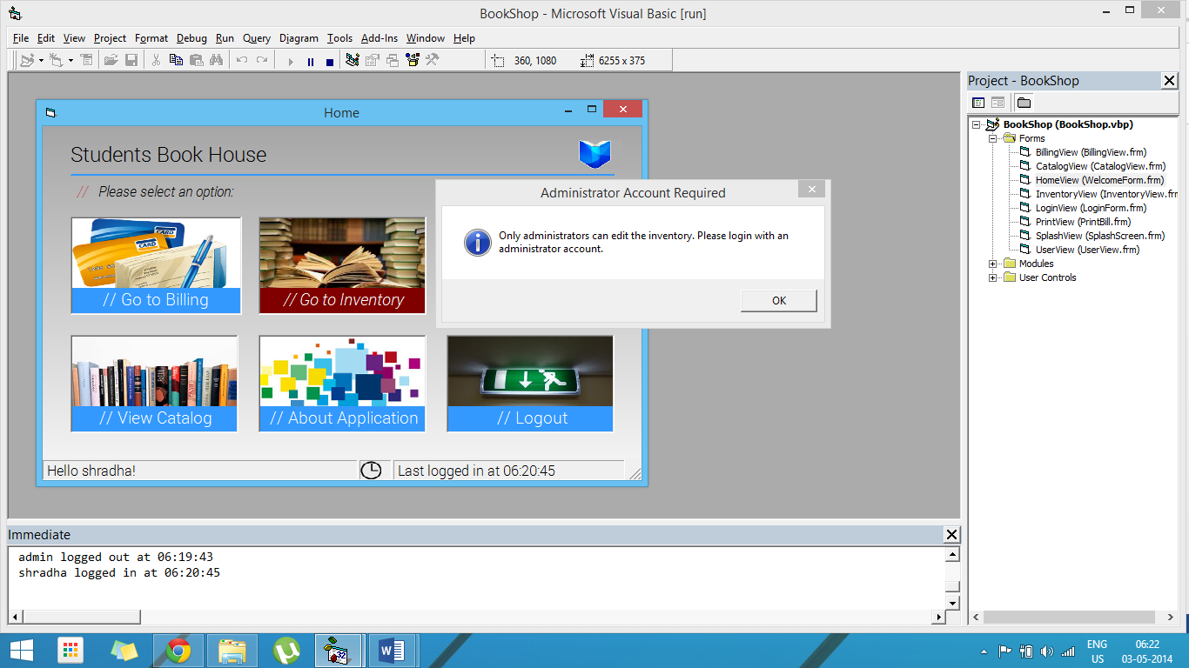

Inventory Screen can only be accessed from an Administrator account.

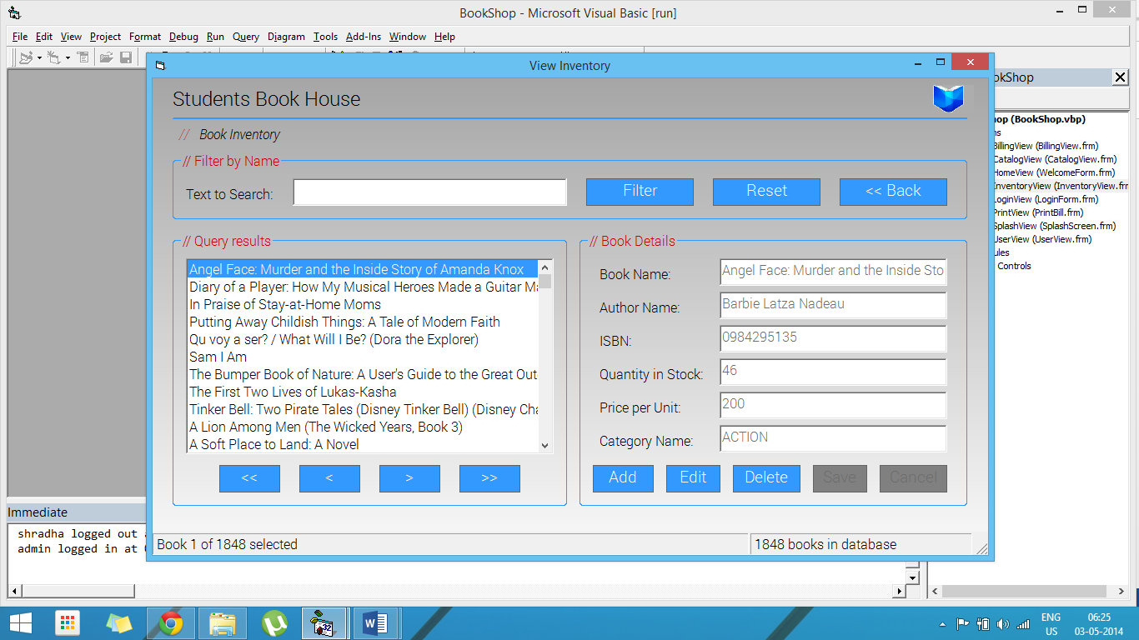

Initial view on opening the Inventory Screen.

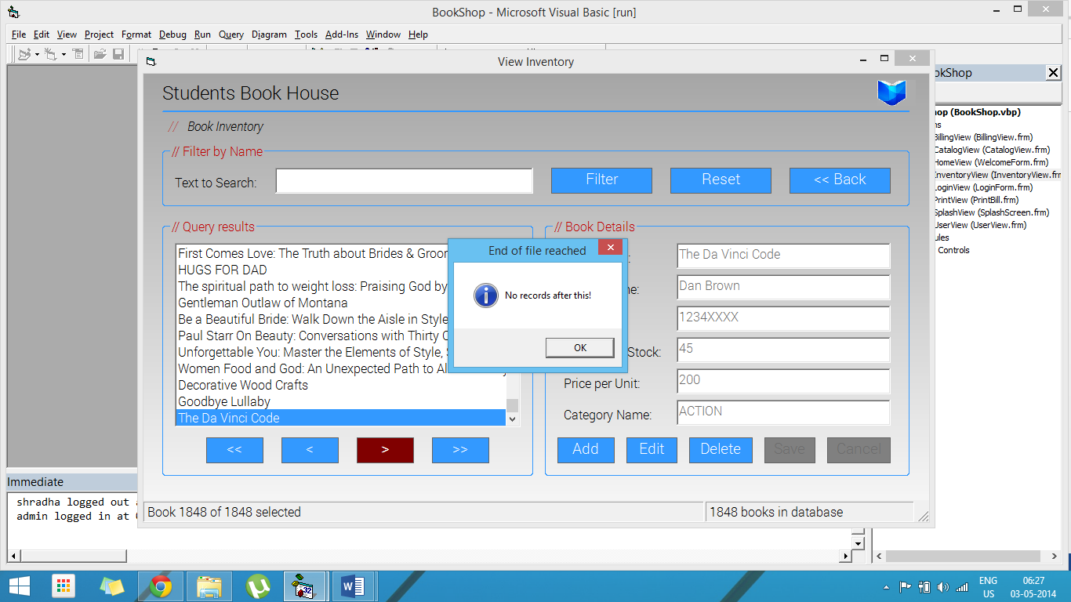

Traversing using the Previous and Next controls.

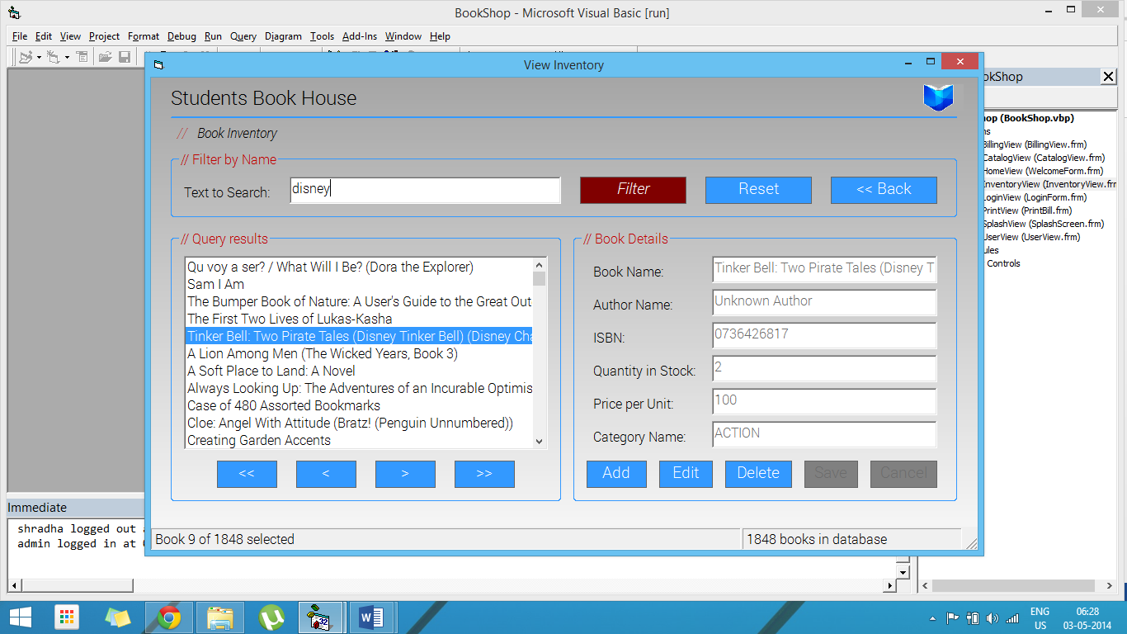

Search for a particular term in the book name.

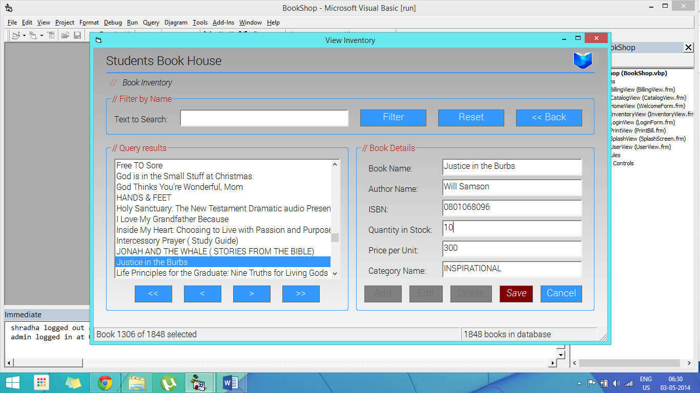

Updating existing stocks of a book. Note that the “Add”, “Edit” and “Delete” buttons are disabled while modifying a record.

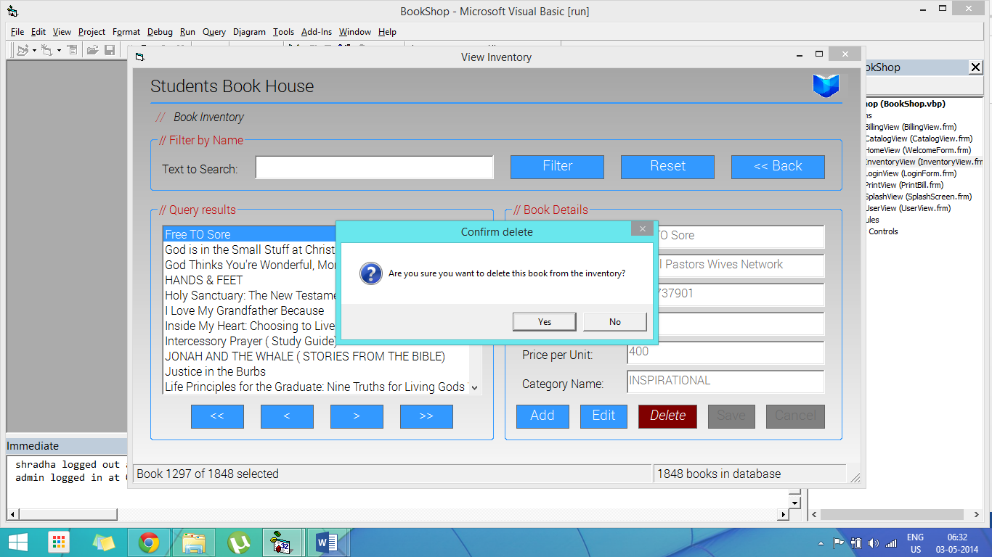

Book delete confirmation dialog

# Catalog Screen (\Forms\CatalogView.frm)

## Source Code

**Option** Explicit

**Dim** Token **As** **Long**

**Dim** C **As** **Long**

**Private** **Sub** **cmdHome_Click**()

    Unload **Me**

**End** **Sub**

**Private** **Sub** **Form_Initialize**()

    Token **=** InitGDIPlus

    C **=** **Me**.BackColor

**If** C **<** 0 **Then** C **=** GetSysColor(C **-** **&**H80000000)

    BookList.ConnectionString **=** "Provider=Microsoft.Jet.OLEDB.4.0;Data Source=" **&** App.Path **&** "\db\BookDB.mdb;Persist Security Info=False"

    BookList.CursorLocation **=** adUseClient

    BookList.CursorType **=** adOpenDynamic

    BookList.CommandType **=** adCmdUnknown

    BookList.RecordSource **=** "Select BOOKNAME, AUTHORNAME, CATEGORY, ISBN, PUBLISHER, BINDING, MRP From BookList"

    BookList.Refresh

**End** **Sub**

**Private** **Sub** **Form_Load**()

   ShopLogo.Picture **=** LoadPictureGDIPlus(App.Path **&** "\Images\logo.png", 100, 80, **&**HADADAD, **True**)

**End** **Sub**

**Private** **Sub** **Form_Unload**(Cancel **As** **Integer**)

**Select** **Case** MsgBox("Go back to home screen?", vbApplicationModal **+** vbYesNo **+** vbQuestion **+** vbDefaultButton1, "Sure to exit?")

**Case** vbYes

            FreeGDIPlus Token

            HomeView.Show

            Unload **Me**

**Case** vbNo

            Cancel **=** 1

**End** **Select**

**End** **Sub**

## Screenshots

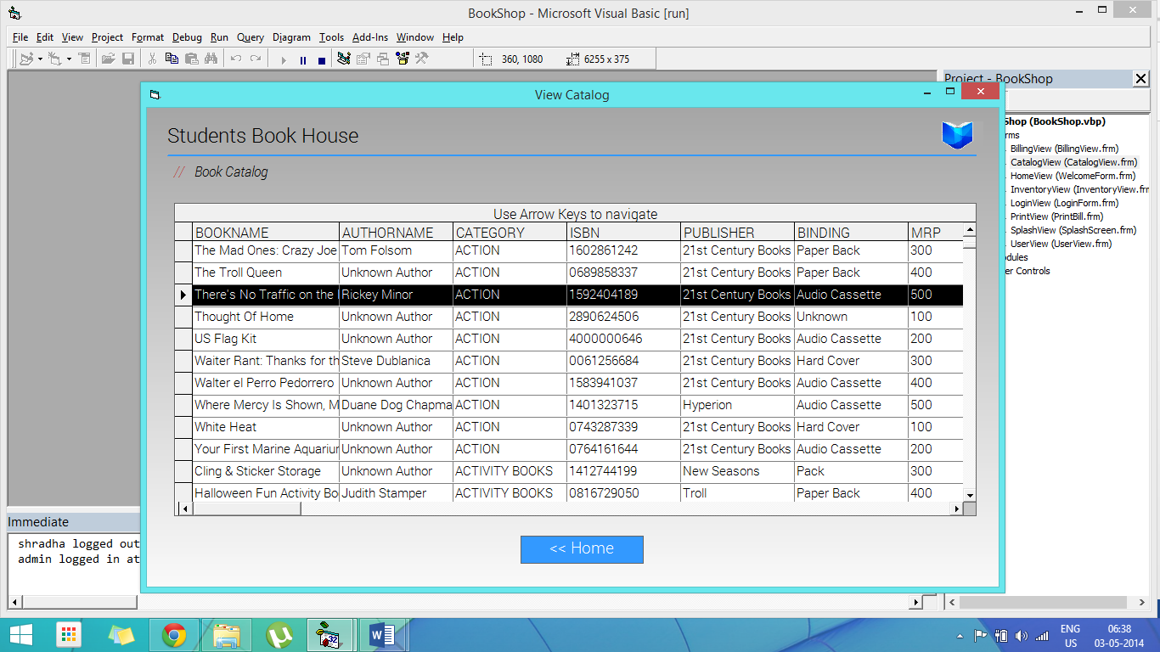

Catalog Screen displaying books and authors in a tabular form.

# Users Screen (\Forms\UserView.frm)

## Source Code

**Option** Explicit

**Dim** Token **As** **Long**

**Dim** C **As** **Long**

**Dim** flagNew **As** **Boolean**

**Private** **Sub** **cmdDelete_Click**()

**Dim** index **As** **Integer**

**Select** **Case** MsgBox("Are you sure you want to delete this user?", vbApplicationModal **+** vbYesNo **+** vbQuestion **+** vbDefaultButton1, "Confirm delete")

**Case** vbYes

            index **=** BookResults.ListIndex **-** 1

            BookList.Recordset.Delete

            BookList.Recordset.Update

            BookResults.RemoveItem BookResults.ListIndex

**If** index **>=** 0 **Then**

                BookResults.ListIndex **=** index

**Else**

                BookResults.ListIndex **=** 0

**End** **If**

**End** **Select**

    StatusView.Panels(2).Text **=** BookResults.ListCount **&** " users in database"

**End** **Sub**

**Private** **Sub** **cmdDelete_MouseMove**(Button **As** **Integer**, Shift **As** **Integer**, X **As** **Single**, Y **As** **Single**)

**If** cmdAdd.Enabled **Then** cmdAdd.BackColor **=** **&**H8000000D

**If** cmdEdit.Enabled **Then** cmdEdit.BackColor **=** **&**H8000000D

**If** cmdSave.Enabled **Then** cmdSave.BackColor **=** **&**H8000000D

**If** cmdCancel.Enabled **Then** cmdCancel.BackColor **=** **&**H8000000D

    cmdBack.BackColor **=** **&**H8000000D

    cmdAdd.FontItalic **=** **False**

    cmdEdit.FontItalic **=** **False**

    cmdSave.FontItalic **=** **False**

    cmdCancel.FontItalic **=** **False**

    cmdBack.FontItalic **=** **False**

**If** cmdDelete.Enabled **Then** cmdDelete.BackColor **=** **&**H80&

    cmdDelete.FontItalic **=** **True**

**End** **Sub**

**Private** **Sub** **BookResults_Click**()

    BookList.Recordset.AbsolutePosition **=** BookResults.ListIndex **+** 1

    txtBookName.Text **=** BookList.Recordset.Fields("USERNAME")

    txtAuthorName.Text **=** BookList.Recordset.Fields("PASSWORD")

    txtISBN.Text **=** BookList.Recordset.Fields("USERTYPE")

    StatusView.Panels(1).Text **=** "User " **&** (BookResults.ListIndex **+** 1) **&** " of " **&** BookResults.ListCount **&** " selected"

**End** **Sub**

**Private** **Sub** **BookResults_MouseMove**(Button **As** **Integer**, Shift **As** **Integer**, X **As** **Single**, Y **As** **Single**)

**If** cmdAdd.Enabled **Then** cmdAdd.BackColor **=** **&**H8000000D

**If** cmdEdit.Enabled **Then** cmdEdit.BackColor **=** **&**H8000000D

**If** cmdSave.Enabled **Then** cmdSave.BackColor **=** **&**H8000000D

**If** cmdCancel.Enabled **Then** cmdCancel.BackColor **=** **&**H8000000D

    cmdBack.BackColor **=** **&**H8000000D

    cmdAdd.FontItalic **=** **False**

    cmdEdit.FontItalic **=** **False**

    cmdSave.FontItalic **=** **False**

    cmdCancel.FontItalic **=** **False**

    cmdBack.FontItalic **=** **False**

**If** cmdDelete.Enabled **Then** cmdDelete.BackColor **=** **&**H8000000D

    cmdDelete.FontItalic **=** **False**

**End** **Sub**

**Private** **Sub** **cmdAdd_Click**()

    txtBookName.Text **=** ""

    txtAuthorName.Text **=** ""

    txtISBN.Text **=** ""

    txtBookName.Enabled **=** **True**

    txtAuthorName.Enabled **=** **True**

    txtISBN.Enabled **=** **True**

    cmdAdd.Enabled **=** **False**

    cmdAdd.BackColor **=** QBColor(8)

    cmdEdit.Enabled **=** **False**

    cmdEdit.BackColor **=** QBColor(8)

    cmdDelete.Enabled **=** **False**

    cmdDelete.BackColor **=** QBColor(8)

    cmdSave.Enabled **=** **True**

    cmdSave.BackColor **=** **&**H8000000D

    cmdCancel.Enabled **=** **True**

    cmdCancel.BackColor **=** **&**H8000000D

    flagNew **=** **True**

    BookList.Recordset.AddNew

    txtBookName.SetFocus

**End** **Sub**

**Private** **Sub** **cmdAdd_MouseMove**(Button **As** **Integer**, Shift **As** **Integer**, X **As** **Single**, Y **As** **Single**)

**If** cmdAdd.Enabled **Then** cmdAdd.BackColor **=** **&**H80&

**If** cmdEdit.Enabled **Then** cmdEdit.BackColor **=** **&**H8000000D

**If** cmdSave.Enabled **Then** cmdSave.BackColor **=** **&**H8000000D

**If** cmdCancel.Enabled **Then** cmdCancel.BackColor **=** **&**H8000000D

    cmdBack.BackColor **=** **&**H8000000D

    cmdAdd.FontItalic **=** **True**

    cmdEdit.FontItalic **=** **False**

    cmdSave.FontItalic **=** **False**

    cmdCancel.FontItalic **=** **False**

    cmdBack.FontItalic **=** **False**

**If** cmdDelete.Enabled **Then** cmdDelete.BackColor **=** **&**H8000000D

    cmdDelete.FontItalic **=** **False**

**End** **Sub**

**Private** **Sub** **cmdBack_Click**()

    Unload **Me**

**End** **Sub**

**Private** **Sub** **cmdBack_MouseMove**(Button **As** **Integer**, Shift **As** **Integer**, X **As** **Single**, Y **As** **Single**)

**If** cmdAdd.Enabled **Then** cmdAdd.BackColor **=** **&**H8000000D

**If** cmdEdit.Enabled **Then** cmdEdit.BackColor **=** **&**H8000000D

**If** cmdSave.Enabled **Then** cmdSave.BackColor **=** **&**H8000000D

**If** cmdCancel.Enabled **Then** cmdCancel.BackColor **=** **&**H8000000D

    cmdBack.BackColor **=** **&**H80&

    cmdAdd.FontItalic **=** **False**

    cmdEdit.FontItalic **=** **False**

    cmdSave.FontItalic **=** **False**

    cmdCancel.FontItalic **=** **False**

    cmdBack.FontItalic **=** **True**

**If** cmdDelete.Enabled **Then** cmdDelete.BackColor **=** **&**H8000000D

    cmdDelete.FontItalic **=** **False**

**End** **Sub**

**Private** **Sub** **cmdCancel_Click**()

**If** flagNew **Then**

        BookList.Recordset.Cancel

        BookList.Recordset.CancelUpdate

        BookResults.ListIndex **=** 0

        flagNew **=** **False**

**End** **If**

    cmdAdd.Enabled **=** **True**

    cmdAdd.BackColor **=** **&**H8000000D

    cmdEdit.Enabled **=** **True**

    cmdEdit.BackColor **=** **&**H8000000D

    cmdDelete.Enabled **=** **True**

    cmdDelete.BackColor **=** **&**H8000000D

    cmdSave.Enabled **=** **False**

    cmdSave.BackColor **=** QBColor(8)

    cmdCancel.Enabled **=** **False**

    cmdCancel.BackColor **=** QBColor(8)

    txtBookName.Enabled **=** **False**

    txtAuthorName.Enabled **=** **False**

    txtISBN.Enabled **=** **False**

**End** **Sub**

**Private** **Sub** **cmdCancel_MouseMove**(Button **As** **Integer**, Shift **As** **Integer**, X **As** **Single**, Y **As** **Single**)

**If** cmdAdd.Enabled **Then** cmdAdd.BackColor **=** **&**H8000000D

**If** cmdEdit.Enabled **Then** cmdEdit.BackColor **=** **&**H8000000D

**If** cmdSave.Enabled **Then** cmdSave.BackColor **=** **&**H8000000D

**If** cmdCancel.Enabled **Then** cmdCancel.BackColor **=** **&**H80&

    cmdBack.BackColor **=** **&**H8000000D

    cmdAdd.FontItalic **=** **False**

    cmdEdit.FontItalic **=** **False**

    cmdSave.FontItalic **=** **False**

    cmdCancel.FontItalic **=** **True**

    cmdBack.FontItalic **=** **False**

**If** cmdDelete.Enabled **Then** cmdDelete.BackColor **=** **&**H8000000D

    cmdDelete.FontItalic **=** **False**

**End** **Sub**

**Private** **Sub** **cmdEdit_Click**()

    txtBookName.Enabled **=** **True**

    txtAuthorName.Enabled **=** **True**

    txtISBN.Enabled **=** **True**

    cmdAdd.Enabled **=** **False**

    cmdAdd.BackColor **=** QBColor(8)

    cmdEdit.Enabled **=** **False**

    cmdEdit.BackColor **=** QBColor(8)

    cmdDelete.Enabled **=** **False**

    cmdDelete.BackColor **=** QBColor(8)

    cmdSave.Enabled **=** **True**

    cmdSave.BackColor **=** **&**H8000000D

    cmdCancel.Enabled **=** **True**

    cmdCancel.BackColor **=** **&**H8000000D

    flagNew **=** **False**

    txtBookName.SetFocus

**End** **Sub**

**Private** **Sub** **cmdEdit_MouseMove**(Button **As** **Integer**, Shift **As** **Integer**, X **As** **Single**, Y **As** **Single**)

**If** cmdAdd.Enabled **Then** cmdAdd.BackColor **=** **&**H8000000D

**If** cmdEdit.Enabled **Then** cmdEdit.BackColor **=** **&**H80&

**If** cmdSave.Enabled **Then** cmdSave.BackColor **=** **&**H8000000D

**If** cmdCancel.Enabled **Then** cmdCancel.BackColor **=** **&**H8000000D

    cmdBack.BackColor **=** **&**H8000000D

    cmdAdd.FontItalic **=** **False**

    cmdEdit.FontItalic **=** **True**

    cmdSave.FontItalic **=** **False**

    cmdCancel.FontItalic **=** **False**

    cmdBack.FontItalic **=** **False**

**If** cmdDelete.Enabled **Then** cmdDelete.BackColor **=** **&**H8000000D

    cmdDelete.FontItalic **=** **False**

**End** **Sub**

**Private** **Sub** **cmdSave_Click**()

**If** txtBookName.Text **=** "" **Then**

        MsgBox "Username cannot be blank!", vbApplicationModal **+** vbExclamation **+** vbOKOnly, "Error"

        txtBookName.SetFocus

**Exit** **Sub**

**End** **If**

**If** txtAuthorName.Text **=** "" **Then**

        MsgBox "Password cannot be blank!", vbApplicationModal **+** vbExclamation **+** vbOKOnly, "Error"

        txtAuthorName.SetFocus

**Exit** **Sub**

**End** **If**

    txtISBN.Text **=** UCase(txtISBN.Text)

**If** txtISBN.Text **<>** "ADMIN" **Then** txtISBN.Text **=** "USER"

    BookList.Recordset.Fields("USERNAME") **=** txtBookName.Text

    BookList.Recordset.Fields("PASSWORD") **=** txtAuthorName.Text

    BookList.Recordset.Fields("USERTYPE") **=** txtISBN.Text

    BookList.Recordset.Update

**If** flagNew **Then**

        flagNew **=** **False**

        BookResults.AddItem txtBookName.Text

        BookResults.ListIndex **=** BookResults.ListCount **-** 1

**End** **If**

    cmdAdd.Enabled **=** **True**

    cmdAdd.BackColor **=** **&**H8000000D

    cmdEdit.Enabled **=** **True**

    cmdEdit.BackColor **=** **&**H8000000D

    cmdDelete.Enabled **=** **True**

    cmdDelete.BackColor **=** **&**H8000000D

    cmdSave.Enabled **=** **False**

    cmdSave.BackColor **=** QBColor(8)

    cmdCancel.Enabled **=** **False**

    cmdCancel.BackColor **=** QBColor(8)

    txtBookName.Enabled **=** **False**

    txtAuthorName.Enabled **=** **False**

    txtISBN.Enabled **=** **False**

    StatusView.Panels(2).Text **=** BookResults.ListCount **&** " users in database"

**End** **Sub**

**Private** **Sub** **cmdSave_MouseMove**(Button **As** **Integer**, Shift **As** **Integer**, X **As** **Single**, Y **As** **Single**)

**If** cmdAdd.Enabled **Then** cmdAdd.BackColor **=** **&**H8000000D

**If** cmdEdit.Enabled **Then** cmdEdit.BackColor **=** **&**H8000000D

**If** cmdSave.Enabled **Then** cmdSave.BackColor **=** **&**H80&

**If** cmdCancel.Enabled **Then** cmdCancel.BackColor **=** **&**H8000000D

    cmdBack.BackColor **=** **&**H8000000D

    cmdAdd.FontItalic **=** **False**

    cmdEdit.FontItalic **=** **False**

    cmdSave.FontItalic **=** **True**

    cmdCancel.FontItalic **=** **False**

    cmdBack.FontItalic **=** **False**

**If** cmdDelete.Enabled **Then** cmdDelete.BackColor **=** **&**H8000000D

    cmdDelete.FontItalic **=** **False**

**End** **Sub**

**Private** **Sub** **Form_Activate**()

    StatusView.Panels(2).Text **=** BookResults.ListCount **&** " users in database"

**End** **Sub**

**Private** **Sub** **Form_Initialize**()

    Token **=** InitGDIPlus

    C **=** **Me**.BackColor

**If** C **<** 0 **Then** C **=** GetSysColor(C **-** **&**H80000000)

    BookList.ConnectionString **=** "Provider=Microsoft.Jet.OLEDB.4.0;Data Source=" **&** App.Path **&** "\db\BookDB.mdb;Persist Security Info=False"

    BookList.CursorLocation **=** adUseClient

    BookList.CursorType **=** adOpenDynamic

    BookList.CommandType **=** adCmdTable

    BookList.RecordSource **=** "Users"

    BookList.Refresh

**End** **Sub**

**Private** **Sub** **Form_Load**()

    ShopLogo.Picture **=** LoadPictureGDIPlus(App.Path **&** "\Images\logo.png", 100, 80, **&**HADADAD, **True**)

    SearchFrame.AutoReDraw **=** **True**

    SearchFrame.ReDraw

    ListFrame.AutoReDraw **=** **True**

    DetailsFrame.ReDraw

    DetailsFrame.AutoReDraw **=** **True**

    DetailsFrame.ReDraw

**Me**.Width **=** **Me**.Width **+** 20

    txtBookName.Enabled **=** **False**

    txtAuthorName.Enabled **=** **False**

    txtISBN.Enabled **=** **False**

    cmdAdd.Enabled **=** **True**

    cmdAdd.BackColor **=** **&**H8000000D

    cmdEdit.Enabled **=** **True**

    cmdEdit.BackColor **=** **&**H8000000D

    cmdDelete.Enabled **=** **True**

    cmdDelete.BackColor **=** **&**H8000000D

    cmdSave.Enabled **=** **False**

    cmdSave.BackColor **=** QBColor(8)

    cmdCancel.Enabled **=** **False**

    cmdCancel.BackColor **=** QBColor(8)

    BookList.ConnectionString **=** "Provider=Microsoft.Jet.OLEDB.4.0;Data Source=" **&** App.Path **&** "\db\BookDB.mdb;Persist Security Info=False"

    BookList.CursorLocation **=** adUseClient

    BookList.CursorType **=** adOpenDynamic

    BookList.CommandType **=** adCmdTable

    BookList.RecordSource **=** "Users"

    BookList.Refresh

    BookList.Recordset.MoveFirst

**While** **Not** BookList.Recordset.EOF

        BookResults.AddItem BookList.Recordset.Fields("USERNAME")

        BookList.Recordset.MoveNext

**Wend**

    BookResults.ListIndex **=** 0

    BookList.Recordset.AbsolutePosition **=** BookResults.ListIndex **+** 1

    flagNew **=** **False**

**End** **Sub**

**Private** **Sub** **Form_MouseMove**(Button **As** **Integer**, Shift **As** **Integer**, X **As** **Single**, Y **As** **Single**)

**If** cmdAdd.Enabled **Then** cmdAdd.BackColor **=** **&**H8000000D

**If** cmdEdit.Enabled **Then** cmdEdit.BackColor **=** **&**H8000000D

**If** cmdSave.Enabled **Then** cmdSave.BackColor **=** **&**H8000000D

**If** cmdCancel.Enabled **Then** cmdCancel.BackColor **=** **&**H8000000D

    cmdBack.BackColor **=** **&**H8000000D

    cmdAdd.FontItalic **=** **False**

    cmdEdit.FontItalic **=** **False**

    cmdSave.FontItalic **=** **False**

    cmdCancel.FontItalic **=** **False**

    cmdBack.FontItalic **=** **False**

**If** cmdDelete.Enabled **Then** cmdDelete.BackColor **=** **&**H8000000D

    cmdDelete.FontItalic **=** **False**

**End** **Sub**

**Private** **Sub** **Form_Resize**()

    SearchFrame.ReDraw

    ListFrame.ReDraw

    DetailsFrame.ReDraw

**End** **Sub**

**Private** **Sub** **Form_Unload**(Cancel **As** **Integer**)

**Select** **Case** MsgBox("Go back to home screen?", vbApplicationModal **+** vbYesNo **+** vbQuestion **+** vbDefaultButton1, "Sure to exit?")

**Case** vbYes

            FreeGDIPlus Token

            HomeView.Show

            Unload **Me**

**Case** vbNo

            Cancel **=** 1

**End** **Select**

**End** **Sub**

**Private** **Sub** **lblAuthorName_MouseMove**(Button **As** **Integer**, Shift **As** **Integer**, X **As** **Single**, Y **As** **Single**)

**If** cmdAdd.Enabled **Then** cmdAdd.BackColor **=** **&**H8000000D

**If** cmdEdit.Enabled **Then** cmdEdit.BackColor **=** **&**H8000000D

**If** cmdSave.Enabled **Then** cmdSave.BackColor **=** **&**H8000000D

**If** cmdCancel.Enabled **Then** cmdCancel.BackColor **=** **&**H8000000D

    cmdBack.BackColor **=** **&**H8000000D

    cmdAdd.FontItalic **=** **False**

    cmdEdit.FontItalic **=** **False**

    cmdSave.FontItalic **=** **False**

    cmdCancel.FontItalic **=** **False**

    cmdBack.FontItalic **=** **False**

**If** cmdDelete.Enabled **Then** cmdDelete.BackColor **=** **&**H8000000D

    cmdDelete.FontItalic **=** **False**

**End** **Sub**

**Private** **Sub** **lblBookName_MouseMove**(Button **As** **Integer**, Shift **As** **Integer**, X **As** **Single**, Y **As** **Single**)

**If** cmdAdd.Enabled **Then** cmdAdd.BackColor **=** **&**H8000000D

**If** cmdEdit.Enabled **Then** cmdEdit.BackColor **=** **&**H8000000D

**If** cmdSave.Enabled **Then** cmdSave.BackColor **=** **&**H8000000D

**If** cmdCancel.Enabled **Then** cmdCancel.BackColor **=** **&**H8000000D

    cmdBack.BackColor **=** **&**H8000000D

    cmdAdd.FontItalic **=** **False**

    cmdEdit.FontItalic **=** **False**

    cmdSave.FontItalic **=** **False**

    cmdCancel.FontItalic **=** **False**

    cmdBack.FontItalic **=** **False**

**If** cmdDelete.Enabled **Then** cmdDelete.BackColor **=** **&**H8000000D

    cmdDelete.FontItalic **=** **False**

**End** **Sub**

**Private** **Sub** **lblISBN_MouseMove**(Button **As** **Integer**, Shift **As** **Integer**, X **As** **Single**, Y **As** **Single**)

**If** cmdAdd.Enabled **Then** cmdAdd.BackColor **=** **&**H8000000D

**If** cmdEdit.Enabled **Then** cmdEdit.BackColor **=** **&**H8000000D

**If** cmdSave.Enabled **Then** cmdSave.BackColor **=** **&**H8000000D

**If** cmdCancel.Enabled **Then** cmdCancel.BackColor **=** **&**H8000000D

    cmdBack.BackColor **=** **&**H8000000D

    cmdAdd.FontItalic **=** **False**

    cmdEdit.FontItalic **=** **False**

    cmdSave.FontItalic **=** **False**

    cmdCancel.FontItalic **=** **False**

    cmdBack.FontItalic **=** **False**

**If** cmdDelete.Enabled **Then** cmdDelete.BackColor **=** **&**H8000000D

    cmdDelete.FontItalic **=** **False**

**End** **Sub**

**Private** **Sub** **txtAuthorName_MouseMove**(Button **As** **Integer**, Shift **As** **Integer**, X **As** **Single**, Y **As** **Single**)

**If** cmdAdd.Enabled **Then** cmdAdd.BackColor **=** **&**H8000000D

**If** cmdEdit.Enabled **Then** cmdEdit.BackColor **=** **&**H8000000D

**If** cmdSave.Enabled **Then** cmdSave.BackColor **=** **&**H8000000D

**If** cmdCancel.Enabled **Then** cmdCancel.BackColor **=** **&**H8000000D

    cmdBack.BackColor **=** **&**H8000000D

    cmdAdd.FontItalic **=** **False**

    cmdEdit.FontItalic **=** **False**

    cmdSave.FontItalic **=** **False**

    cmdCancel.FontItalic **=** **False**

    cmdBack.FontItalic **=** **False**

**If** cmdDelete.Enabled **Then** cmdDelete.BackColor **=** **&**H8000000D

    cmdDelete.FontItalic **=** **False**

**End** **Sub**

**Private** **Sub** **txtBookName_MouseMove**(Button **As** **Integer**, Shift **As** **Integer**, X **As** **Single**, Y **As** **Single**)

**If** cmdAdd.Enabled **Then** cmdAdd.BackColor **=** **&**H8000000D

**If** cmdEdit.Enabled **Then** cmdEdit.BackColor **=** **&**H8000000D

**If** cmdSave.Enabled **Then** cmdSave.BackColor **=** **&**H8000000D

**If** cmdCancel.Enabled **Then** cmdCancel.BackColor **=** **&**H8000000D

    cmdBack.BackColor **=** **&**H8000000D

    cmdAdd.FontItalic **=** **False**

    cmdEdit.FontItalic **=** **False**

    cmdSave.FontItalic **=** **False**

    cmdCancel.FontItalic **=** **False**

    cmdBack.FontItalic **=** **False**

**If** cmdDelete.Enabled **Then** cmdDelete.BackColor **=** **&**H8000000D

    cmdDelete.FontItalic **=** **False**

**End** **Sub**

**Private** **Sub** **txtISBN_MouseMove**(Button **As** **Integer**, Shift **As** **Integer**, X **As** **Single**, Y **As** **Single**)

**If** cmdAdd.Enabled **Then** cmdAdd.BackColor **=** **&**H8000000D

**If** cmdEdit.Enabled **Then** cmdEdit.BackColor **=** **&**H8000000D

**If** cmdSave.Enabled **Then** cmdSave.BackColor **=** **&**H8000000D

**If** cmdCancel.Enabled **Then** cmdCancel.BackColor **=** **&**H8000000D

    cmdBack.BackColor **=** **&**H8000000D

    cmdAdd.FontItalic **=** **False**

    cmdEdit.FontItalic **=** **False**

    cmdSave.FontItalic **=** **False**

    cmdCancel.FontItalic **=** **False**

    cmdBack.FontItalic **=** **False**

**If** cmdDelete.Enabled **Then** cmdDelete.BackColor **=** **&**H8000000D

    cmdDelete.FontItalic **=** **False**

**End** **Sub**

## Screenshots

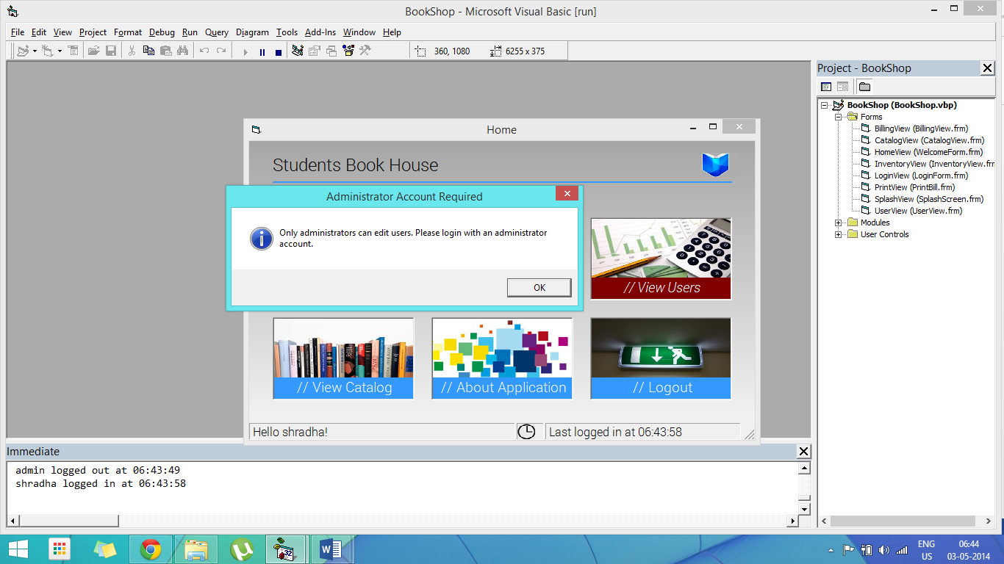

Access rights management being enforced when trying to access the Users Screen from a non-Administrator account.

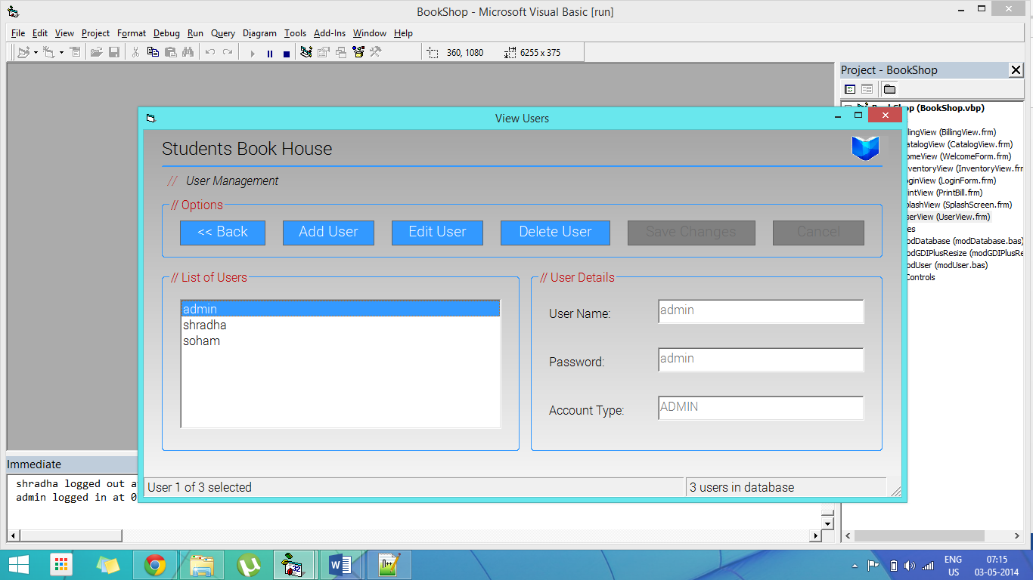

The initial view on opening the Users Screen

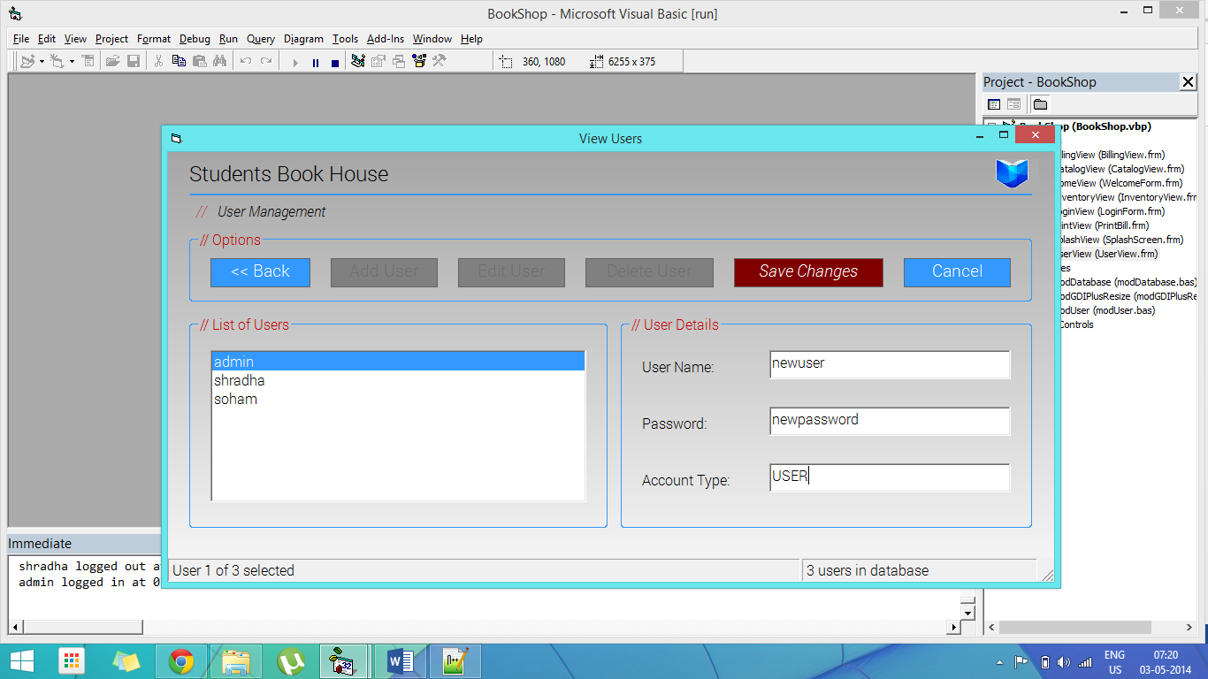

Add a new user to the database

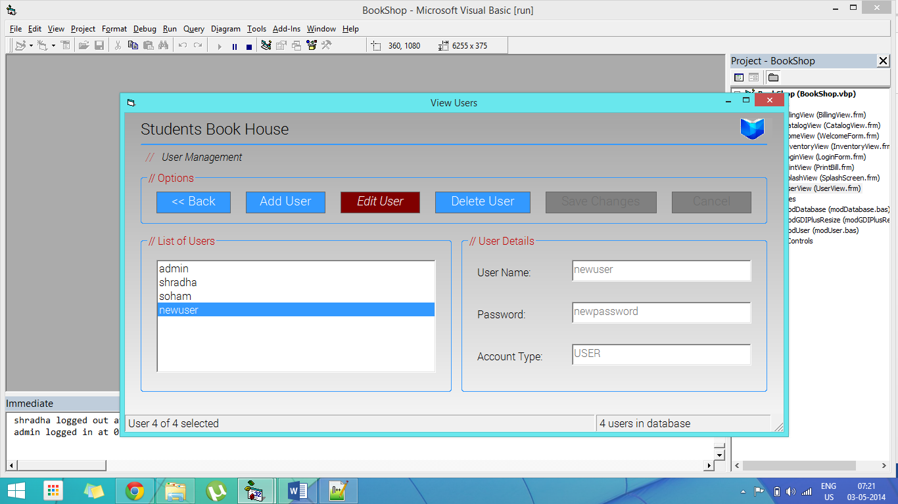

Users Screen after adding new user

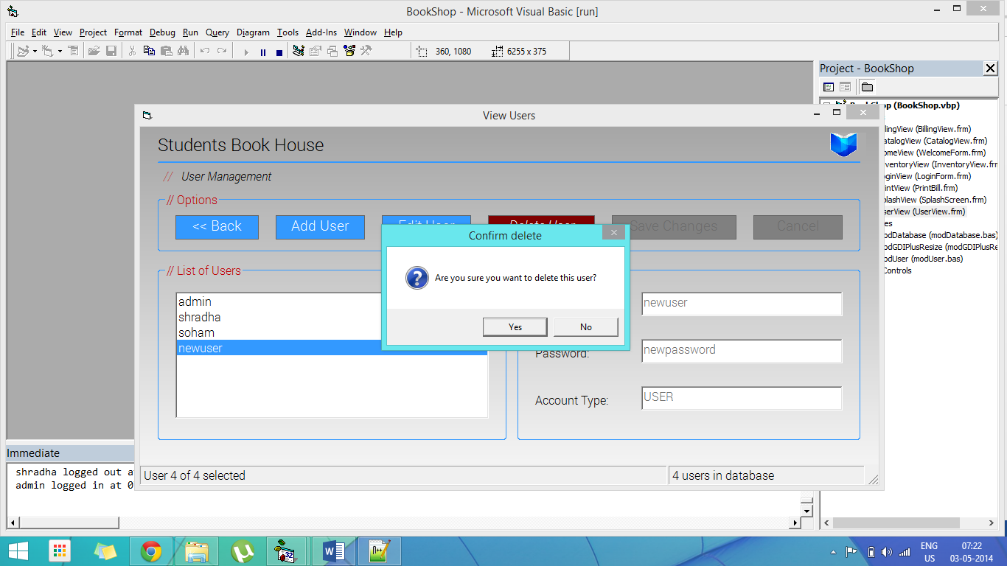

Delete user confirmation dialog

Modules

# modGDIplusResize (\lib\modGDIplusResize.bas)

## Description

It uses the Win32 API to offload graphics processing onto the Graphics Driver Interface library. It is needed for the Active Resizing of elements whenever a form is scaled. It also supports loading of PNGs and GIFs in a PictureBox with full alpha transparency layer. Together with the OpenFrameset control, this is used to create most of the transparencies and gradients that give the project its look and feel.

## Source Code

**Option** Explicit

**Public** **Declare** **Function** **GetSysColor** **Lib** "user32" (**ByVal** nIndex **As** **Long**) **As** **Long**

**Private** Type GUID

   Data1 **As** **Long**

   Data2 **As** **Integer**

   Data3 **As** **Integer**

   Data4(7) **As** **Byte**

**End** Type

**Private** Type PICTDESC

   size **As** **Long**

   Type **As** **Long**

   hBmp **As** **Long**

   hPal **As** **Long**

   Reserved **As** **Long**

**End** Type

**Private** Type GdiplusStartupInput

    GdiplusVersion **As** **Long**

    DebugEventCallback **As** **Long**

    SuppressBackgroundThread **As** **Long**

    SuppressExternalCodecs **As** **Long**

**End** Type

**Private** Type PWMFRect16

    left **As** **Integer**

    top **As** **Integer**

    Right **As** **Integer**

    Bottom **As** **Integer**

**End** Type

**Private** Type wmfPlaceableFileHeader

    Key **As** **Long**

    hMf **As** **Integer**

    BoundingBox **As** PWMFRect16

    Inch **As** **Integer**

    Reserved **As** **Long**

    CheckSum **As** **Integer**

**End** Type

*' GDI Functions*

**Private** **Declare** **Function** **CreateCompatibleDC** **Lib** "gdi32" (**ByVal** hDC **As** **Long**) **As** **Long**

**Private** **Declare** **Function** **OleCreatePictureIndirect** **Lib** "olepro32.dll" (PicDesc **As** PICTDESC, RefIID **As** GUID, **ByVal** fPictureOwnsHandle **As** **Long**, IPic **As** IPicture) **As** **Long**

**Private** **Declare** **Function** **CreateCompatibleBitmap** **Lib** "gdi32" (**ByVal** hDC **As** **Long**, **ByVal** nWidth **As** **Long**, **ByVal** nHeight **As** **Long**) **As** **Long**

**Private** **Declare** **Function** **GetDeviceCaps** **Lib** "gdi32" (**ByVal** hDC **As** **Long**, **ByVal** nIndex **As** **Long**) **As** **Long**

**Private** **Declare** **Function** **PatBlt** **Lib** "gdi32" (**ByVal** hDC **As** **Long**, **ByVal** x **As** **Long**, **ByVal** y **As** **Long**, **ByVal** nWidth **As** **Long**, **ByVal** nHeight **As** **Long**, **ByVal** dwRop **As** **Long**) **As** **Long**

**Private** **Declare** **Function** **CreateBitmap** **Lib** "gdi32" (**ByVal** nWidth **As** **Long**, **ByVal** nHeight **As** **Long**, **ByVal** nPlanes **As** **Long**, **ByVal** nBitCount **As** **Long**, lpBits **As** Any) **As** **Long**

**Private** **Declare** **Function** **SelectObject** **Lib** "gdi32" (**ByVal** hDC **As** **Long**, **ByVal** hObject **As** **Long**) **As** **Long**

**Private** **Declare** **Function** **CreateSolidBrush** **Lib** "gdi32" (**ByVal** crColor **As** **Long**) **As** **Long**

**Private** **Declare** **Function** **DeleteObject** **Lib** "gdi32" (**ByVal** hObject **As** **Long**) **As** **Long**

**Private** **Declare** **Function** **DeleteDC** **Lib** "gdi32" (**ByVal** hDC **As** **Long**) **As** **Long**

*' GDI+ functions*

**Private** **Declare** **Function** **GdipLoadImageFromFile** **Lib** "gdiplus.dll" (**ByVal** FileName **As** **Long**, GpImage **As** **Long**) **As** **Long**

**Private** **Declare** **Function** **GdiplusStartup** **Lib** "gdiplus.dll" (Token **As** **Long**, gdipInput **As** GdiplusStartupInput, GdiplusStartupOutput **As** **Long**) **As** **Long**

**Private** **Declare** **Function** **GdipCreateFromHDC** **Lib** "gdiplus.dll" (**ByVal** hDC **As** **Long**, GpGraphics **As** **Long**) **As** **Long**

**Private** **Declare** **Function** **GdipSetInterpolationMode** **Lib** "gdiplus.dll" (**ByVal** Graphics **As** **Long**, **ByVal** InterMode **As** **Long**) **As** **Long**

**Private** **Declare** **Function** **GdipDrawImageRectI** **Lib** "gdiplus.dll" (**ByVal** Graphics **As** **Long**, **ByVal** Img **As** **Long**, **ByVal** x **As** **Long**, **ByVal** y **As** **Long**, **ByVal** Width **As** **Long**, **ByVal** Height **As** **Long**) **As** **Long**

**Private** **Declare** **Function** **GdipDeleteGraphics** **Lib** "gdiplus.dll" (**ByVal** Graphics **As** **Long**) **As** **Long**

**Private** **Declare** **Function** **GdipDisposeImage** **Lib** "gdiplus.dll" (**ByVal** Image **As** **Long**) **As** **Long**

**Private** **Declare** **Function** **GdipCreateBitmapFromHBITMAP** **Lib** "gdiplus.dll" (**ByVal** hBmp **As** **Long**, **ByVal** hPal **As** **Long**, GpBitmap **As** **Long**) **As** **Long**

**Private** **Declare** **Function** **GdipGetImageWidth** **Lib** "gdiplus.dll" (**ByVal** Image **As** **Long**, Width **As** **Long**) **As** **Long**

**Private** **Declare** **Function** **GdipGetImageHeight** **Lib** "gdiplus.dll" (**ByVal** Image **As** **Long**, Height **As** **Long**) **As** **Long**

**Private** **Declare** **Function** **GdipCreateMetafileFromWmf** **Lib** "gdiplus.dll" (**ByVal** hWmf **As** **Long**, **ByVal** deleteWmf **As** **Long**, WmfHeader **As** wmfPlaceableFileHeader, Metafile **As** **Long**) **As** **Long**

**Private** **Declare** **Function** **GdipCreateMetafileFromEmf** **Lib** "gdiplus.dll" (**ByVal** hEmf **As** **Long**, **ByVal** deleteEmf **As** **Long**, Metafile **As** **Long**) **As** **Long**

**Private** **Declare** **Function** **GdipCreateBitmapFromHICON** **Lib** "gdiplus.dll" (**ByVal** hIcon **As** **Long**, GpBitmap **As** **Long**) **As** **Long**

**Private** **Declare** **Function** **GdipDrawImageRectRectI** **Lib** "gdiplus.dll" (**ByVal** Graphics **As** **Long**, **ByVal** GpImage **As** **Long**, **ByVal** dstx **As** **Long**, **ByVal** dsty **As** **Long**, **ByVal** dstwidth **As** **Long**, **ByVal** dstheight **As** **Long**, **ByVal** srcx **As** **Long**, **ByVal** srcy **As** **Long**, **ByVal** srcwidth **As** **Long**, **ByVal** srcheight **As** **Long**, **ByVal** srcUnit **As** **Long**, **ByVal** imageAttributes **As** **Long**, **ByVal** callback **As** **Long**, **ByVal** callbackData **As** **Long**) **As** **Long**

**Private** **Declare** **Sub** **GdiplusShutdown** **Lib** "gdiplus.dll" (**ByVal** Token **As** **Long**)

*' GDI and GDI+ constants*

**Private** **Const** PLANES **=** 14 *' Number of planes*

**Private** **Const** BITSPIXEL **=** 12 *' Number of bits per pixel*

**Private** **Const** PATCOPY **=** **&**HF00021 *' (DWORD) dest = pattern*

**Private** **Const** PICTYPE_BITMAP **=** 1 *' Bitmap type*

**Private** **Const** InterpolationModeHighQualityBicubic **=** 7

**Private** **Const** GDIP_WMF_PLACEABLEKEY **=** **&**H9AC6CDD7

**Private** **Const** UnitPixel **=** 2

*' Initialises GDI Plus*

**Public** **Function** **InitGDIPlus**() **As** **Long**

**Dim** Token **As** **Long**

**Dim** gdipInit **As** GdiplusStartupInput

    gdipInit.GdiplusVersion **=** 1

    GdiplusStartup Token, gdipInit, **ByVal** 0**&**

    InitGDIPlus **=** Token

**End** **Function**

*' Frees GDI Plus*

**Public** **Sub** **FreeGDIPlus**(Token **As** **Long**)

    GdiplusShutdown Token

**End** **Sub**

*' Loads the picture (optionally resized)*

**Public** **Function** **LoadPictureGDIPlus**(PicFile **As** **String**, **Optional** Width **As** **Long** **=** **-**1, **Optional** Height **As** **Long** **=** **-**1, **Optional** **ByVal** BackColor **As** **Long** **=** vbWhite, **Optional** RetainRatio **As** **Boolean** **=** **False**) **As** IPicture

**Dim** hDC **As** **Long**

**Dim** hBitmap **As** **Long**

**Dim** Img **As** **Long**

*' Load the image*

**If** GdipLoadImageFromFile(StrPtr(PicFile), Img) **<>** 0 **Then**

        Err.Raise 999, "GDI+ Module", "Error loading picture " **&** PicFile

**Exit** **Function**

**End** **If**

*' Calculate picture's width and height if not specified*

**If** Width **=** **-**1 **Or** Height **=** **-**1 **Then**

        GdipGetImageWidth Img, Width

        GdipGetImageHeight Img, Height

**End** **If**

*' Initialise the hDC*

    InitDC hDC, hBitmap, BackColor, Width, Height

*' Resize the picture*

    gdipResize Img, hDC, Width, Height, RetainRatio

    GdipDisposeImage Img

*' Get the bitmap back*

    GetBitmap hDC, hBitmap

*' Create the picture*

**Set** LoadPictureGDIPlus **=** CreatePicture(hBitmap)

**End** **Function**

*' Initialises the hDC to draw*

**Private** **Sub** **InitDC**(hDC **As** **Long**, hBitmap **As** **Long**, BackColor **As** **Long**, Width **As** **Long**, Height **As** **Long**)

**Dim** hBrush **As** **Long**

*' Create a memory DC and select a bitmap into it, fill it in with the backcolor*

    hDC **=** CreateCompatibleDC(**ByVal** 0**&**)

    hBitmap **=** CreateBitmap(Width, Height, GetDeviceCaps(hDC, PLANES), GetDeviceCaps(hDC, BITSPIXEL), **ByVal** 0**&**)

    hBitmap **=** SelectObject(hDC, hBitmap)

    hBrush **=** CreateSolidBrush(BackColor)

    hBrush **=** SelectObject(hDC, hBrush)

    PatBlt hDC, 0, 0, Width, Height, PATCOPY

    DeleteObject SelectObject(hDC, hBrush)

**End** **Sub**

*' Resize the picture using GDI plus*

**Private** **Sub** **gdipResize**(Img **As** **Long**, hDC **As** **Long**, Width **As** **Long**, Height **As** **Long**, **Optional** RetainRatio **As** **Boolean** **=** **False**)

**Dim** Graphics **As** **Long** *' Graphics Object Pointer*

**Dim** OrWidth **As** **Long** *' Original Image Width*

**Dim** OrHeight **As** **Long** *' Original Image Height*

**Dim** OrRatio **As** **Double** *' Original Image Ratio*

**Dim** DesRatio **As** **Double** *' Destination rect Ratio*

**Dim** DestX **As** **Long** *' Destination image X*

**Dim** DestY **As** **Long** *' Destination image Y*

**Dim** DestWidth **As** **Long** *' Destination image Width*

**Dim** DestHeight **As** **Long** *' Destination image Height*

    GdipCreateFromHDC hDC, Graphics

    GdipSetInterpolationMode Graphics, InterpolationModeHighQualityBicubic

**If** RetainRatio **Then**

        GdipGetImageWidth Img, OrWidth

        GdipGetImageHeight Img, OrHeight

        OrRatio **=** OrWidth **/** OrHeight

        DesRatio **=** Width **/** Height

*' Calculate destination coordinates*

        DestWidth **=** IIf(DesRatio **<** OrRatio, Width, Height **\*** OrRatio)

        DestHeight **=** IIf(DesRatio **<** OrRatio, Width **/** OrRatio, Height)

*' DestX = (Width - DestWidth) / 2*

*' DestY = (Height - DestHeight) / 2*

        DestX **=** 0

        DestY **=** 0

        GdipDrawImageRectRectI Graphics, Img, DestX, DestY, DestWidth, DestHeight, 0, 0, OrWidth, OrHeight, UnitPixel, 0, 0, 0

**Else**

        GdipDrawImageRectI Graphics, Img, 0, 0, Width, Height

**End** **If**

    GdipDeleteGraphics Graphics

**End** **Sub**

*' Replaces the old bitmap of the hDC, Returns the bitmap and Deletes the hDC*

**Private** **Sub** **GetBitmap**(hDC **As** **Long**, hBitmap **As** **Long**)

    hBitmap **=** SelectObject(hDC, hBitmap)

    DeleteDC hDC

**End** **Sub**

*' Creates a Picture Object from a handle to a bitmap*

**Private** **Function** **CreatePicture**(hBitmap **As** **Long**) **As** IPicture

**Dim** IID_IDispatch **As** GUID

**Dim** Pic **As** PICTDESC

**Dim** IPic **As** IPicture

*' Fill in OLE IDispatch Interface ID*

    IID_IDispatch.Data1 **=** **&**H20400

    IID_IDispatch.Data4(0) **=** **&**HC0

    IID_IDispatch.Data4(7) **=** **&**H46

*' Fill Pic with necessary parts*

    Pic.size **=** Len(Pic) *' Length of structure*

    Pic.Type **=** PICTYPE_BITMAP *' Type of Picture (bitmap)*

    Pic.hBmp **=** hBitmap *' Handle to bitmap*

*' Create the picture*

    OleCreatePictureIndirect Pic, IID_IDispatch, **True**, IPic

**Set** CreatePicture **=** IPic

**End** **Function**

*' Returns a resized version of the picture*

**Public** **Function** **Resize**(Handle **As** **Long**, PicType **As** PictureTypeConstants, Width **As** **Long**, Height **As** **Long**, **Optional** BackColor **As** **Long** **=** vbWhite, **Optional** RetainRatio **As** **Boolean** **=** **False**) **As** IPicture

**Dim** Img **As** **Long**

**Dim** hDC **As** **Long**

**Dim** hBitmap **As** **Long**

**Dim** WmfHeader **As** wmfPlaceableFileHeader

*' Determine pictyre type*

**Select** **Case** PicType

**Case** vbPicTypeBitmap

         GdipCreateBitmapFromHBITMAP Handle, **ByVal** 0**&**, Img

**Case** vbPicTypeMetafile

         FillInWmfHeader WmfHeader, Width, Height

         GdipCreateMetafileFromWmf Handle, **False**, WmfHeader, Img

**Case** vbPicTypeEMetafile

         GdipCreateMetafileFromEmf Handle, **False**, Img

**Case** vbPicTypeIcon

*' Does not return a valid Image object*

         GdipCreateBitmapFromHICON Handle, Img

**End** **Select**

*' Continue with resizing only if we have a valid image object*

**If** Img **Then**

        InitDC hDC, hBitmap, BackColor, Width, Height

        gdipResize Img, hDC, Width, Height, RetainRatio

        GdipDisposeImage Img

        GetBitmap hDC, hBitmap

**Set** Resize **=** CreatePicture(hBitmap)

**End** **If**

**End** **Function**

*' Fills in the wmfPlacable header*

**Private** **Sub** **FillInWmfHeader**(WmfHeader **As** wmfPlaceableFileHeader, Width **As** **Long**, Height **As** **Long**)

    WmfHeader.BoundingBox.Right **=** Width

    WmfHeader.BoundingBox.Bottom **=** Height

    WmfHeader.Inch **=** 1440

    WmfHeader.Key **=** GDIP_WMF_PLACEABLEKEY

**End** **Sub**

# modUser (\lib\modUser.bas)

## Description

It is a multi-user handling library to enforce user profile based access rights management. It includes methods to automate login and logout for easy access.

## Source Code

**Public** username **As** **String**, password **As** **String**, usertype **As** **String**

**Public** lastLogin **As** **Date**

**Public** loggedIn **As** **Boolean**

**Public** **Sub** **initUser**()

    username **=** ""

    password **=** ""

    usertype **=** "USER"

    loggedIn **=** **False**

**End** **Sub**

**Public** **Sub** **usrLogin**(usr **As** **String**, pwd **As** **String**, ut **As** **String**)

**If** **Not** loggedIn **Then**

        username **=** usr

        password **=** pwd

        loggedIn **=** **True**

        usertype **=** ut

        lastLogin **=** Time

        Debug.Print username **&** " logged in at " **&** lastLogin

**Else**

        Debug.Print username **&** " is already logged in! Please logout first."

**End** **If**

**End** **Sub**

**Public** **Sub** **usrLogout**()

**If** loggedIn **Then**

        Debug.Print username **&** " logged out at " **&** Time

        username **=** ""

        password **=** ""

        usertype **=** "USER"

        loggedIn **=** **False**

**Else**

        Debug.Print "No user is logged in! Please login first."

**End** **If**

**End** **Sub**

# modDatabase (\lib\modDatabase.bas)

## Description

It provides a wrapper for the Microsoft ActiveX Data Objects Database class. It provides methods to open and close a Database connection by specifying the path to the database. It returns a Recordset object which can be manipulated programmatically.

## Source Code

**Option** Explicit

**Public** conn **As** ADODB.Connection

**Public** dbOpen **As** **Boolean**

**Public** **Sub** **initDB**()

StartConn:

    dbOpen **=** **False**

**Set** conn **=** **New** ADODB.Connection

    conn.ConnectionString **=** "Provider=Microsoft.Jet.OLEDB.4.0;Data Source=" **&** App.Path **&** "\db\BookDB.mdb;Persist Security Info=False"

    conn.CursorLocation **=** adUseClient

    conn.Open

**If** **Not** conn.State **=** adStateOpen **Then**

**Select** **Case** MsgBox("There was an error opening the databse! Please exit and restart the program. Alternately, you can try to connect again.", vbCritical **+** vbApplicationModal **+** vbRetryCancel **+** vbDefaultButton1, "Database Error")

**Case** vbRetry

**GoTo** StartConn

**Case** vbCancel

**End**

**End** **Select**

**Else**

        dbOpen **=** **True**

**End** **If**

**End** **Sub**

**Public** **Sub** **closeDB**()

    conn.Close

    dbOpen **=** **False**

**End** **Sub**

Conclusion

# Roadmap

Further planned improvements to the software include:

* A better user authentication system, including password hashing and salting for better security.
* Offloading the billing section to a secondary database to keep track of individual sales.
* More thorough testing and bug fixes.

# Discussion

The project has helped me develop a lot of understanding of the software test and release cycle apart from helping me have a better grasp over Visual Basic and designing fluid and responsive Graphical User Interfaces (GUIs). It has also helped to improve my knowledge of the Win32 API and the various methods that it provides.

# References

* MSDN: Visual Basic 6.0 Technical Reference  
  <http://msdn.microsoft.com/en-us/library/hh127540.aspx>
* Programming Win32 Under the API  
  <http://books.google.co.in/books?isbn=1578200679>
* Windows API Index (Windows) – MSDN – Microsoft  
  <http://msdn.microsoft.com/en-us/library/ff818516(v=vs.85).aspx‎>